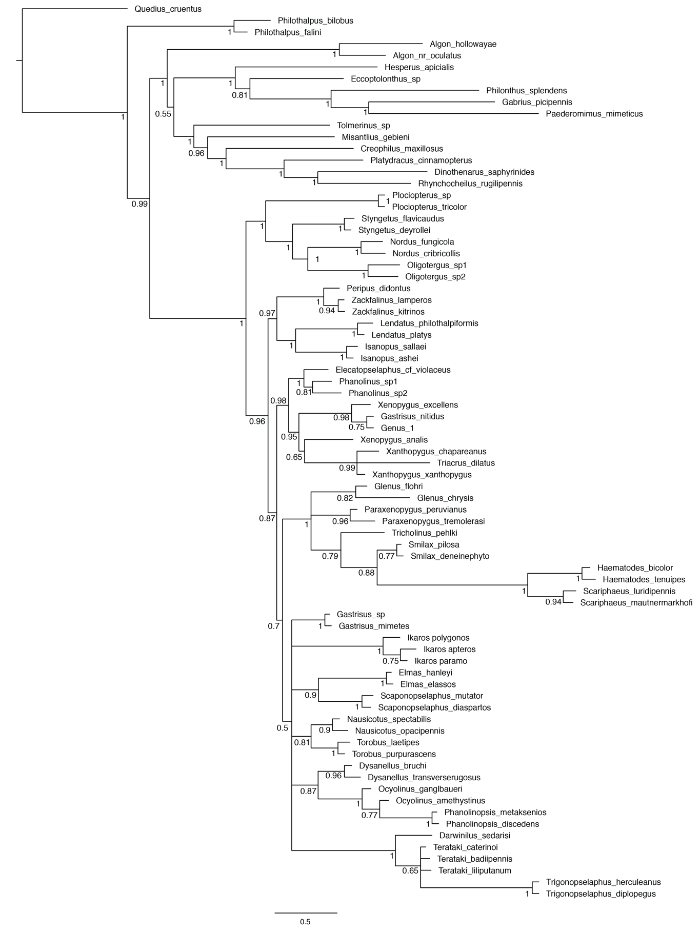
Supp. file 3. Full topologies of all phylogenetic analyses.
Chatzimanolis S. & Brunke A.J. 2021. A new apterous rove beetle genus (Coleoptera: Staphylinidae) from the Northern Andes with an assessment of its phylogenetic position. European Journal of Taxonomy. https://doi.org/10.5852/ejt.2021.731.1303.3943

Supplementary Figure S1. Fifty percent majority rules consensus tree from a partitioned, total evidence Bayesian phylogenetic analysis of six genes and morphology (all characters), with posterior probabilities to the left of the corresponding node.
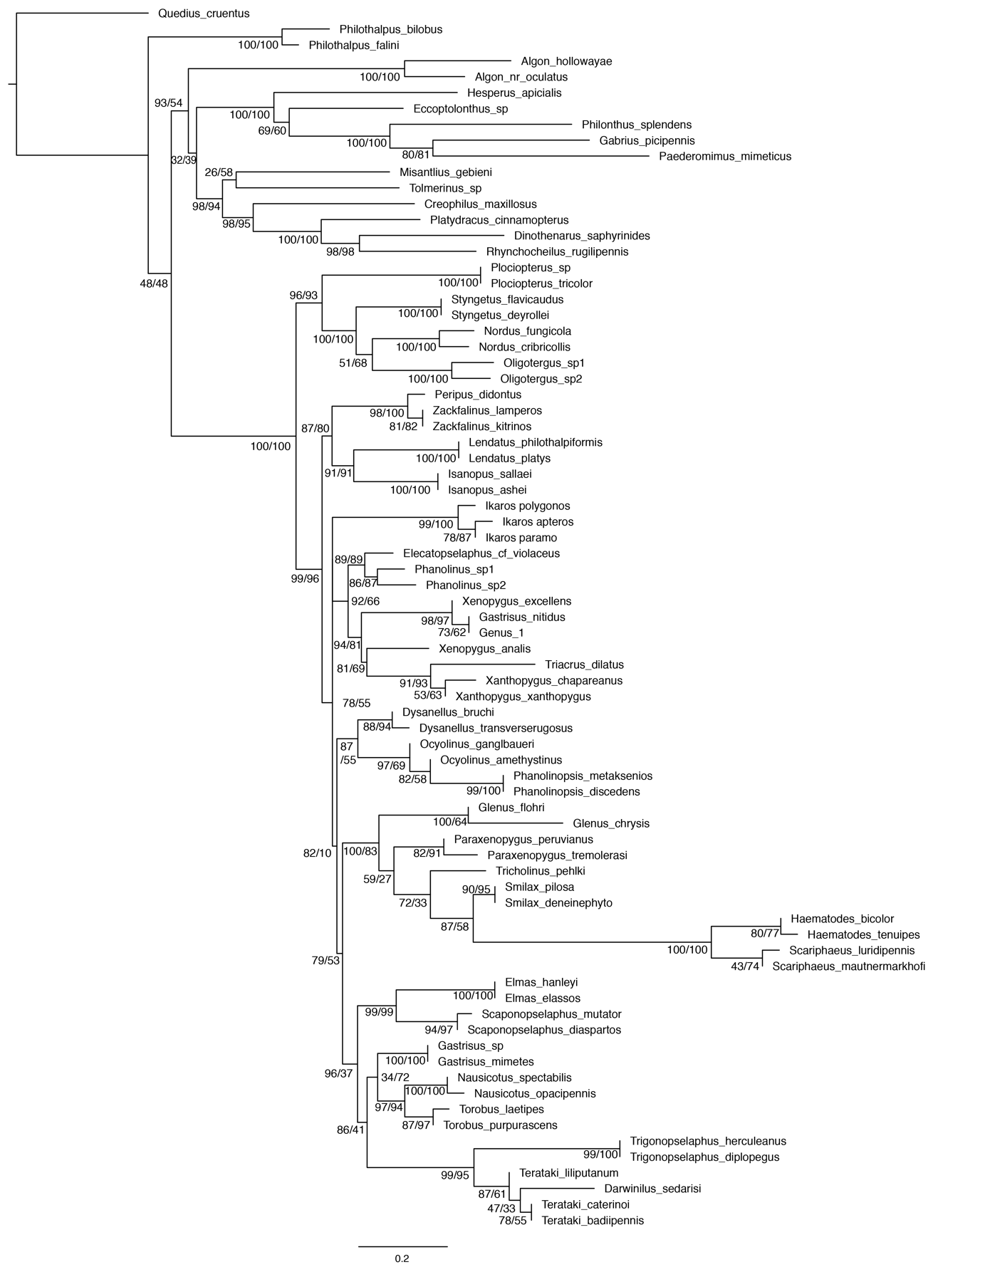
Supplementary Figure S2. Maximum likelihood topology from a partitioned, total evidence maximum likelihood phylogenetic analysis of six genes and morphology (all characters), with SH-aLRT (left) and ultrafast bootstrap (right) values to the left of the corresponding node.

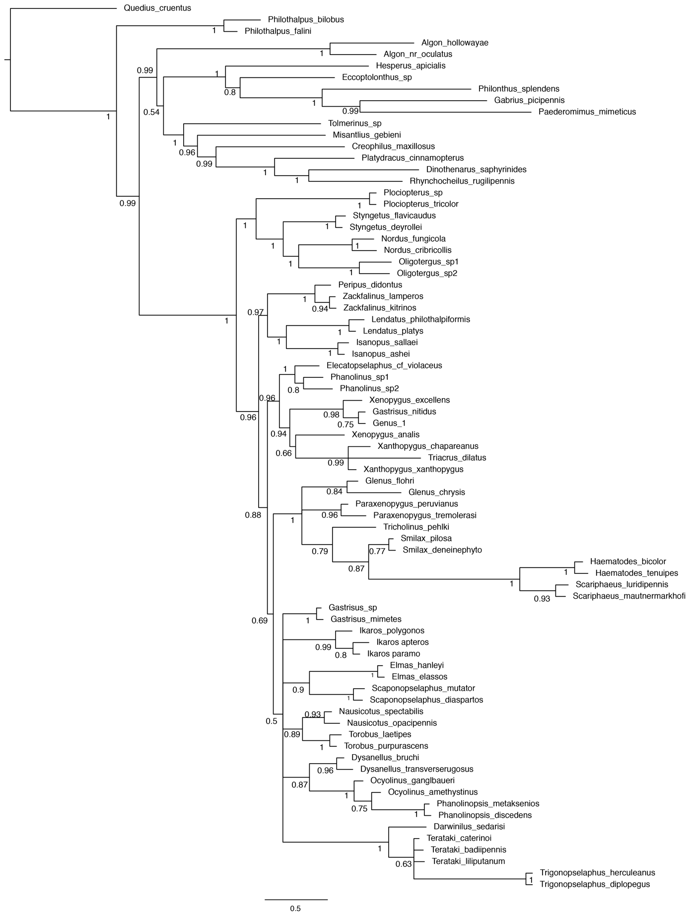
Supplementary Figure S3. Fifty percent majority rules consensus tree from a partitioned, total evidence Bayesian phylogenetic analysis of six genes and morphology (3 aptery-associated characters removed), with posterior probabilities to the left of the corresponding node.
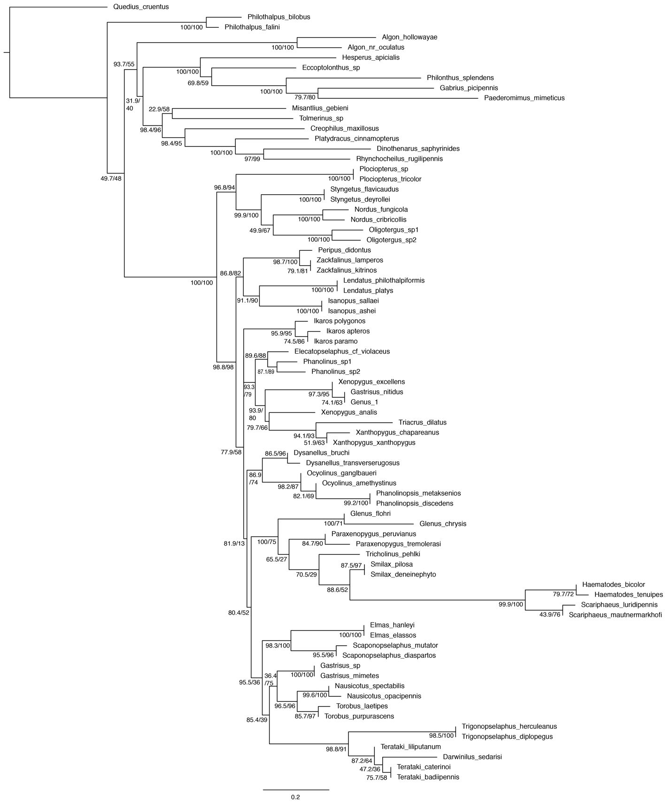
Supplementary Figure S4. Maximum likelihood topology from a partitioned, total evidence maximum likelihood phylogenetic analysis of six genes and morphology (3 aptery-associated characters removed), with SH-aLRT (left) and ultrafast bootstrap (right) values to the left of the corresponding node.

