Supp. file 3. Supplementary figures.
https://doi.org/10.5852/ejt.2021.754.1393.4427

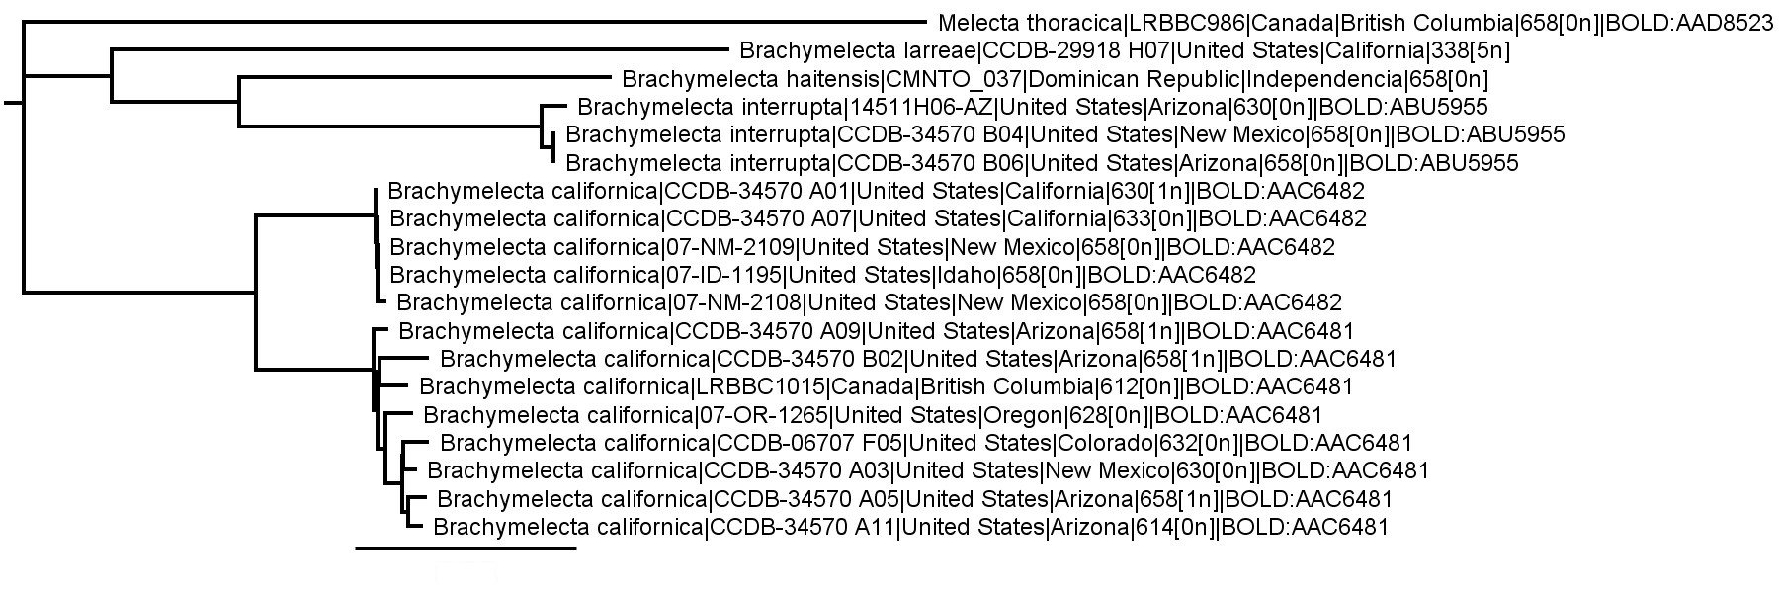

Fig. S1. A rooted neighbor-joining tree of Brachymelecta COI sequences >300 bp in length (with Melecta thoracica Cresson, 1875 selected as the outgroup), generated in Geneious and based on the Tamura-Nei genetic distance model. For each sample, the length of the barcode sequence is given, with the number of ambiguous bases appearing in square brackets. Scale bar = 5% pairwise distance.

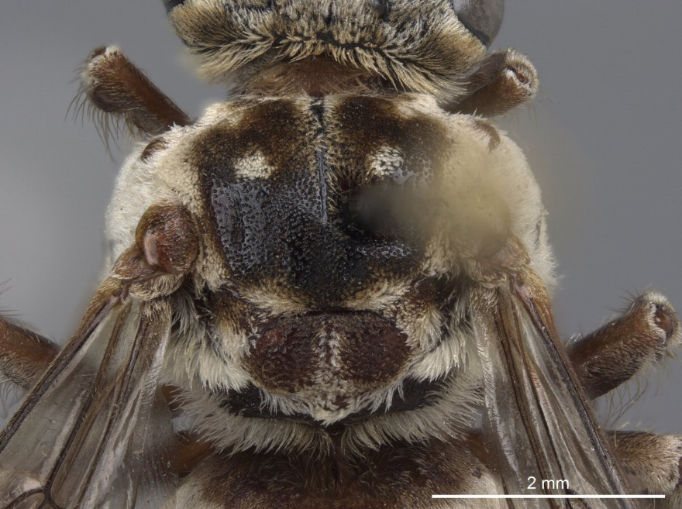

Fig. S2. Mesosoma, dorsal view, of female Zacosmia maculata (Cresson, 1879) (PCYU).

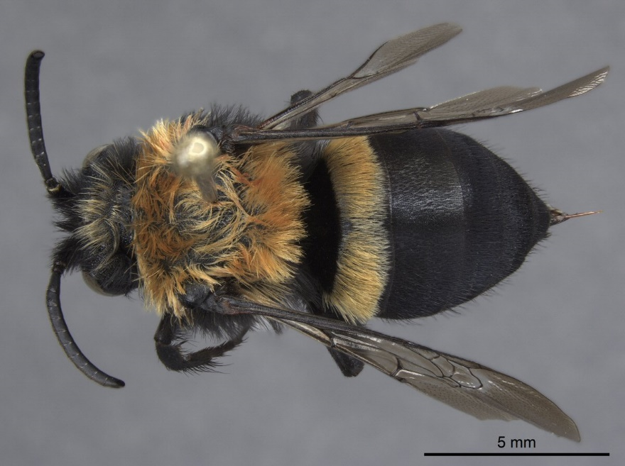

Fig. S3. Female Melecta thoracica Cresson, 1875 (BOLD sample ID: LRBBC986; PCYU LRB09-2548), habitus, dorsal view.

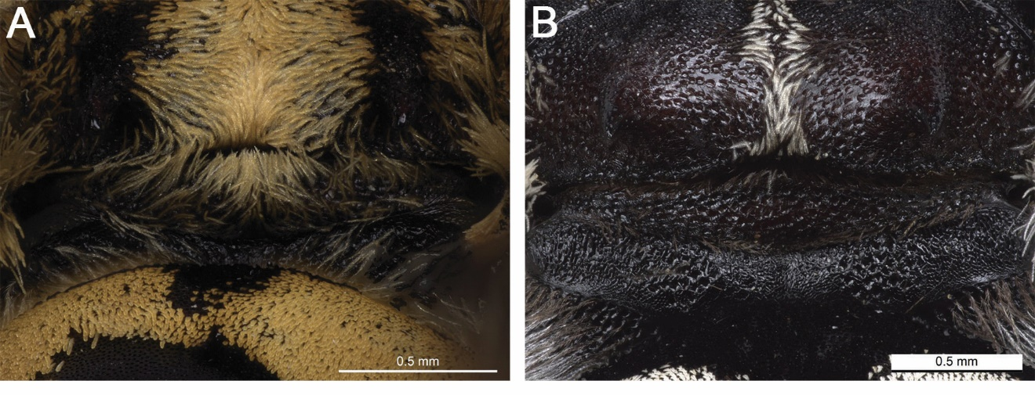

Fig. S4. Metanotum of male, posterior view. A. Brachymelecta alayoi (Michener, 1988) (USNM). B. B. tibialis (Fabricius, 1793) (UPRM).

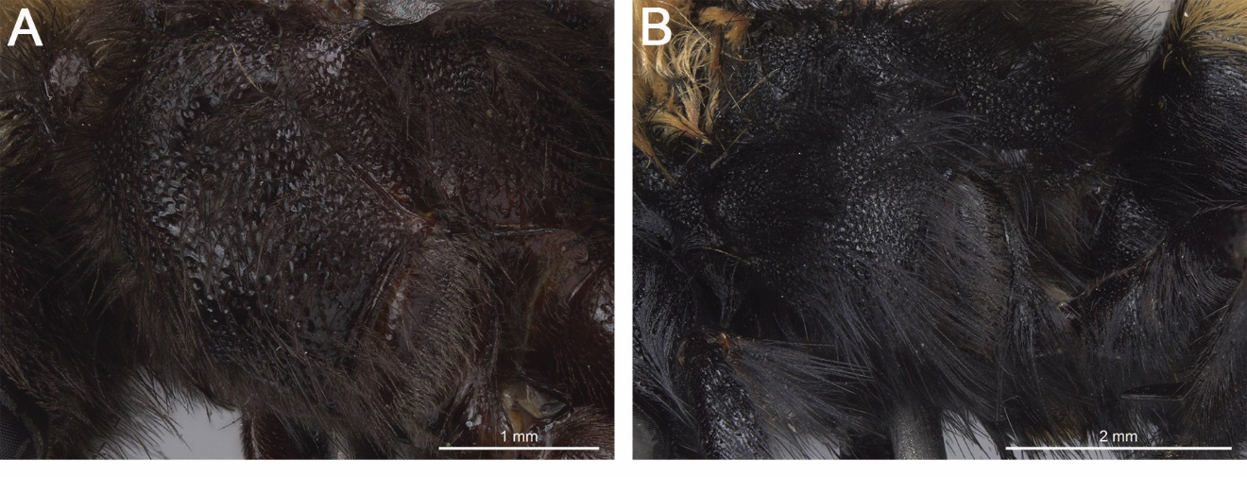

Fig. S5. Mesopleuron of female, lateral view. A. Brachymelecta larreae (Cockerell, 1900) (CAS). B. Melecta thoracica Cresson, 1875 (BOLD sample ID: LRBBC986; PCYU LRB09-2548).

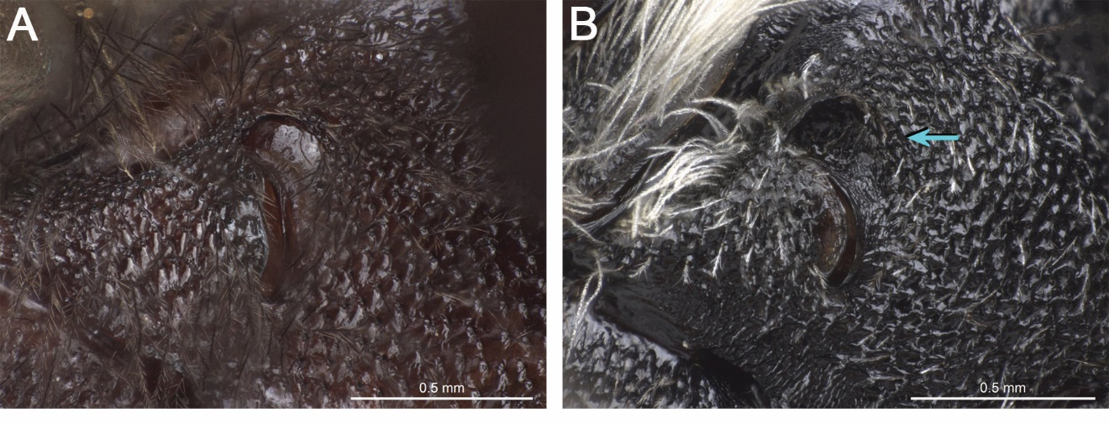

Fig. S6. Propodeal spiracle of female, lateral view. A. Brachymelecta larreae (Cockerell, 1900) (CAS). B. B. tibialis (Fabricius, 1793) (UPRM) (blue arrow indicates rugose crescent ridge extending from anterior lip of spiracle).

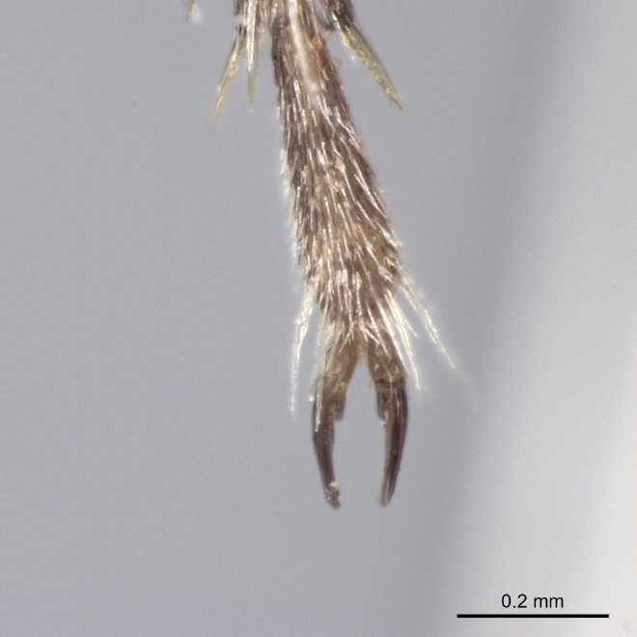

Fig. S7. Metadistitarsus, dorsal view, of female Zacosmia maculata (Cresson, 1879) (PCYU).

