Supp. file 1. Phylogenetic trees. Outgroup taxa were pruned off. Specimens identified by two-digit locality code in bold, four digit individual DNA code, and orographic unit (see Table 1) or GenBank accession number; posterior probabilities or bootstrap support values at nodes; scale bars in substitutions per site; the sequence of H. tellinii (Pollonera, 1898) was generated by Ponder et al. (2008). https://doi.org/10.5852/ejt.2021.775.1555.5329

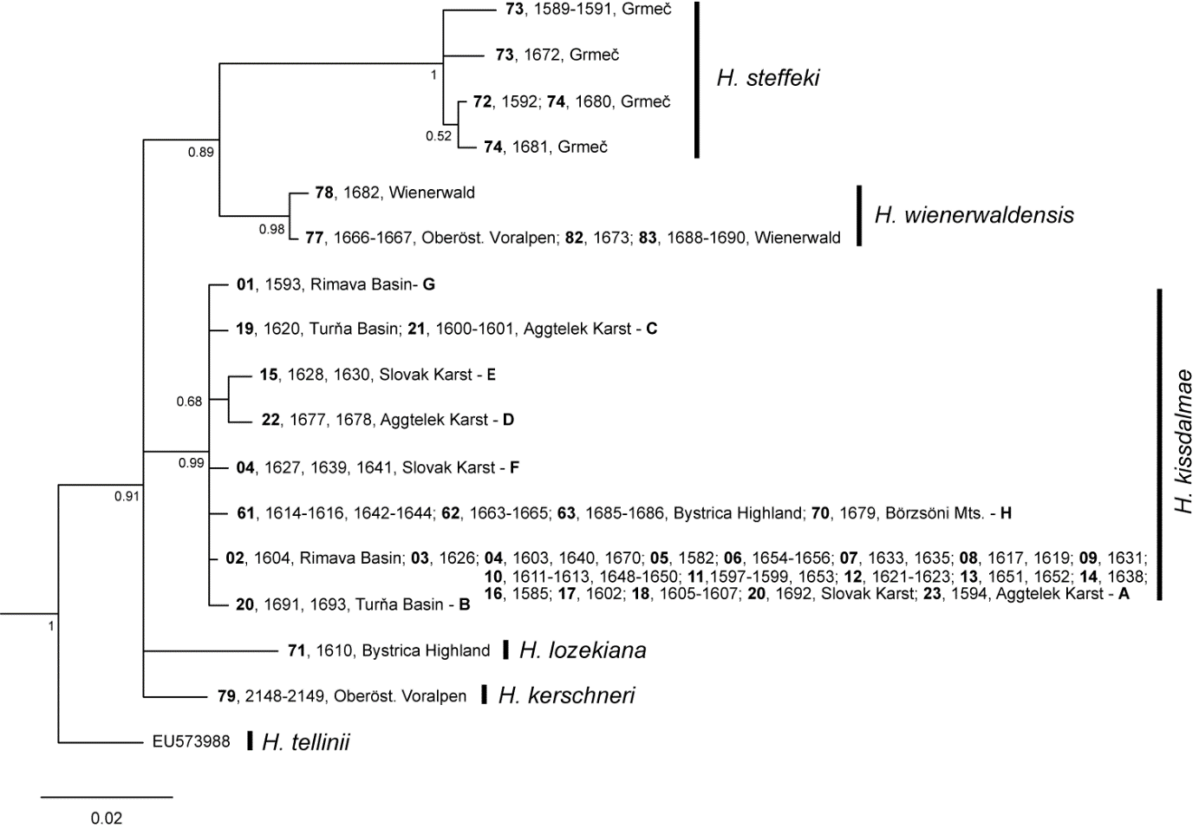
Figure S1. Phylogenetic tree from Bayesian analysis in MrBayes based on 16S rRNA. Bold capitals denote haplotypes of H. kissdalmae from statistical parsimony network in Figure 9.
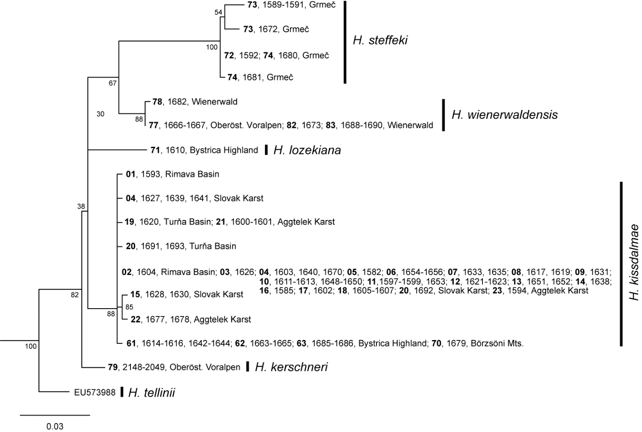
Figure S2. Phylogenetic tree from maximum likelihood (ML) analysis in W-IQ-TREE based on 16S rRNA.
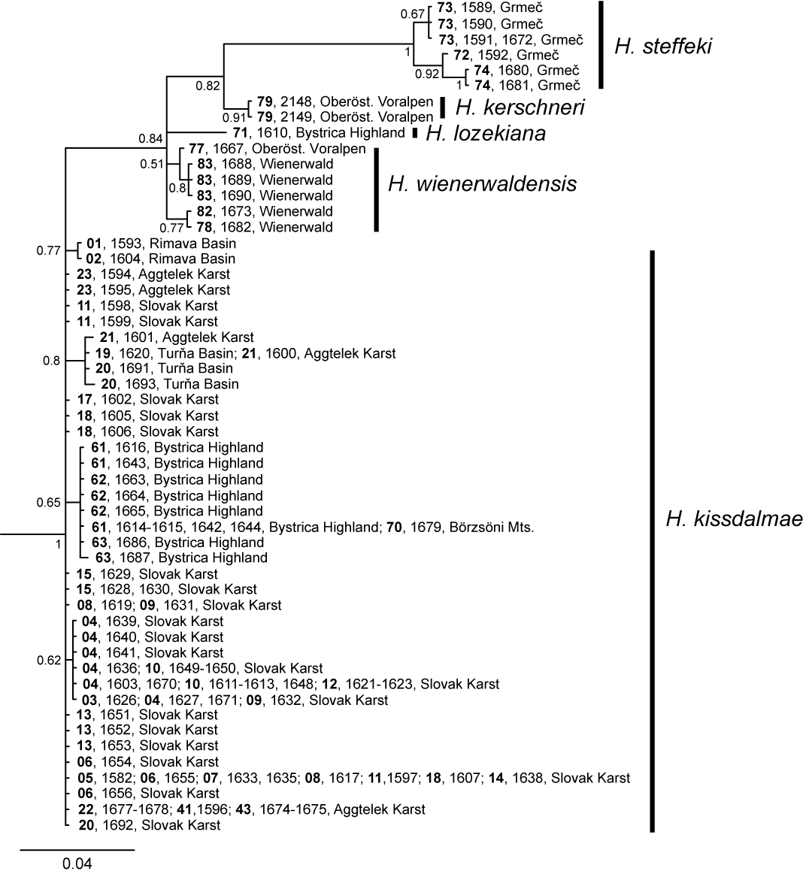
Figure S3. Phylogenetic tree from Bayesian analysis in MrBayes based on ITS2.
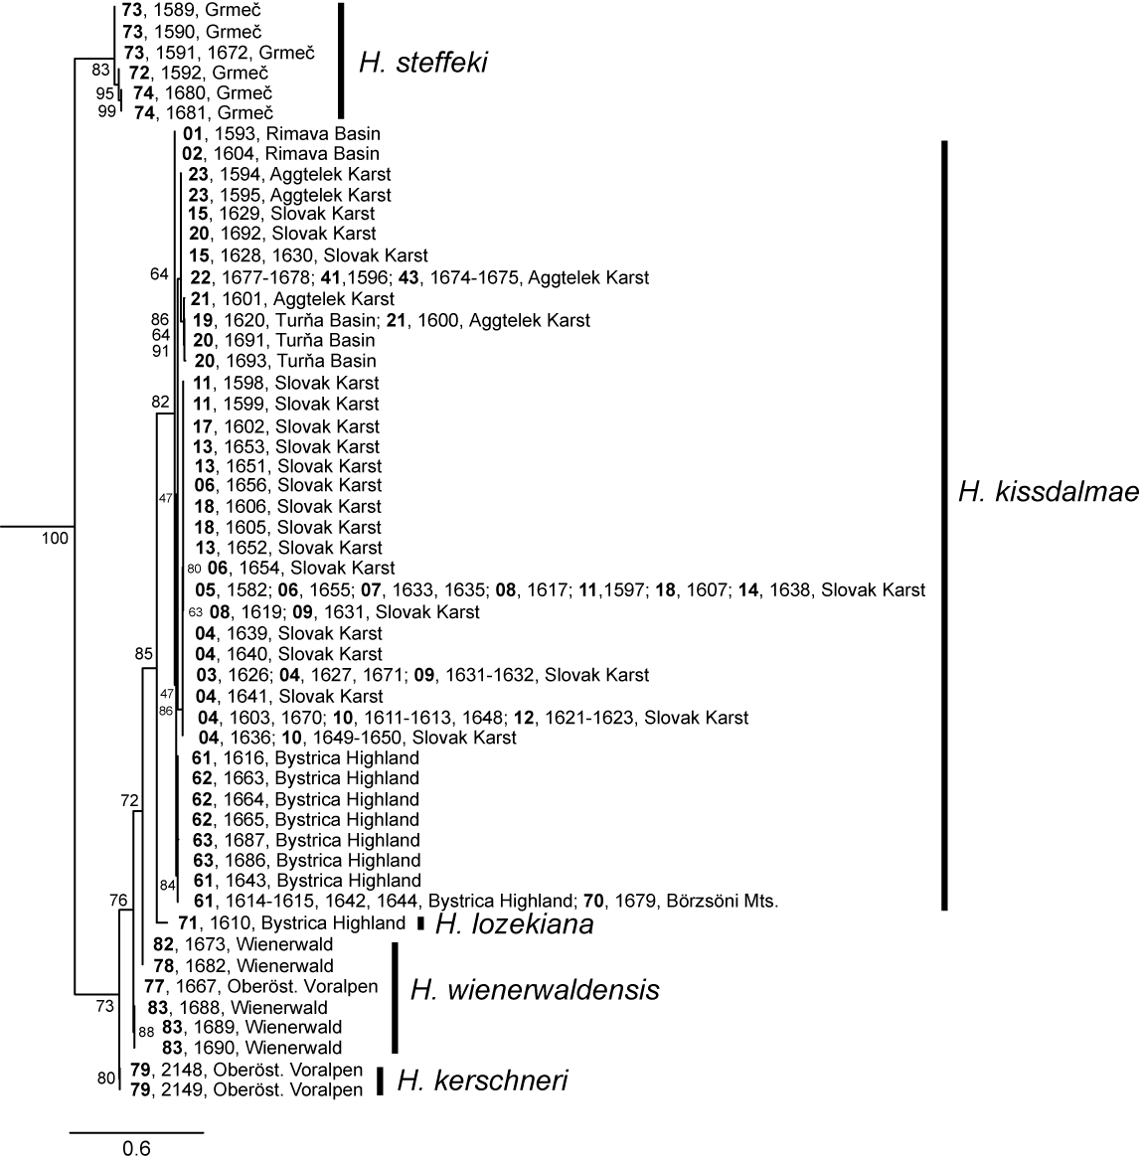
Figure S4. Phylogenetic tree from maximum likelihood (ML) analysis in W-IQ-TREE based on ITS2.
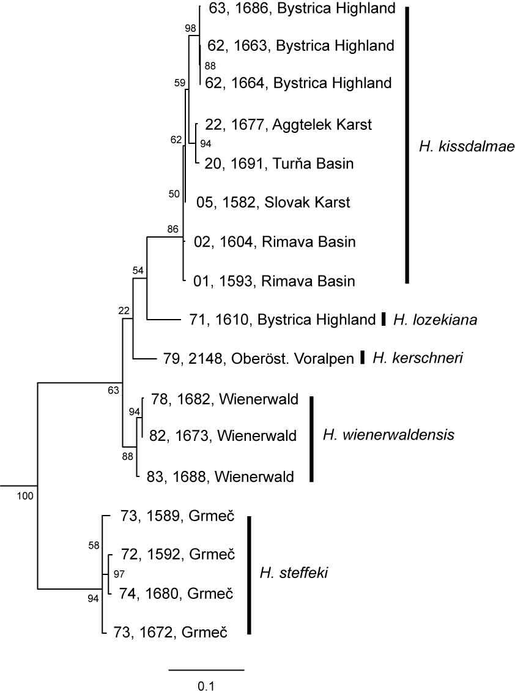
Figure S5. Phylogenetic tree from maximum likelihood (ML) analysis in W-IQ-TREE based on COI, 16S rRNA and ITS2.
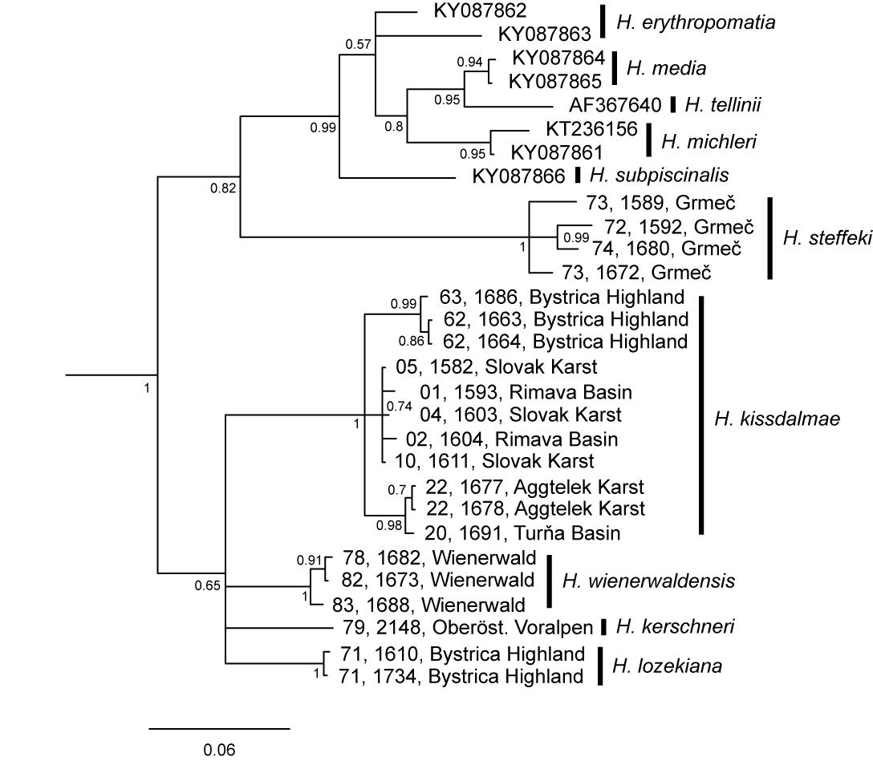
Figure S6. Phylogenetic tree from Bayesian analysis in MrBayes based on COI.
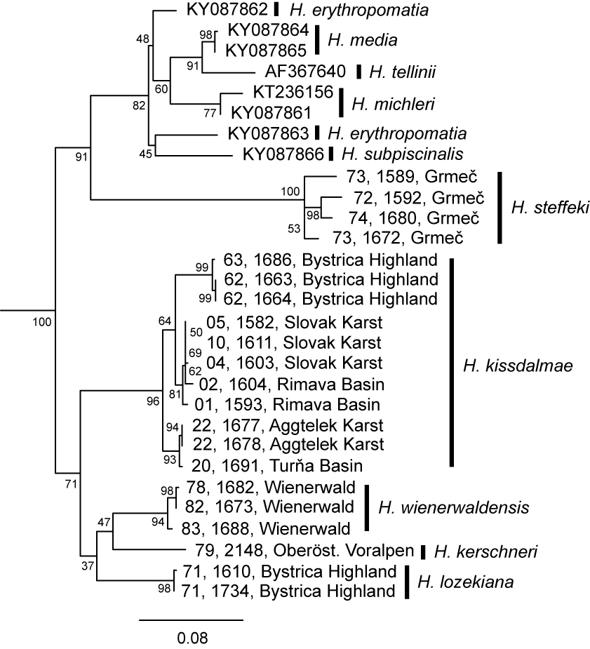
Figure S7. Phylogenetic tree from maximum likelihood (ML) analysis in W-IQ-TREE based on COI.

Reference
Ponder W.F., Wilke T., Zhang W.-H., Golding R.E., Fukuda H. & Mason R.A.B. 2008. Edgbastonia alanwillsi n. gen. & n. sp. (Tateinae: Hydrobiidae s.l.: Rissooidea: Caenogastropoda); a snail from an artesian spring group in western Queensland, Australia, convergent with some Asian Amnicolidae. Molluscan Research 28: 89-106.

