https://doi.org/10.5852/ejt.2024.931.2505.11209
Supp. file 2. Supplementary figures including images of the primary types and associated labels of all species of Triepeolus known from South America and their junior synonyms except that of T. nemoralis, which has been destroyed.

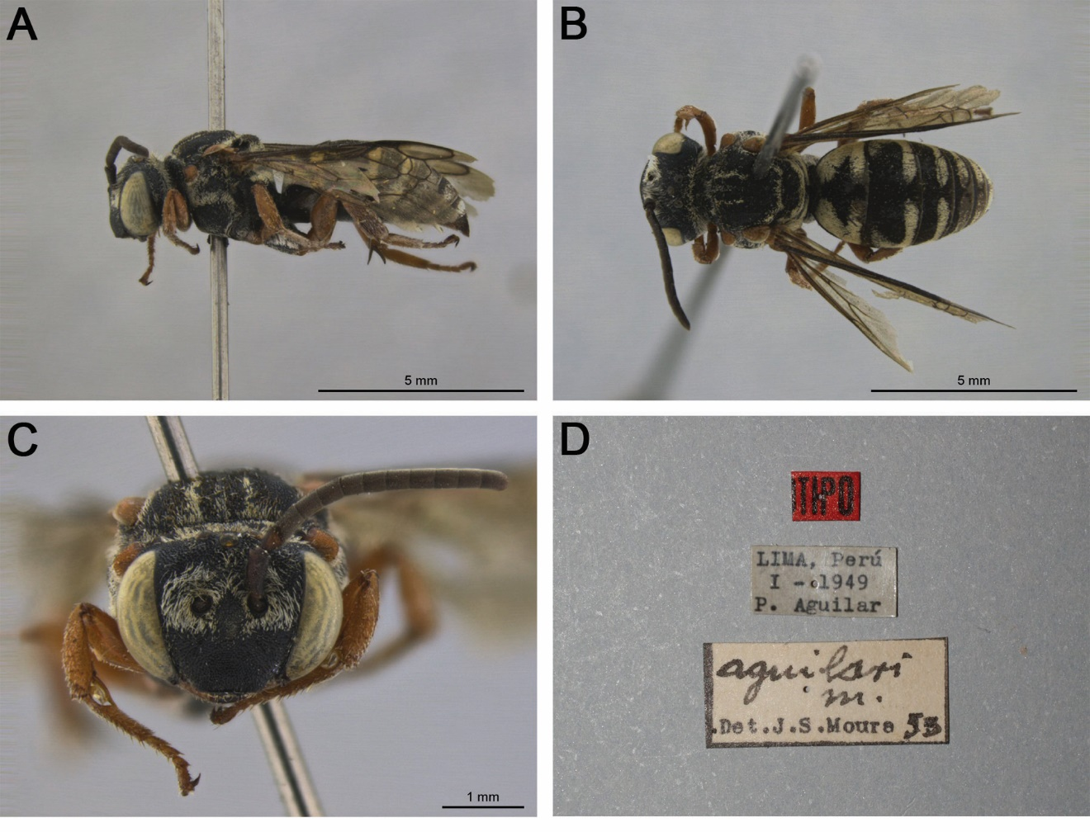

Fig. S1. Triepeolus aguilari Moure, 1955 holotype, ♂ (DZUP) (herein synonymized under T. buchwaldi (Friese, 1908)). A. Habitus, lateral view. B. Habitus, dorsal view. C. Head, frontal view. D. Associated labels.

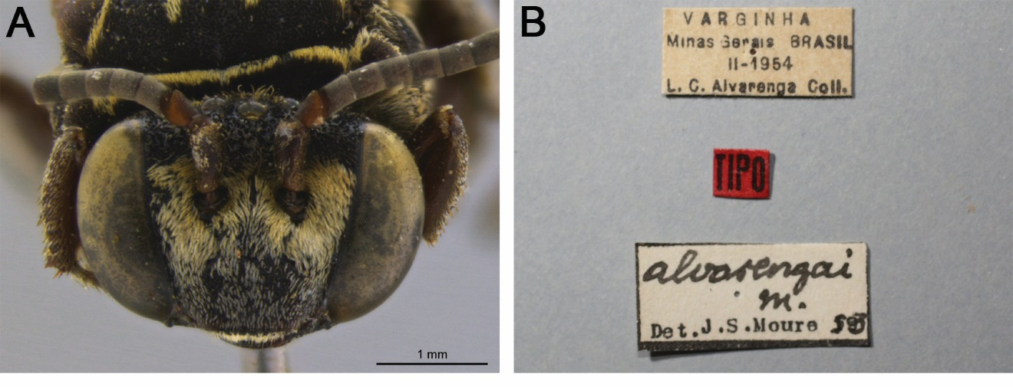

Fig. S2. Triepeolus alvarengai Moure, 1955, ♀ (DZUP). A. Head, frontal view. B. Associated labels.

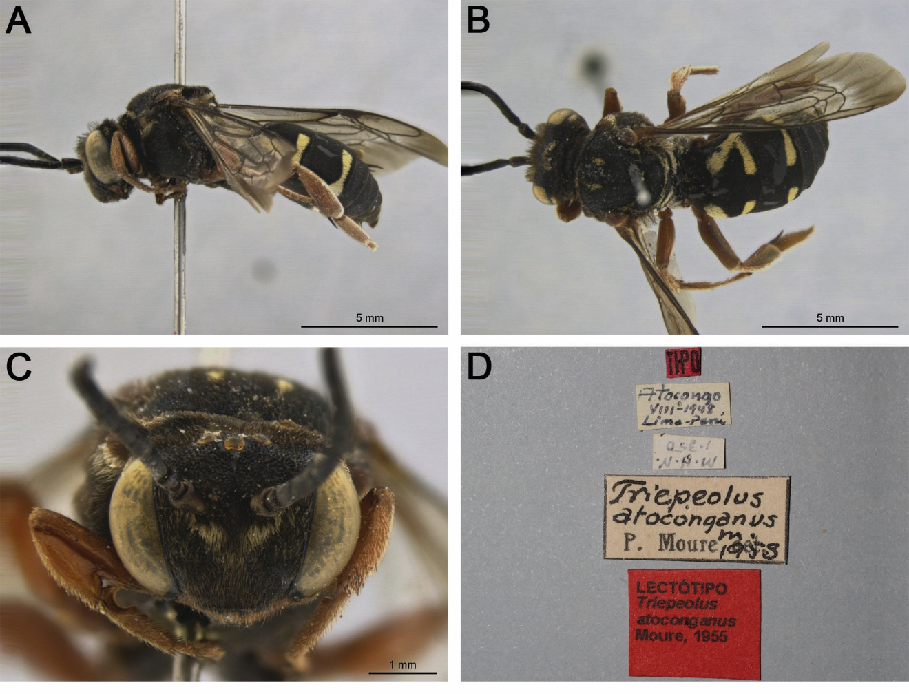

Fig. S3. Triepeolus atoconganus Moure, 1955 lectotype, ♂ (DZUP). A. Habitus, lateral view. B. Habitus, dorsal view. C. Head, frontal view. D. Associated labels.

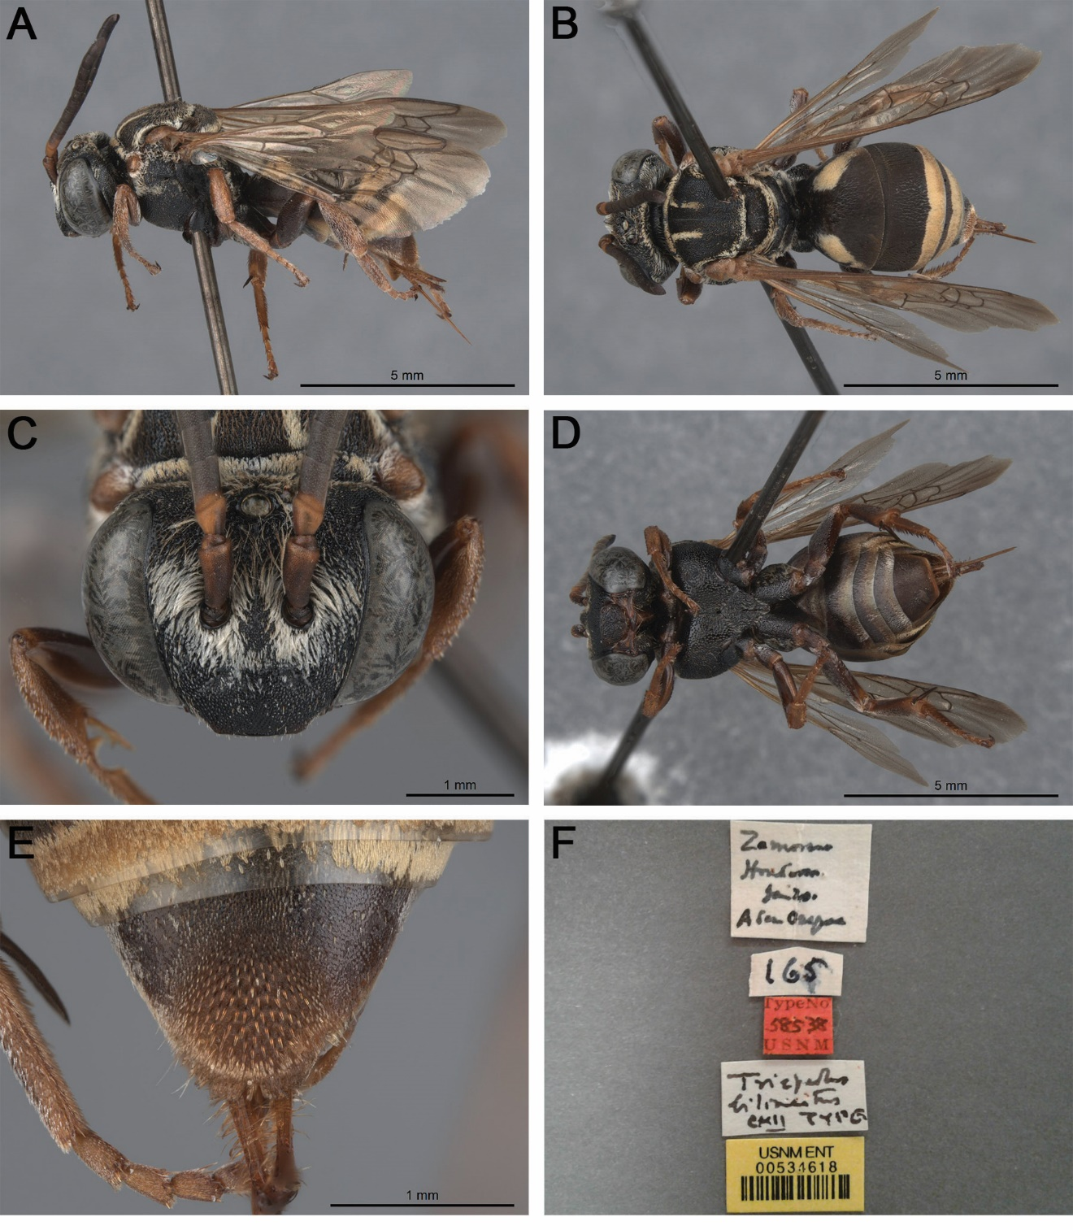

Fig. S4. Triepeolus bilineatus Cockerell, 1949 holotype, ♀ (USNM 534618). A. Habitus, lateral view. B. Habitus, dorsal view. C. Head, frontal view. D. Habitus, ventral view. E. Pseudopygidial area, dorsal view. F. Associated labels.

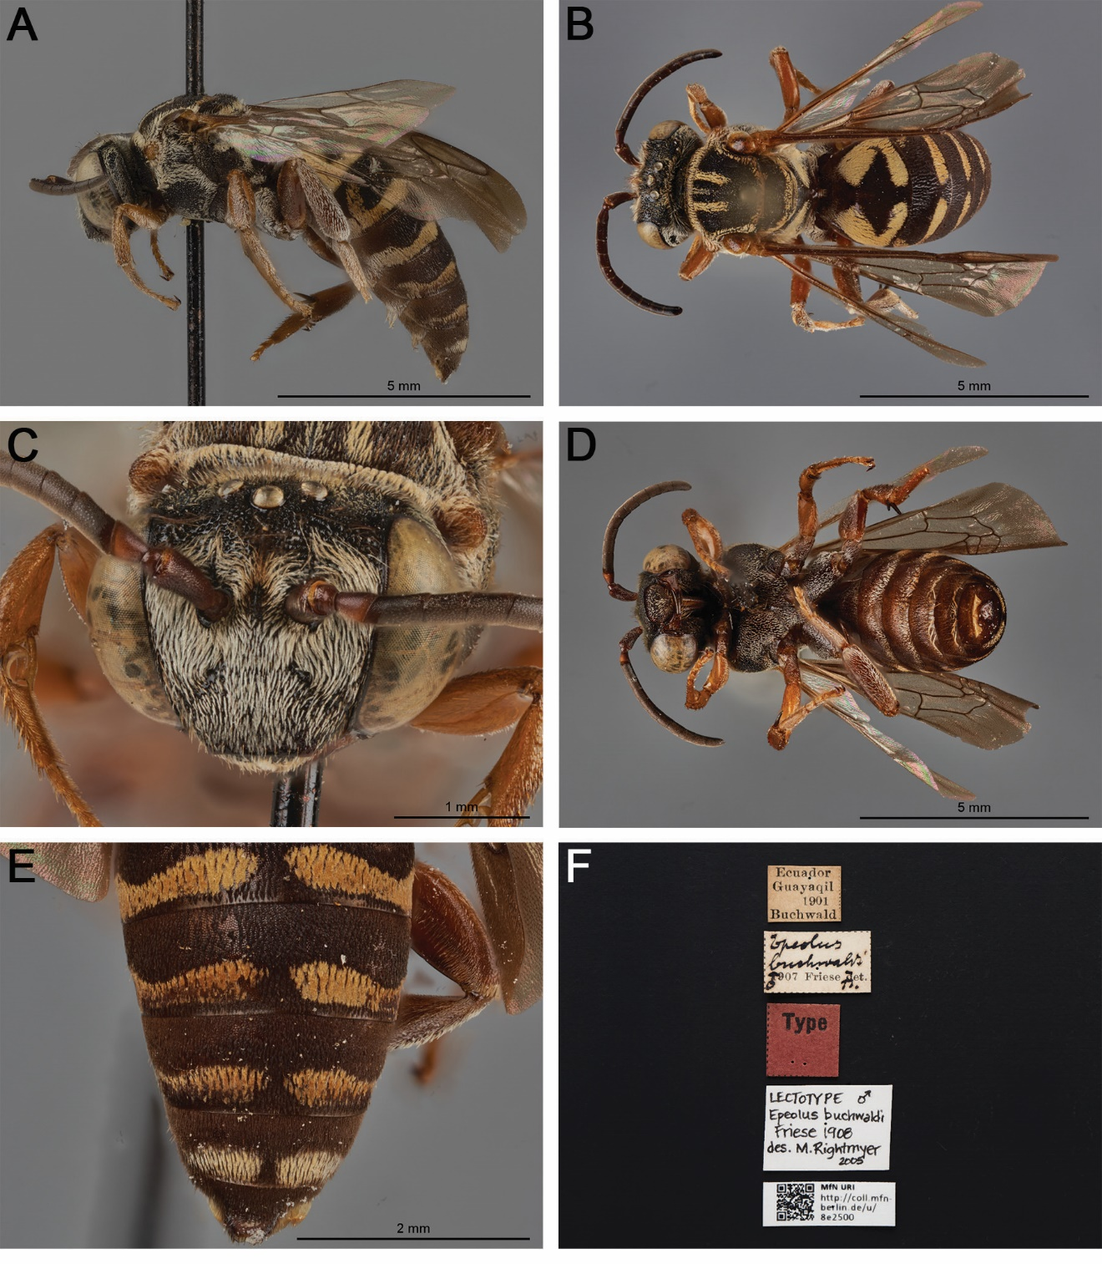

Fig. S5. Epeolus buchwaldi Friese, 1908 lectotype, ♂ (ZMB 8e2500). A. Habitus, lateral view. B. Habitus, dorsal view. C. Head, frontal view. D. Habitus, ventral view. E. Posterior metasoma, dorsal view. F. Associated labels (note that the lectotype designation label is provisional and will be replaced). Images are copyright of the Museum für Naturkunde and reproduced here with permission.

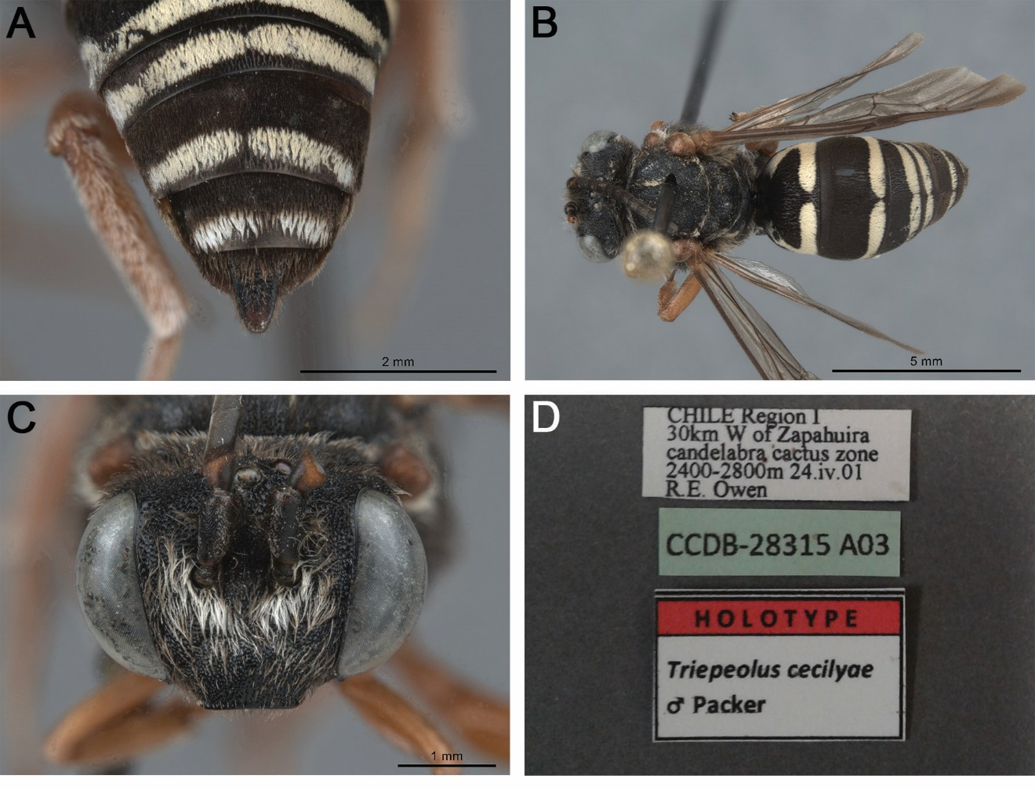

Fig. S6. Triepeolus cecilyae Packer, 2016 holotype, ♂ (PCYU). A. Posterior metasoma, dorsal view. B. Habitus, dorsal view. C. Head, frontal view. D. Associated labels.

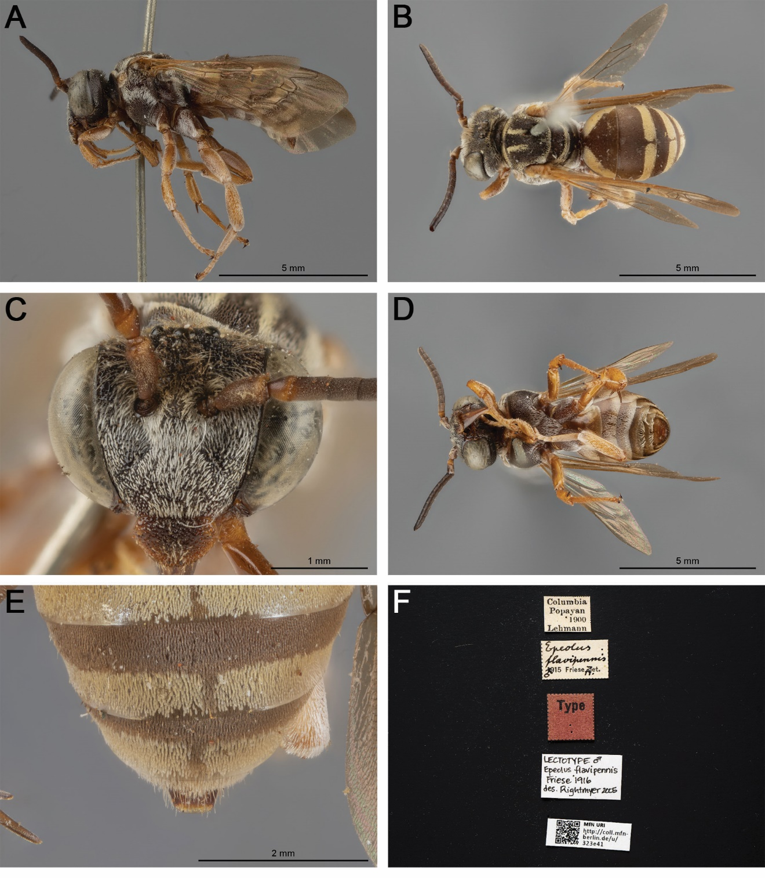

Fig. S7. Epeolus flavipennis Friese, 1916 lectotype, ♂ (ZMB 323e41). A. Habitus, lateral view. B. Habitus, dorsal view. C. Head, frontal view. D. Habitus, ventral view. E. Posterior metasoma, dorsal view. F. Associated labels (note that the lectotype designation label is provisional and will be replaced). Images are copyright of the Museum für Naturkunde and reproduced here with permission.

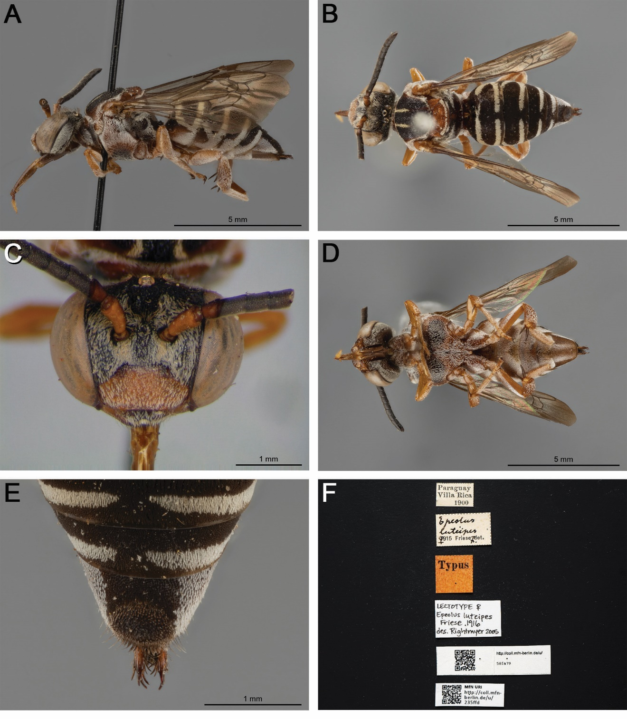

Fig. S8. Epeolus luteipes Friese, 1916 lectotype, ♀ (ZMB 235ffd). A. Habitus, lateral view. B. Habitus, dorsal view. C. Head, frontal view. D. Habitus, ventral view. E. Pseudopygidial area, dorsal view. F. Associated labels (note that the lectotype designation label is provisional and will be replaced). Images are copyright of the Museum für Naturkunde and reproduced here with permission.

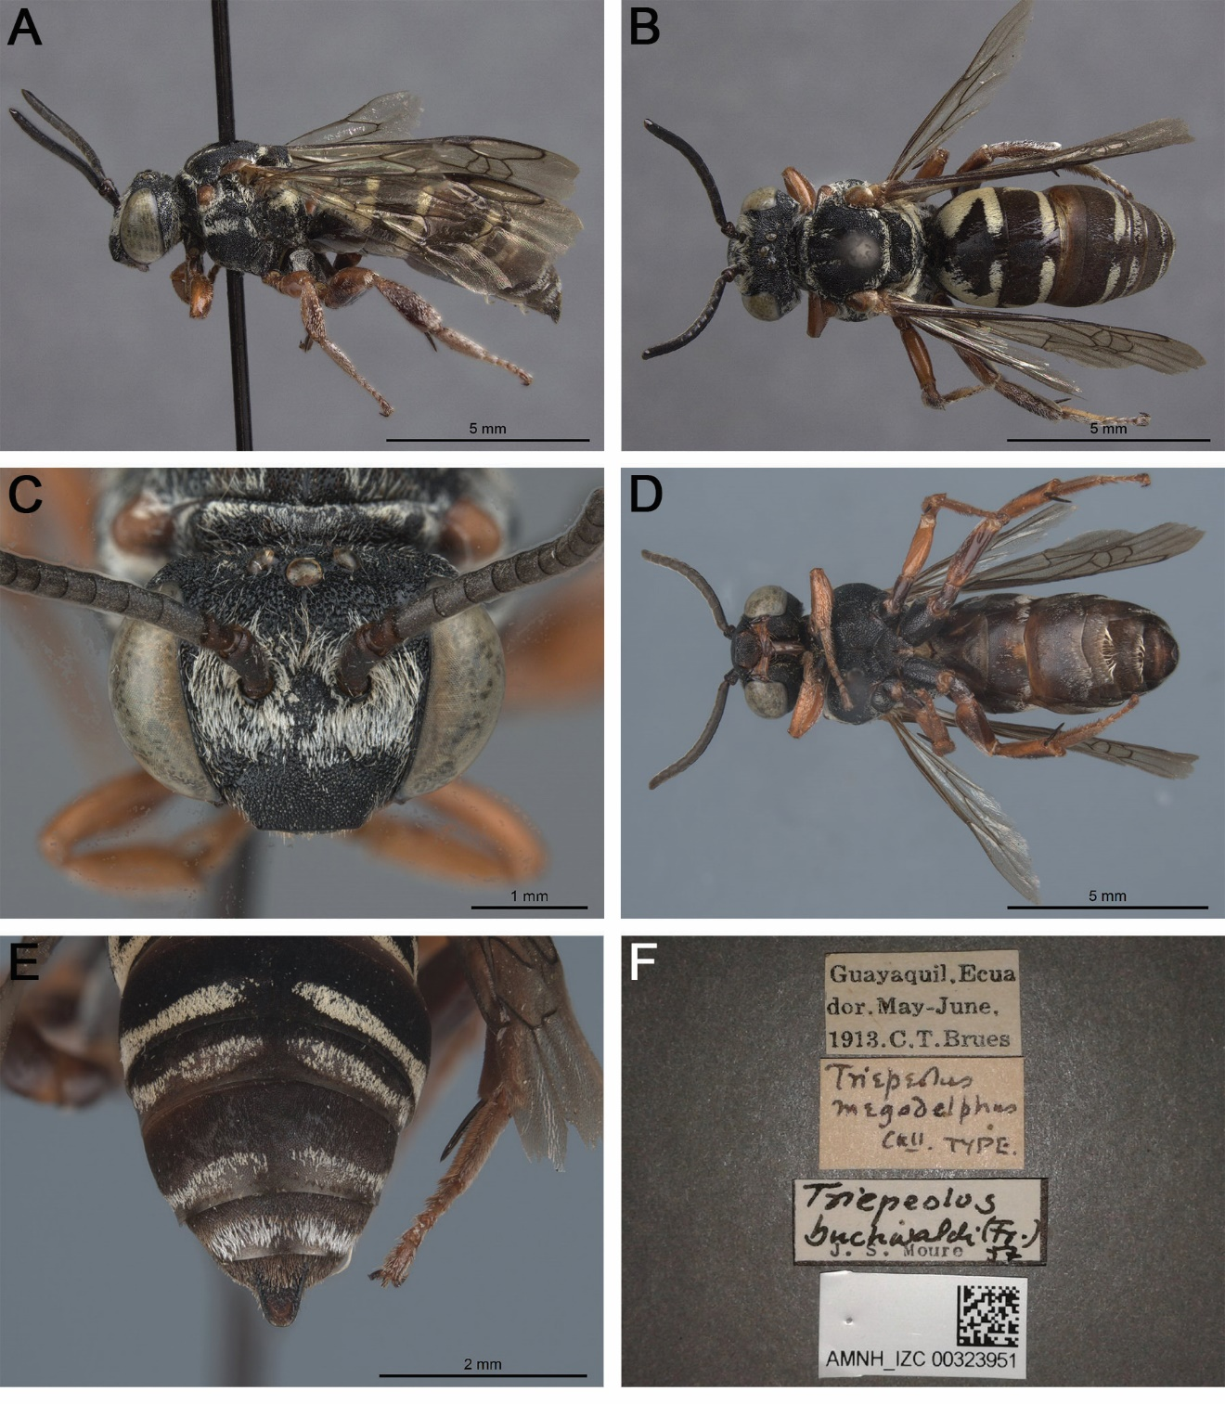

Fig. S9. Triepeolus megadelphus Cockerell, 1914 holotype, ♂ (AMNH AMNH_IZC 00323951) (herein synonymized under T. buchwaldi (Friese, 1908)). A. Habitus, lateral view. B. Habitus, dorsal view. C. Head, frontal view. D. Habitus, ventral view. E. Posterior metasoma, dorsal view. F. Associated labels.

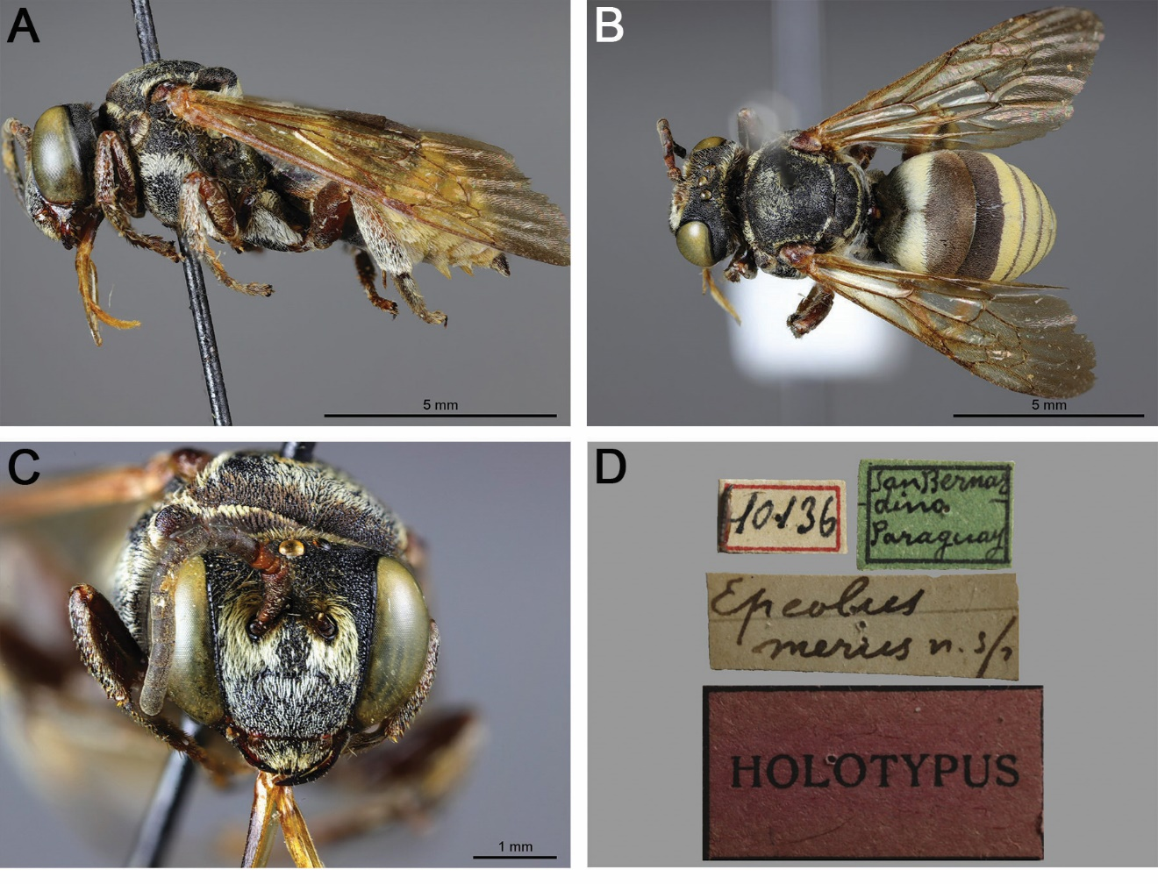

Fig. S10. Epeolus merus Brèthes, 1909 holotype, ♂ (MACN 10136). A. Habitus, lateral view. B. Habitus, dorsal view. C. Head, frontal view. D. Associated labels.

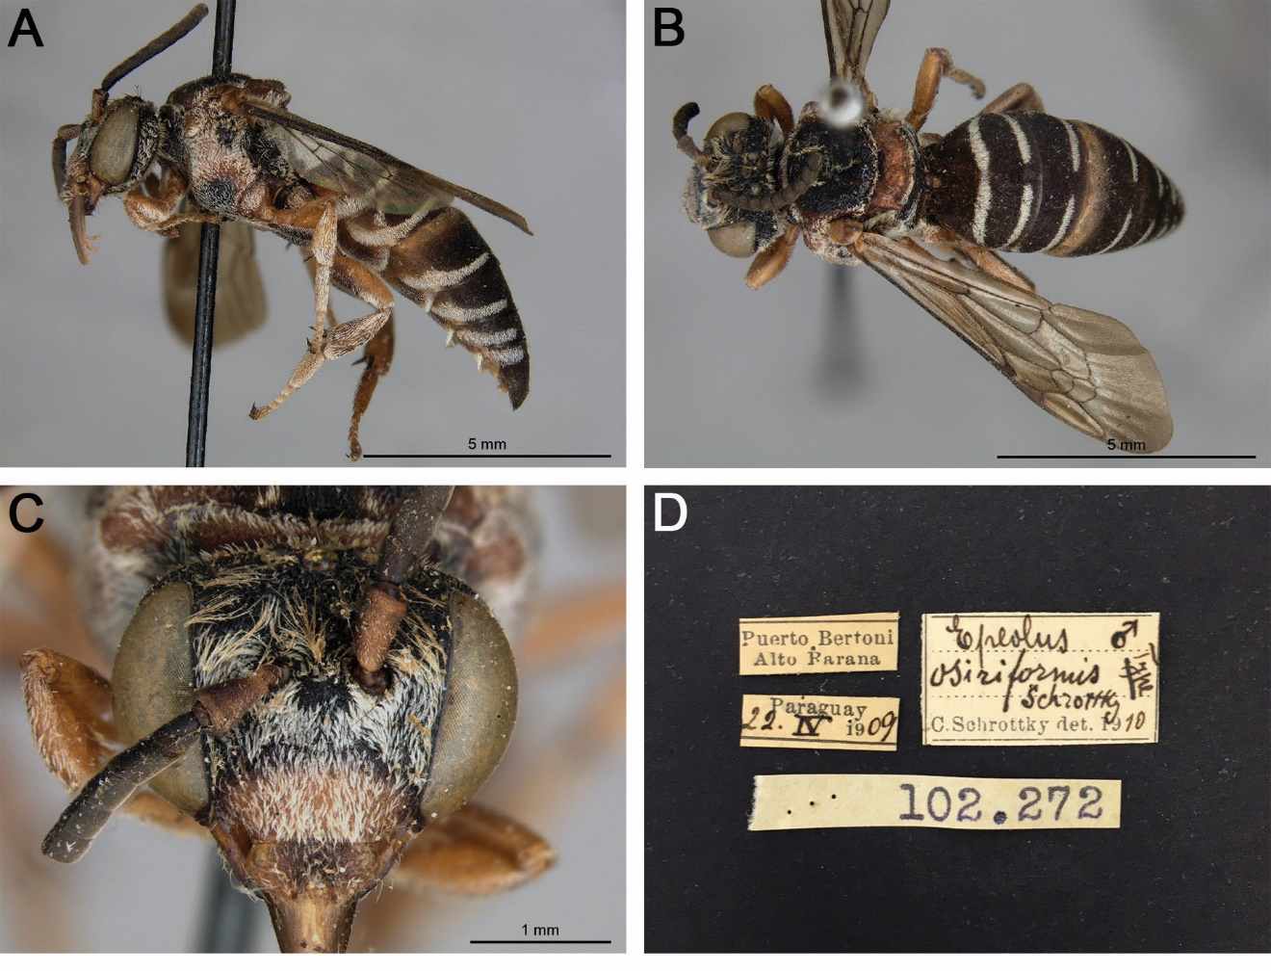

Fig. S11. Epeolus osiriformis Schrottky, 1910 lectotype, ♂ (MZUSP 102.272). A. Habitus, lateral view. B. Habitus, dorsal view. C. Head, frontal view. D. Associated labels (note that a lectotype designation label is missing but will be added).

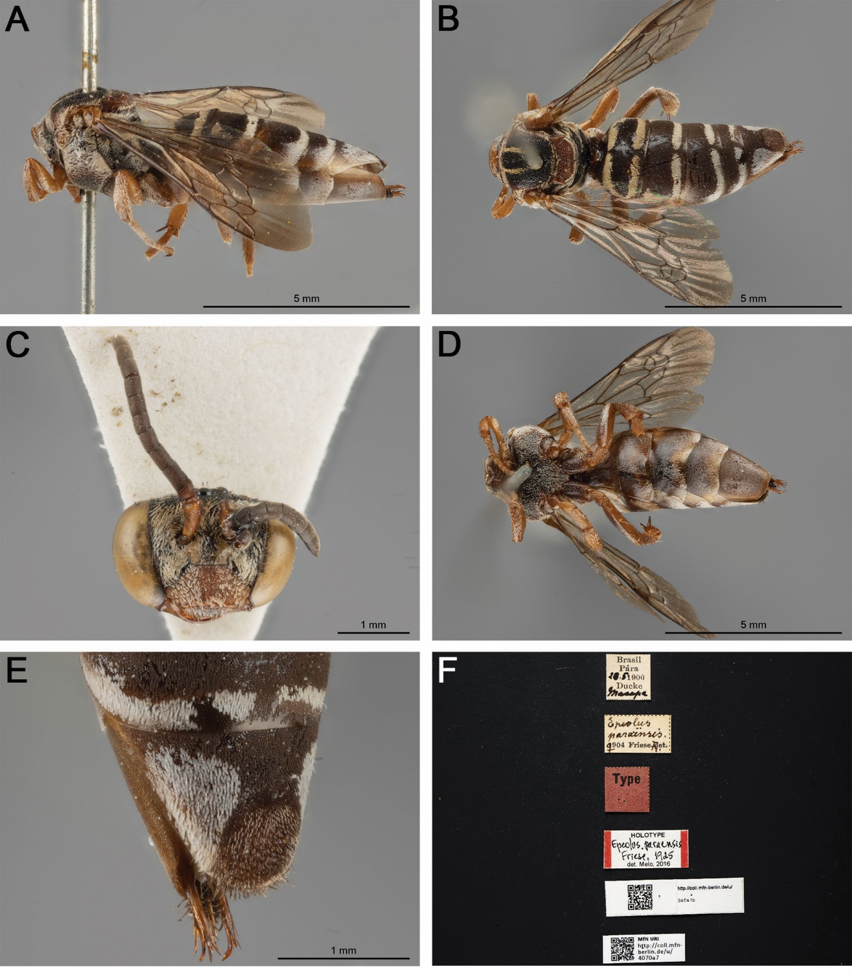

Fig. S12. Epeolus paraensis Friese, 1925 holotype, ♀ (ZMB 4070a7). A. Habitus, lateral view. B. Habitus, dorsal view. C. Head, frontal view. D. Habitus, ventral view. E. Pseudopygidial area, dorsal view. F. Associated labels. Images are copyright of the Museum für Naturkunde and reproduced here with permission.

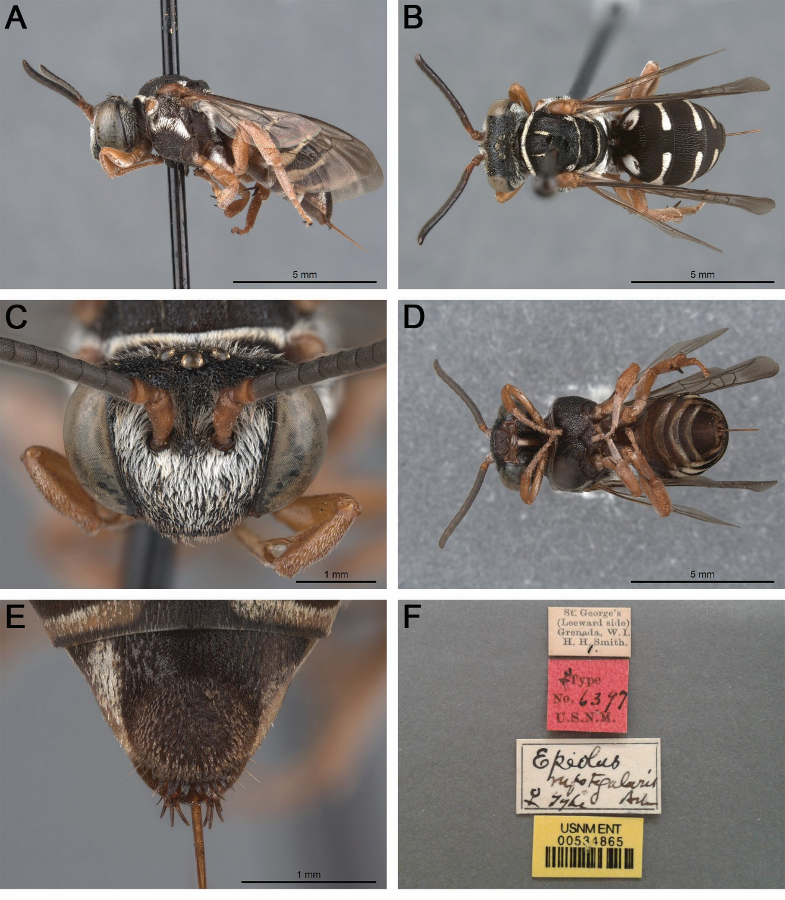

Fig. S13. Epeolus rufotegularis Ashmead, 1900 lectotype, ♀ (USNM 534865). A. Habitus, lateral view. B. Habitus, dorsal view. C. Head, frontal view. D. Habitus, ventral view. E. Pseudopygidial area, dorsal view. F. Associated labels (note that a lectotype designation label is missing but will be added).

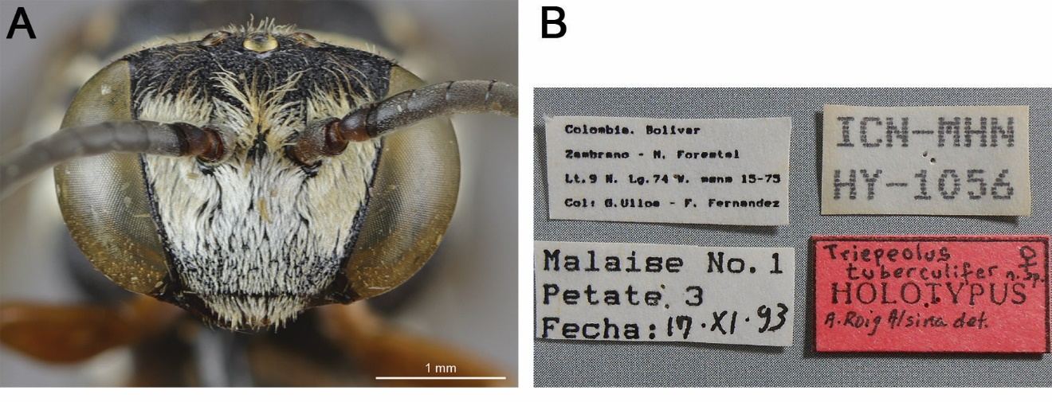

Fig. S14. Triepeolus tuberculifer Onuferko, Rightmyer & Roig-Alsina sp. nov. holotype, ♀ (ICN HY-1056). A. Head, frontal view. B. Associated labels (note that the holotype determination label is provisional and will be replaced).

