Supp. file 1. Additional information. https://doi.org/10.5852/ejt.2024.943.2585.11773
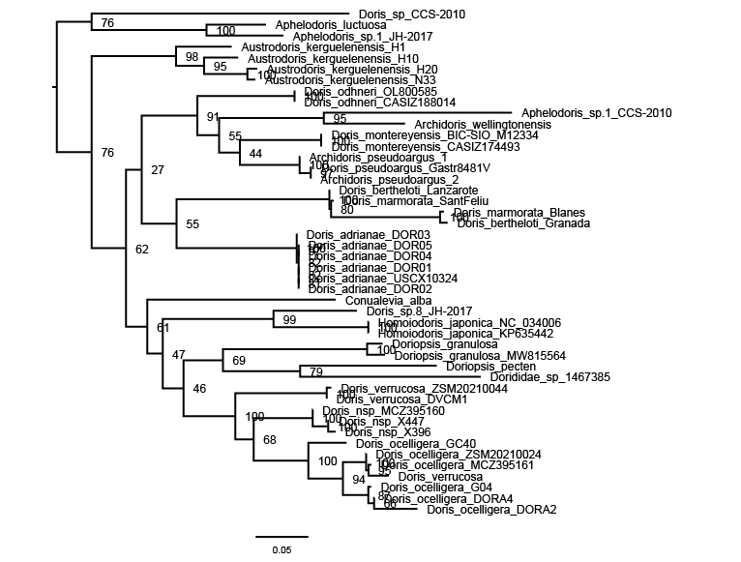

Fig. S1. Maximum likelihood tree for Dorididae Rafinesque, 1815 based on the concatenated alignment of COI, 16S, and H3 markers (1449 bp). Bootstrap support values are shown on branches. The outgroup used to root the tree was Aphelodoris Bergh, 1879. Scale bar indicates substitutions per site.

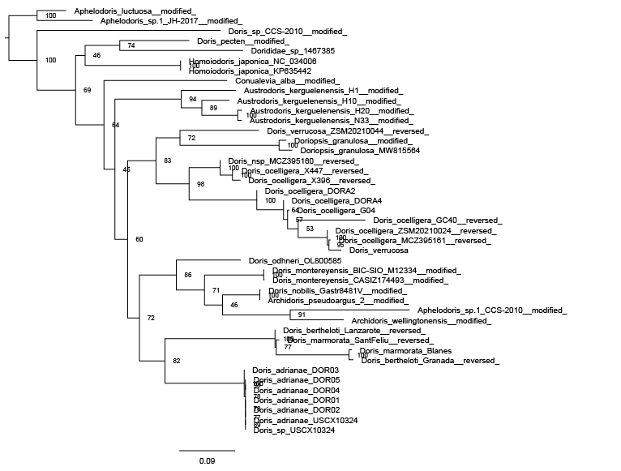

Fig. S2: Maximum likelihood tree for Dorididae Rafinesque, 1815 based on the COI marker (659 bp). Bootstrap support values are shown on branches. The outgroup used to root the tree was Aphelodoris Bergh, 1879. Scale bar indicates substations per site.

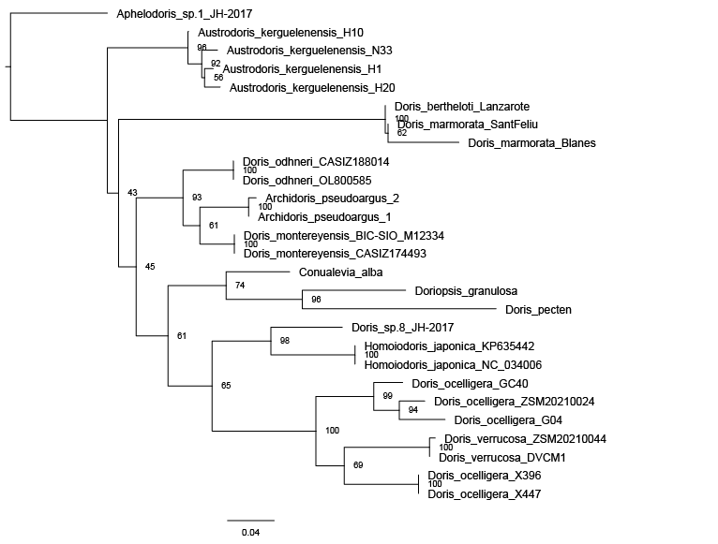

Fig. S3: Maximum likelihood tree for Dorididae Rafinesque, 1815 based on the 16S marker (462 bp). Bootstrap support values are shown on branches. The outgroup used to root the tree was Aphelodoris Bergh, 1879. Scale bar indicates substations per site.

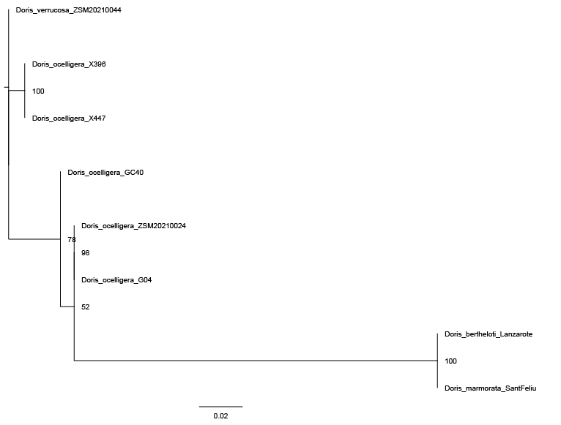

Fig. S4: Maximum likelihood tree for Dorididae Rafinesque, 1815 based on the H3 marker (328 bp). Bootstrap support values are shown on branches. The outgroup used to root the tree was Doris verrucosa Linnaeus, 1758. Scale bar indicates substations per site.

Table S1: Material used in molecular phylogenetic analyses and species delimitation tests, with GenBank accession numbers and relevant references.

Species | Voucher number | Locality | COI | 16S | H3 | Reference
Doris ocelligera | X396 | Coves Cala Maset, Sant Feliu de Guíxols, Girona, Spain | OR286433 | OR286512 | OR340967 | This study
Doris ocelligera | X447 | Coves Cala Maset, Sant Feliu de Guíxols, Girona, Spain | OR286434 | OR286513 | OR340968 | This study
Doris ocelligera | MCZ395160 | Punta del Romaní, l'Escala, Girona, Spain | OR286432 | – | – | This study
Doris berghi | G04 | Playa viveiro, Galicia, Spain | OR286435 | OR286514 | OR340969 | This study
Doris berghi | GC40 | Piscinas de Agaete, Gran Canaria, Spain | OR286436 | OR286515 | OR340970 | This study
Doris berghi | ZSM20210024 | Coves Cala Maset, Sant Feliu de Guíxols, Girona, Spain | OR286438 | OR286516 | OR340971 | This study
Doris berghi | MCZ395161 | Aigua Freda, Begur, Girona, Spain | OR286437 | – | – | This study
Doris marmorata | B2 | Blanes, Girona, Spain | OR286430 | OR286510 | – | This study
Doris marmorata | ZSMMol20210023 | Coves Cala Maset, Sant Feliu de Guíxols, Girona, Spain | OR286431 | OR286511 | OR340966 | This study
Doris bertheloti | ZSMMol20210045 | Caleta Caballo, Lanzarote, Spain | OR286429 | OR286509 | OR340965 | This study
Doris bertheloti | B7 | La Herradura, Granada, Spain | OR286428 | – | – | This study
Doris verrucosa | ZSM20210044 | Étang de Thau, Sète, France | OR286439 | OR286517 | OR340972 | This study
Doris verrucosa |  | – | ON716048 | – | – | Mugnai & Costantini (unpubl.)
Doris verrucosa | DVCM1 | Capo Miseno, Naples, Italy | – | HE861892 | – | De Masi et al. 2015
Austrodoris kerguelenensis | – | Burdwood Bank, Antarctica | EU823127 | EU823219 | – | Wilson et al. 2009
Austrodoris kerguelenensis | ZSM200210482 | Elephant Is., Antarctica | EU823136 | EU823228 | – | Wilson et al. 2009
Austrodoris kerguelenensis |  | Bransfield Strait, Antarctica | EU823146 | EU823238 | – | Wilson et al. 2009
Austrodoris kerguelenensis | – | McMurdo Sound, Ross Sea, Antarctica | GU227115 | GU227000 | – | Heimeier et al. 2010
Doris odhneri | CASIZ188014 | USA: Duxbury Reef, Marin Co., California | – | MF958295 | – | Hallas et al. 2017
Doris odhneri | – | Munamjin-ri Gangwon-do, South Korea | OL800585 | OL800585 | – | Do et al. 2022
Conualevia alba | – | California, La Jolla, Bird Rock, USA | KC153021 | KC153023 | – | Wilson, Maschek & Baker (unpubl.)
Doris montereyensis | BICSIOM12334 | USA: California, La Jolla, La Jolla Canyon | KC153022 | KC153024 | – | GenBank
Doris montereyensis | CASIZ174493 | USA: Battery Point, Cresceent City, Del Norte Co., California | MF958425 | MF958294 | – | Hallas et al. 2017
Archidoris pseudoargus | – | Helgoland, North Sea | – | AF249224 | – | Wollscheid-Lengeling et al. 2001
Archidoris pseudoargus |  | Plymouth, Devonshire, UK | AJ223256 | AJ225180 | – | Thollesson 2000
Archidoris wellingtonensis | – | Ross Sea, Antarctica | GQ292034 | – | – | Shields, Marko, Woods & Moran (unpubl.)
Archidoris pseudoargus | – | Plymouth, Devonshire, UK | AJ223256 | AJ225180 | – | Thollesson 2000
Doriopsis pecten | – | Australia: Queensland, Mooloolaba | KJ001311 | KJ018914 | – | Cheney et al. 2014
Homoiodoris japonica | – | China | KP635442 | KP635442 | – | Liu et al. 2015
Homoiodoris japonica |  | China | NC_034006 | NC_034006 | – | Liu & Shen (unpubl.)
Doris sp. | CASIZ192348 | Saudi Arabia: Red Sea | – | MF958306 | – | Hallas et al. 2017
Aphelodoris luctuosa |  | Auckland, New Zealand | GQ292042 | – | – | Hallas et al. 2017
Aphelodoris sp. | CCS-2010 | Ross Sea, Antarctica | GQ292033 | – | – | Shields, Marko, Woods & Moran (unpubl.)
Aphelodoris sp. | CASIZ176920 | Oudekraal, Cape Prov., South Africa | MF958424 | MF958293 | – | Hallas et al. 2017
Dorididae sp. | 1467385 | Papua New Guinea | MZ560065 | – | – | Plaisance, Matterson, Drovetski, Fabricius, Meyer & Knowlton (unpubl.)
Doriopsis granulosa | – | Indo-Pacific region | AF249798 | AF249223 | – | Wollscheid-Lengeling et al. 2001
Doriopsis granulosa | D. granulosa | Mauritius | MW815564 | – | – | Ah-Shee-Tee et al. 2022
Doris adrianae | DOR01 | Vigo | MW518047 | – | – | Almón, Pérez & Pérez (unpubl.)
Doris adrianae | DOR02 | Vigo | MW518048 | – | – | Almón, Pérez & Pérez (unpubl.)
Doris adrianae | DOR03 | Vigo | MW518049 | – | – | Almón, Pérez & Pérez (unpubl.)
Doris adrianae | DOR04 | Vigo | MW518050 | – | – | Almón, Pérez & Pérez (unpubl.)
Doris adrianae | DOR05 | Vigo | MW518051 | – | – | Almón, Pérez & Pérez (unpubl.)
Doris adrianae | USCX10324 | Ría de Ferrol, Galicia, Spain | MW602531 | – | – | Urgorri et al. 2021
Doris nobilis | Gastr 8481V | – | MG935354 | – | – | Lundin (unpubl.)
Doris ocelligera | DORA2 | Vigo | MW522603 | – | – | Almón, Pérez & Pérez (unpubl.)
Doris ocelligera | DORA4 | Vigo | MW522602 | – | – | Almón, Pérez & Pérez (unpubl.)
Doris sp. | CCS-2010 | Ross Sea, Antarctica | GQ292046 | – | – | Shields, Marko, Woods & Moran (unpubl.)

References
Ah-Shee-Tee L., Puchooa D., Appadoo C., Bhoyroo V., Kerovec D. 2022. Occurrence and distribution of opisthobranch sea slugs in environment-impacted areas of Mauritius. Regional Studies in Marine Science 52: 102249. https://doi.org/10.1016/j.rsma.2022.102249
Cheney K.L., Cortesi F., How M.J., Wilson N.G., Blomberg S.P., Winters A.E., Umanzör S. & Marshall N.J. 2014. Conspicuous visual signals do not coevolve with increased body size in marine sea slugs. Journal of Evolutionary Biology 27: 676–687. https://doi.org/10.1111/jeb.12348
Do T.D., Jung D.-W. & Kim C.-B. 2022. Molecular phylogeny of selected dorid nudibranchs based on complete mitochondrial genome. Scientific Reports 12: 18797. https://doi.org/10.1038/s41598-022-23400-9
Hallas J.M., Chichvarkhin A. & Gosliner T.M. 2017. Aligning evidence: concerns regarding multiple sequence alignments in estimating the phylogeny of the Nudibranchia suborder Doridina. Royal Society Open Science 4: 171095. https://doi.org/10.1098/rsos.171095
Heimeier D., Lavery S. & Sewell M.A. 2010. Using DNA barcoding and phylogenetics to identify Antarctic invertebrate larvae: lessons from a large scale study. Marine Genomics 3: 165–177. https://doi.org/10.1016/j.margen.2010.09.004
De Masi L., Adelfi M.G., Pignone D. & Laratta B. 2015. Identification of Doris verrucosa mollusc via mitochondrial 16S rDNA. Biochemical Systematics and Ecology 58: 21–29. https://doi.org/10.1016/j.bse.2014.10.009
Liu C., Wu X. & Shen H.D. 2015. Complete mitochondrial genome of Vaginulus alte and Homoiodoris japonica. Mitochondrial DNA Part A 27: 3454–3457. https://doi.org/10.3109/19401736.2015.1066345
Thollesson M. 2000. Increasing fidelity in parsimony analysis of dorid nudibranchs by differential weighting, or a tale of two genes. Molecular Phylogenetics and Evolution (16): 161–172. https://doi.org/10.1006/mpev.2000.0789
Urgorri V., Pérez Señarís M., Díaz Agras G., Candás Romero M., Gómez Rodríguez C. 2021. Doris adrianae sp. nov. (Heterobranchia; Nudibranchia; Doridina) from the Galician coasts (NW Iberian Peninsula). Nova Acta Científica Compostelana 28: 1–33. https://doi.org/10.15304/nacc.id7500
Wilson N.G., Schrödl M. & Halanych K.M. 2009. Ocean barriers and glaciation: evidence for explosive radiation of mitochondrial lineages in the Antarctic sea slug Doris kerguelenensis (Mollusca, Nudibranchia). Molecular Ecology 18: 965–984. https://doi.org/10.1111/j.1365-294X.2008.04071.x
Wollscheid-Lengeling E., Boore J., Brown W. & Wägele H. 2001. The phylogeny of Nudibranchia (Opisthobranchia, Gastropoda, Mollusca) reconstructed by three molecular markers. Organisms Diversity & Evolution 1: 241–256. https://doi.org/10.1078/1439-6092-00022

