Supp. file 2. Supplementary figures including images of the primary types and associated labels of all species in the Triepeolus simplex group and their junior synonyms except Epeolus metatarsalis Friese, 1921, whose whereabouts are unknown, and species occurring in South America, for which images have recently been made available (see Onuferko et al. 2024).
https://doi.org/10.5852/ejt.2024.950.2643.12189

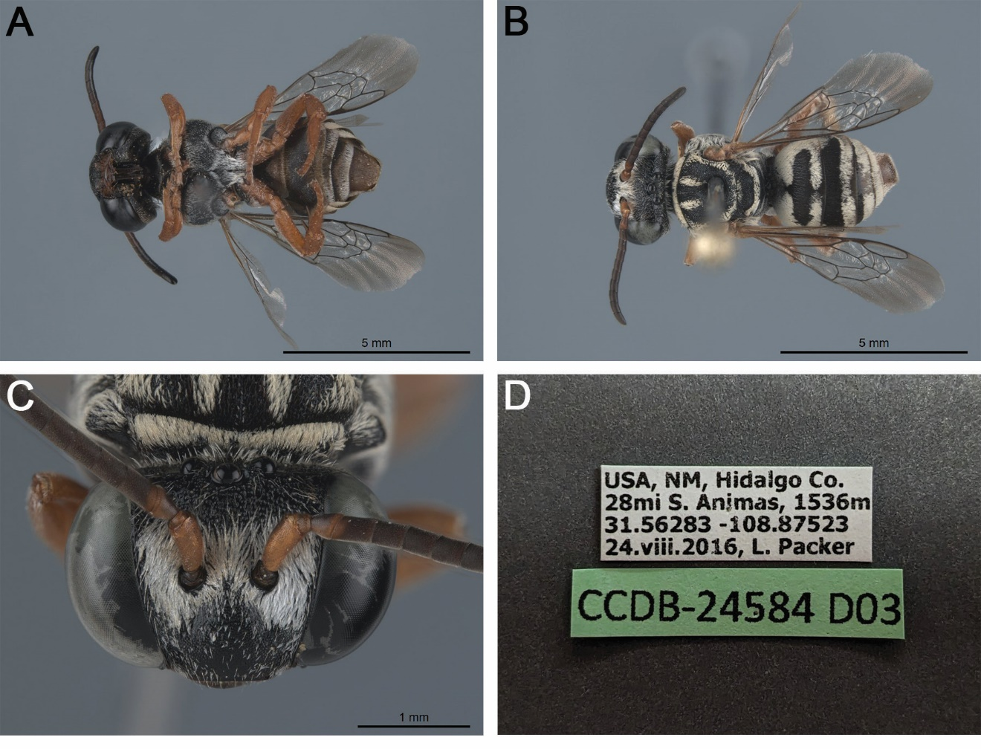

Fig. S1. Triepeolus apache sp. nov., holotype, ♀ (BOLD sample ID: CCDB-24584 D03; PCYU). A. Habitus, ventral view. B. Habitus, dorsal view. C. Head, frontal view. D. Associated labels.

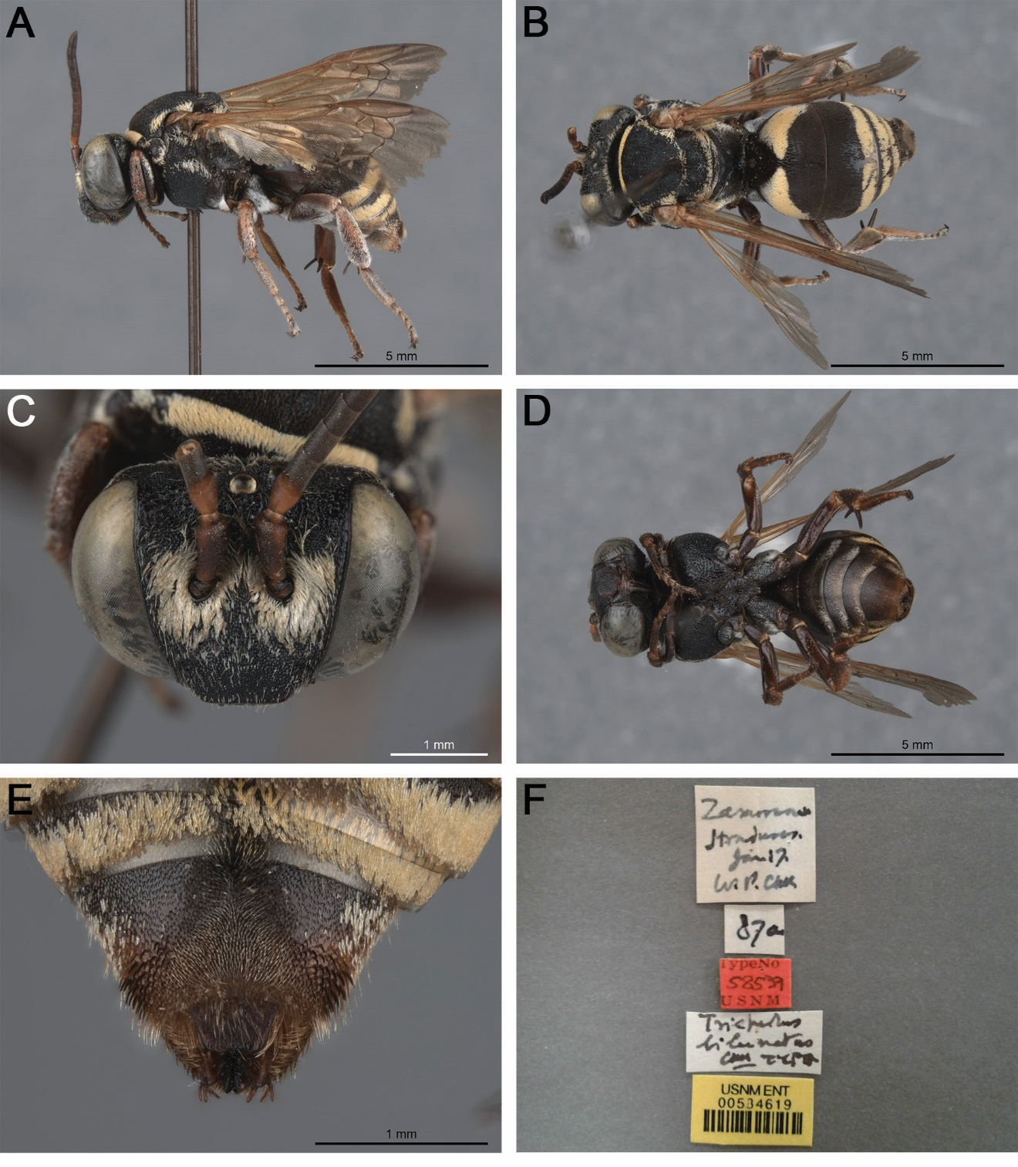

Fig. S2. Triepeolus bilunatus Cockerell, 1949 holotype, ♀ (USNM 534619). A. Habitus, lateral view. B. Habitus, dorsal view. C. Head, frontal view. D. Habitus, ventral view. E. Pseudopygidial area, dorsal view. F. Associated labels.

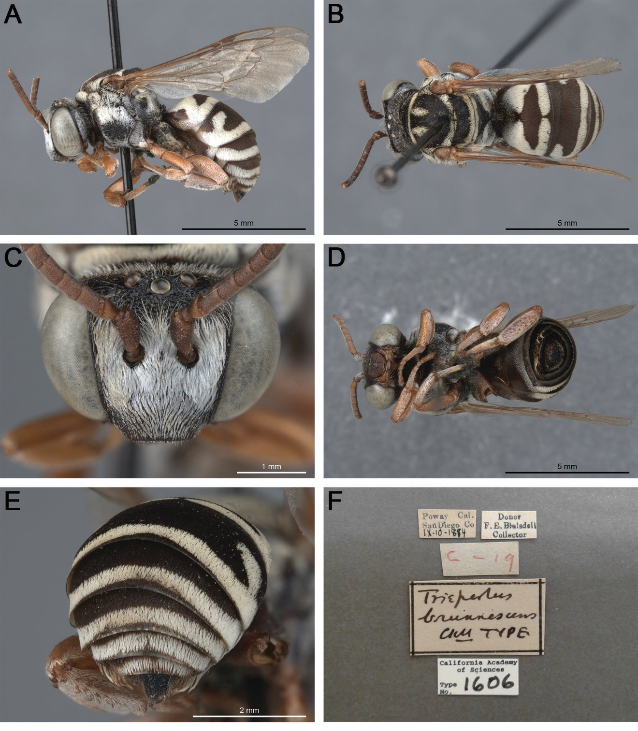

Fig. S3. Triepeolus brunnescens Cockerell & Sandhouse, 1924 holotype, ♂ (CAS 1606). A. Habitus, lateral view. B. Habitus, dorsal view. C. Head, frontal view. D. Habitus, ventral view. E. Posterior metasoma, dorsal view. F. Associated labels.

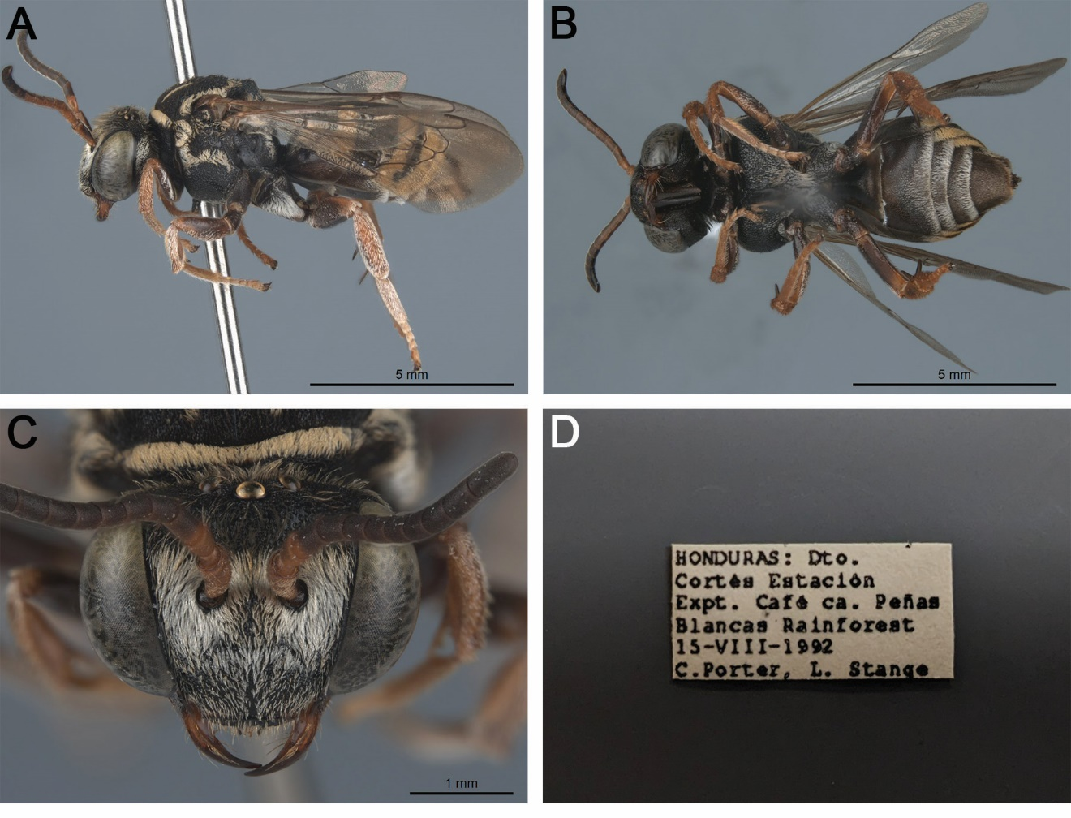

Fig. S4. Triepeolus eumeniformis sp. nov., holotype, ♀ (FSCA). A. Habitus, lateral view. B. Habitus, ventral view. C. Head, frontal view. D. Associated labels.

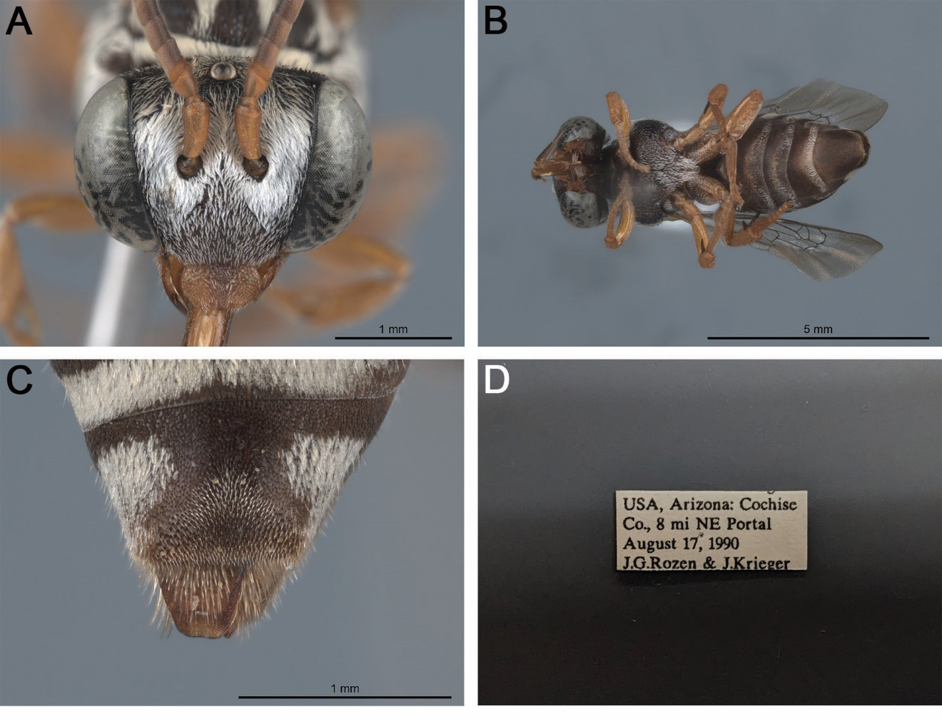

Fig. S5. Triepeolus hirsutus sp. nov., holotype, ♀ (AMNH). A. Head, frontal view. B. Habitus, ventral view. C. Pseudopygidial area, dorsal view. D. Associated labels.

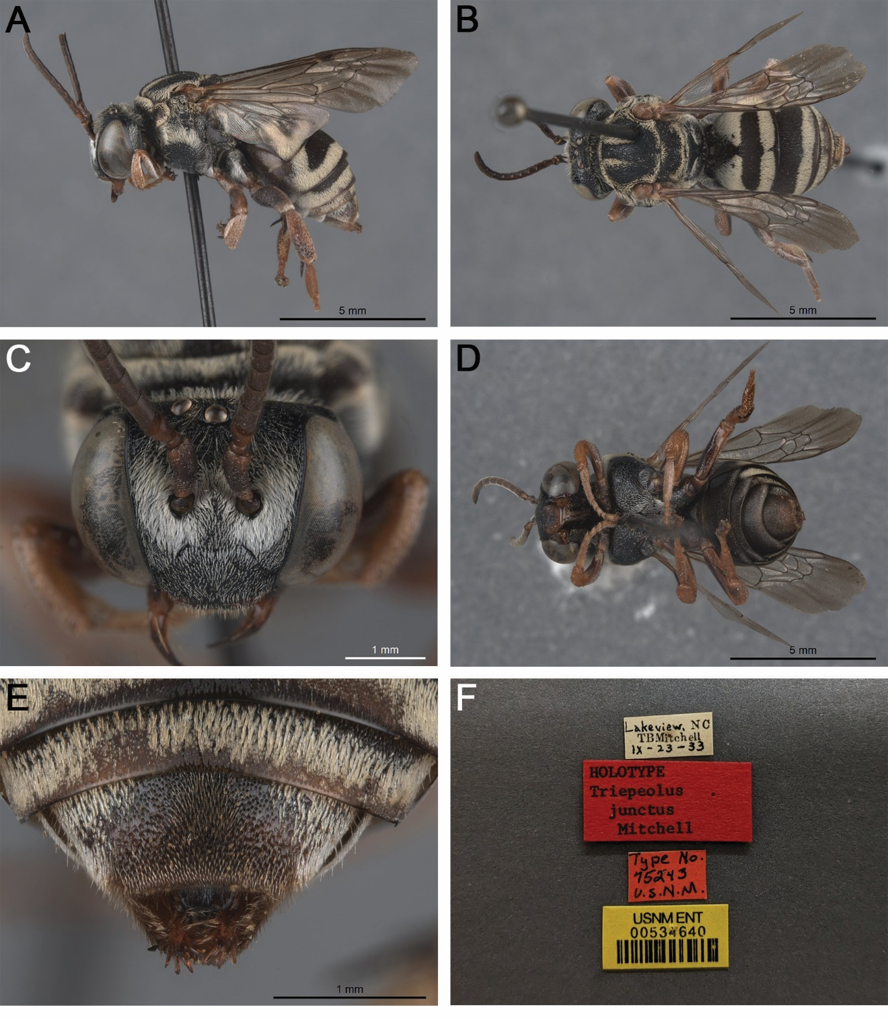

Fig. S6. Triepeolus junctus Mitchell, 1962 holotype, ♀ (USNM 534640). A. Habitus, lateral view. B. Habitus, dorsal view. C. Head, frontal view. D. Habitus, ventral view. E. Pseudopygidial area, dorsal view. F. Associated labels.

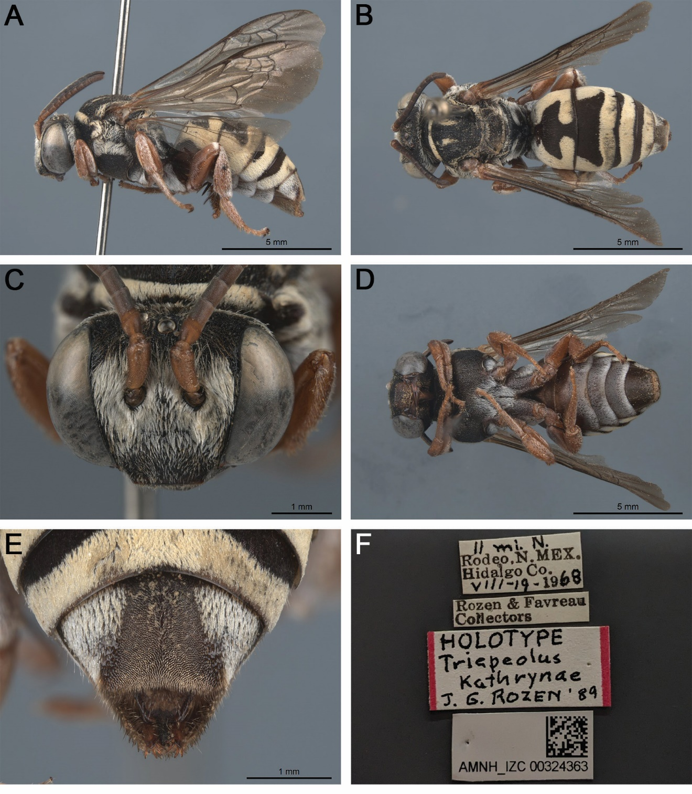

Fig. S7. Triepeolus kathrynae Rozen, 1989 holotype, ♀ (AMNH AMNH_IZC 00324363). A. Habitus, lateral view. B. Habitus, dorsal view. C. Head, frontal view. D. Habitus, ventral view. E. Pseudopygidial area, dorsal view. F. Associated labels.

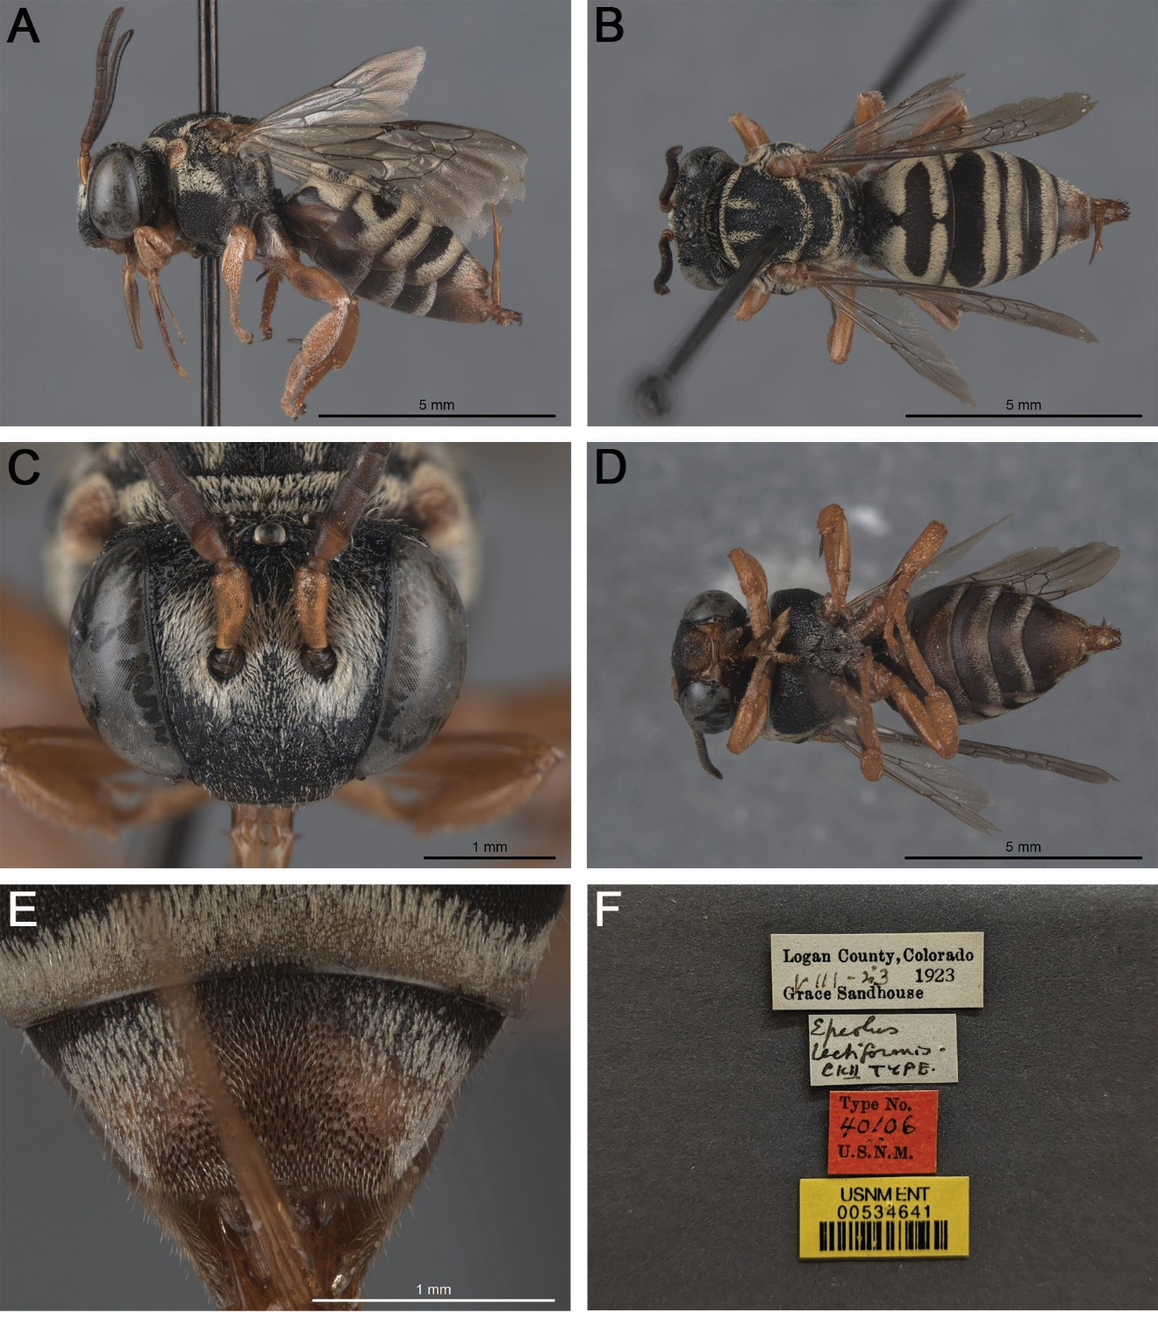

Fig. S8. Epeolus lectiformis Cockerell, 1925 holotype, ♀ (USNM 534641). A. Habitus, lateral view. B. Habitus, dorsal view. C. Head, frontal view. D. Habitus, ventral view. E. Pseudopygidial area, dorsal view. F. Associated labels.

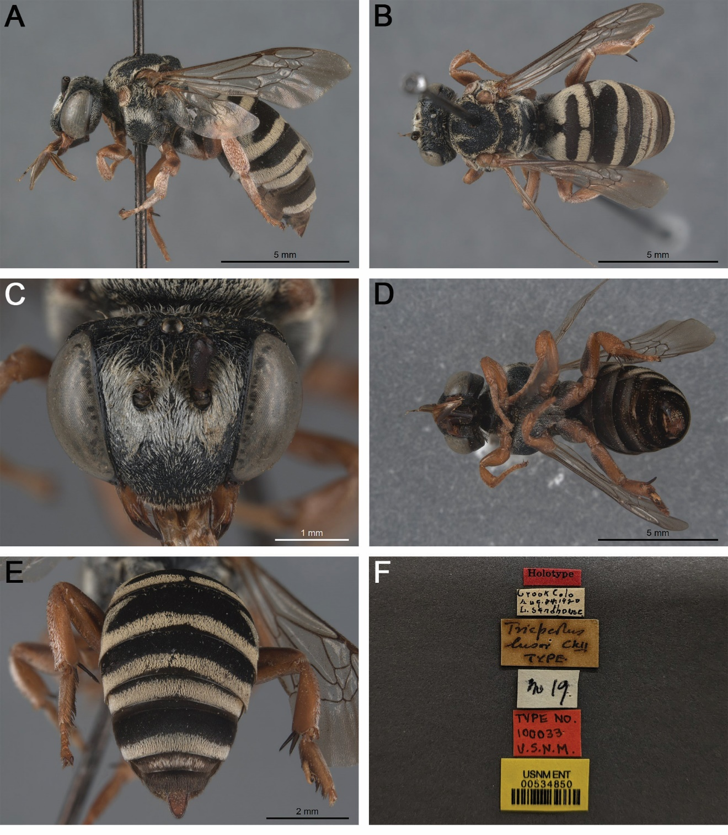

Fig. S9. Triepeolus lusor Cockerell, 1925 holotype, ♂ (USNM 534850). A. Habitus, lateral view. B. Habitus, dorsal view. C. Head, frontal view. D. Habitus, ventral view. E. Posterior metasoma, dorsal view. F. Associated labels.

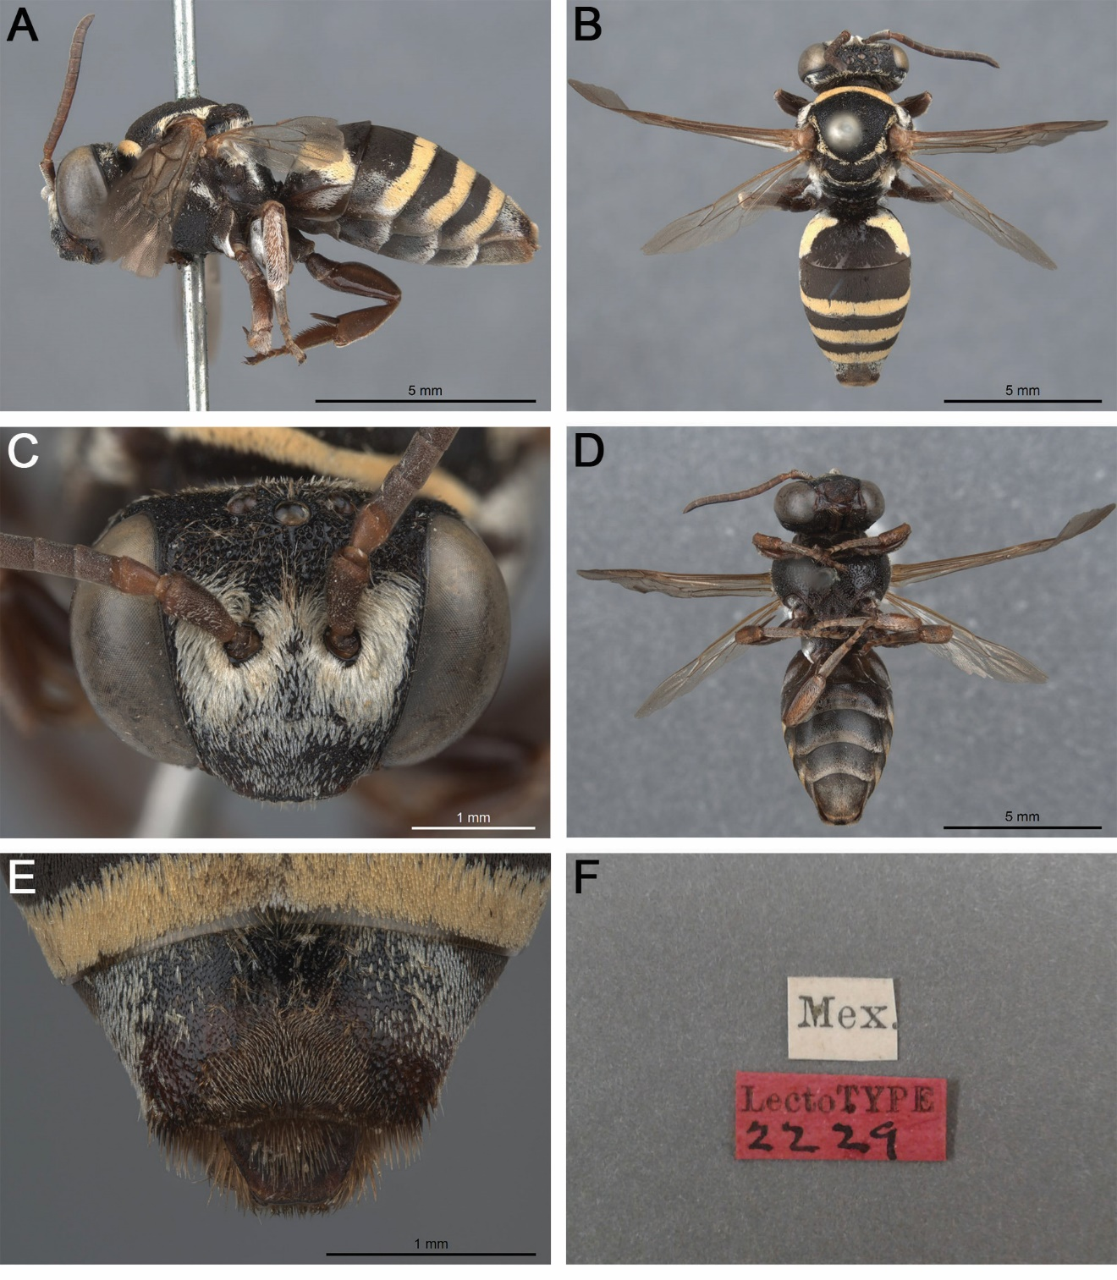

Fig. S10. Epeolus mexicanus Cresson, 1878 lectotype, ♀ (ANSP 2229). A. Habitus, lateral view. B. Habitus, dorsal view. C. Head, frontal view. D. Habitus, ventral view. E. Pseudopygidial area, dorsal view. F. Associated labels.

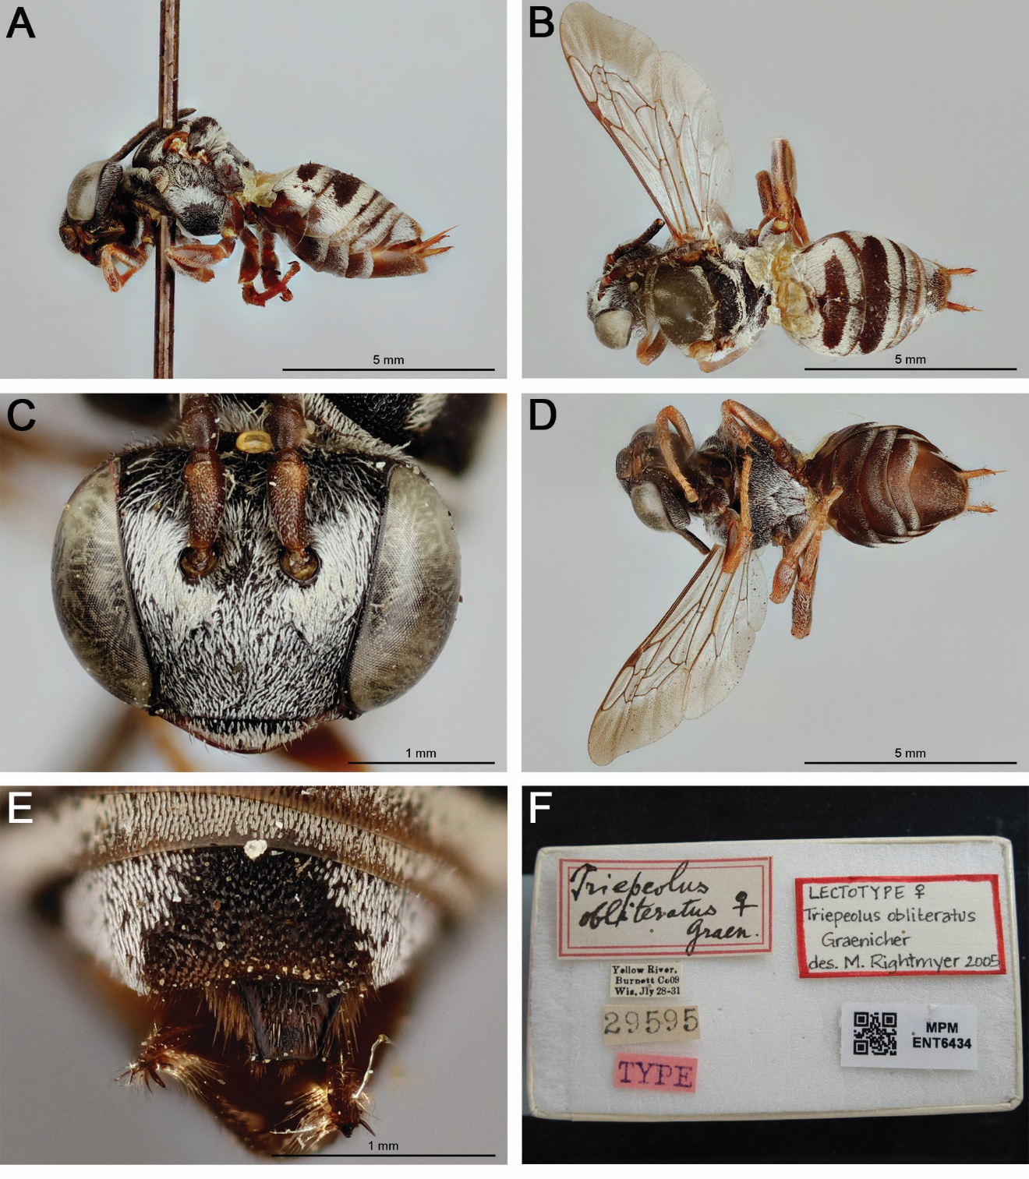

Fig. S11. Triepeolus obliteratus Graenicher, 1911 lectotype, ♀ (MPM ENT6434). A. Habitus, lateral view. B. Habitus, dorsal view. C. Head, frontal view. D. Habitus, ventral view. E. Pseudopygidial area, dorsal view. F. Associated labels (note that the lectotype designation label is provisional and will be replaced). Images are copyright of the Milwaukee Public Museum and reproduced here with permission under a CC BY-NC license.

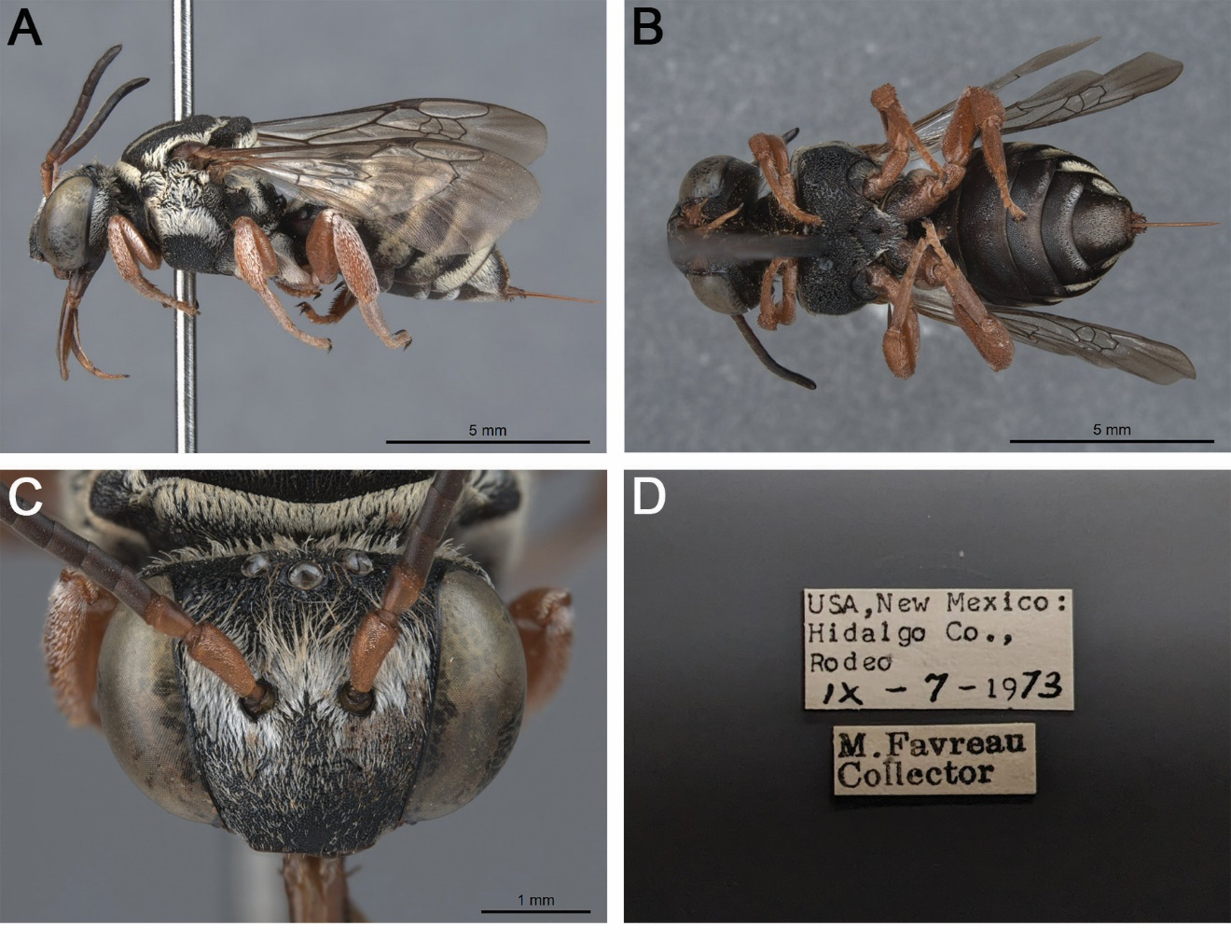

Fig. S12. Triepeolus oblongimacula sp. nov., holotype, ♀ (AMNH). A. Habitus, lateral view. B. Habitus, ventral view. C. Head, frontal view. D. Associated labels.

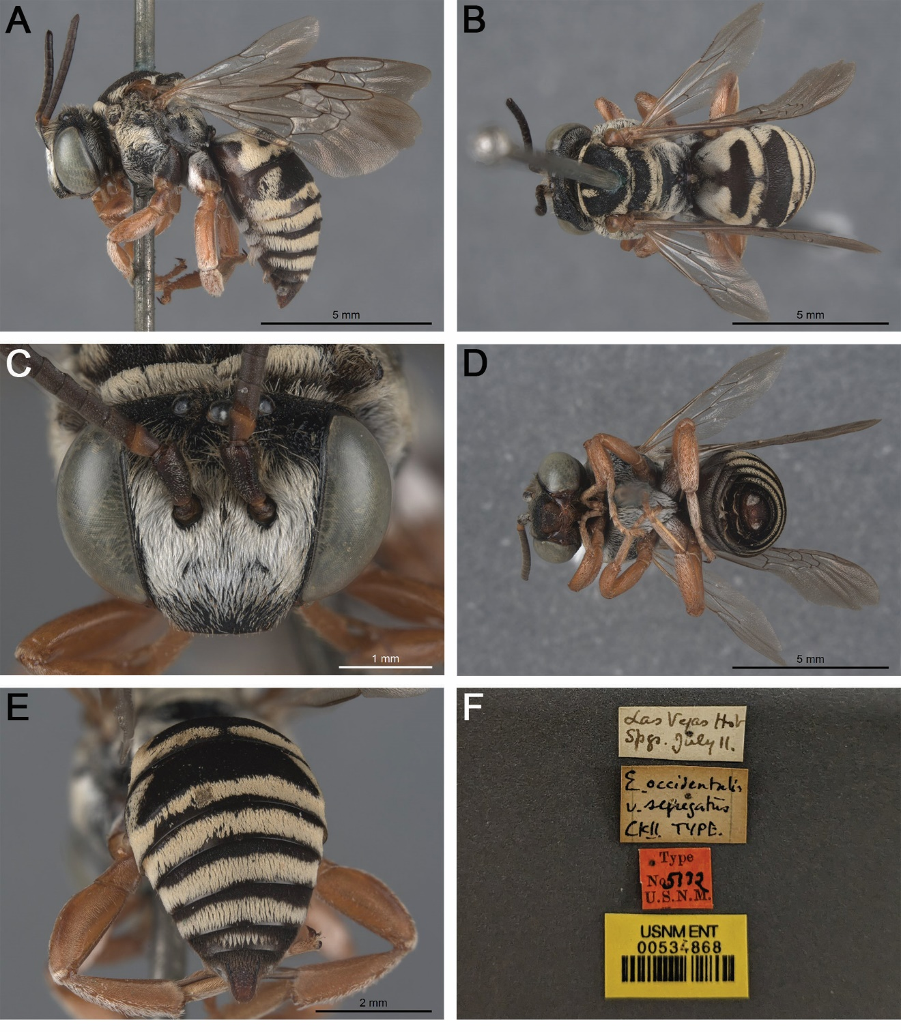

Fig. S13. Epeolus occidentalis var. segregatus Cockerell, 1900 holotype, ♂ (USNM 534868). A. Habitus, lateral view. B. Habitus, dorsal view. C. Head, frontal view. D. Habitus, ventral view. E. Posterior metasoma, dorsal view. F. Associated labels.

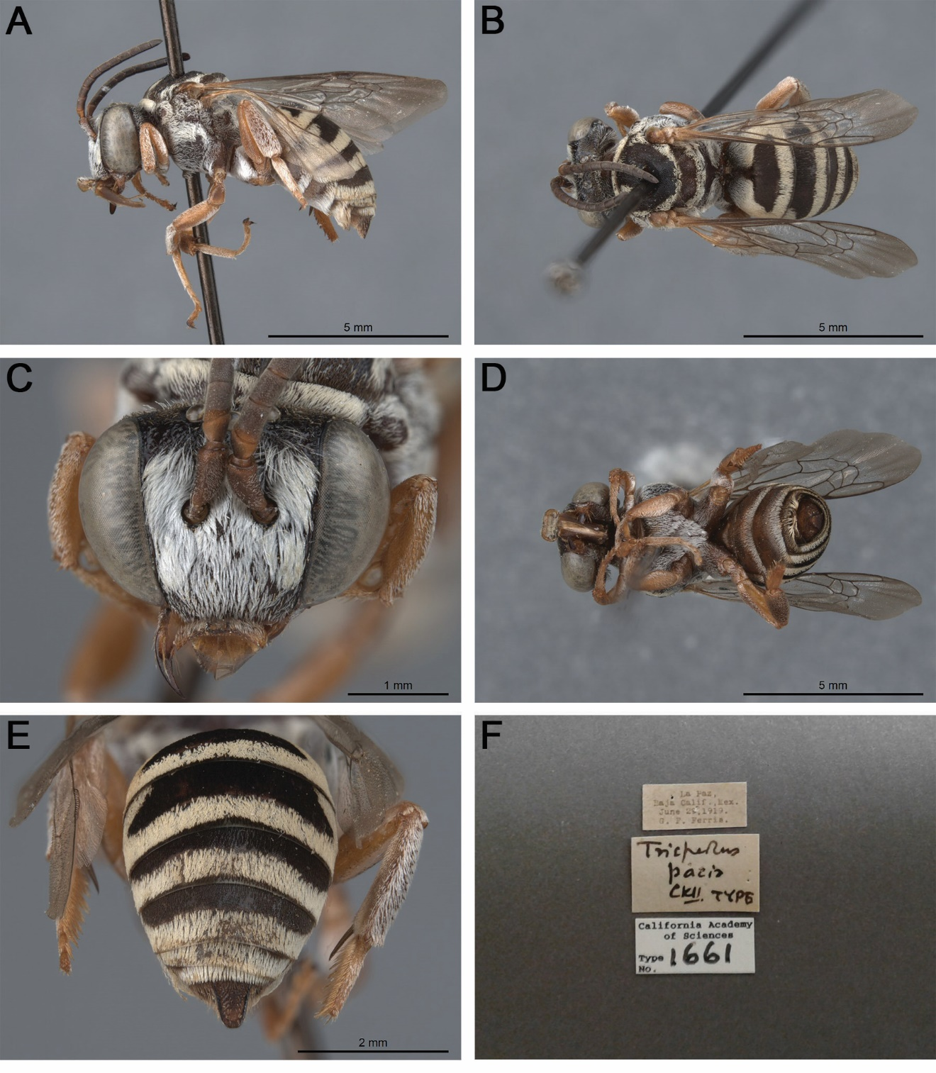

Fig. S14. Triepeolus pacis Cockerell, 1925 holotype, ♂ (CAS 1661). A. Habitus, lateral view. B. Habitus, dorsal view. C. Head, frontal view. D. Habitus, ventral view. E. Posterior metasoma, dorsal view. F. Associated labels.

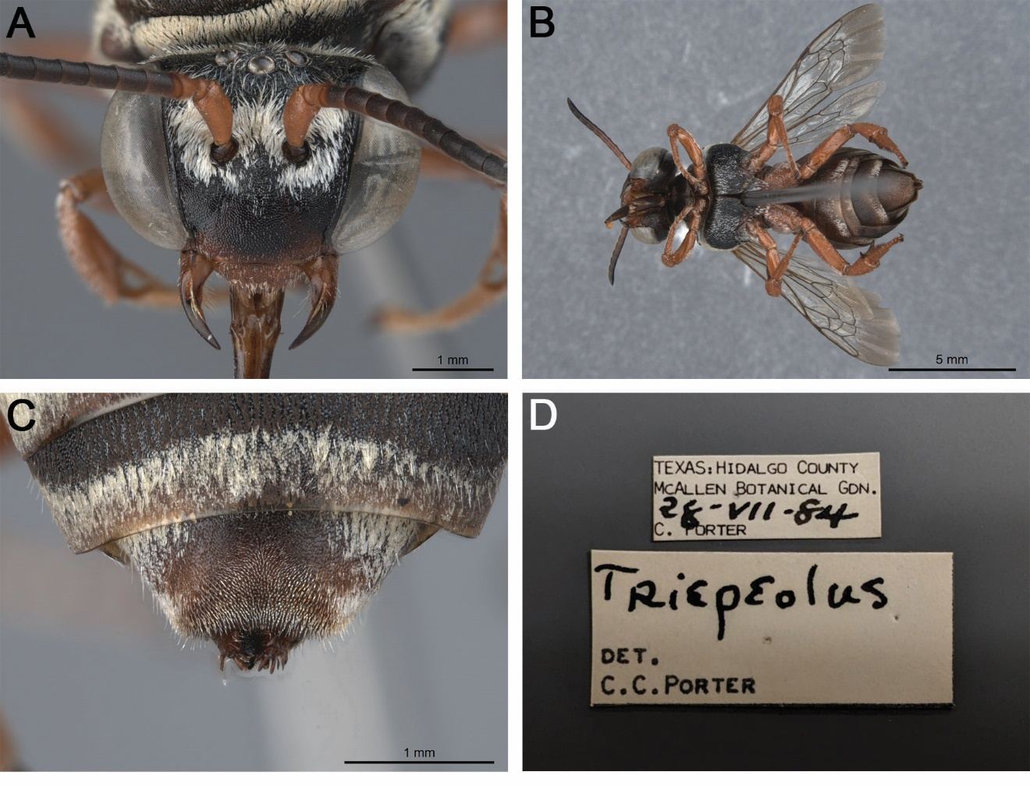

Fig. S15. Triepeolus parahirsutus sp. nov., holotype, ♀ (FSCA). A. Head, frontal view. B. Habitus, ventral view. C. Pseudopygidial area, dorsal view. D. Associated labels.

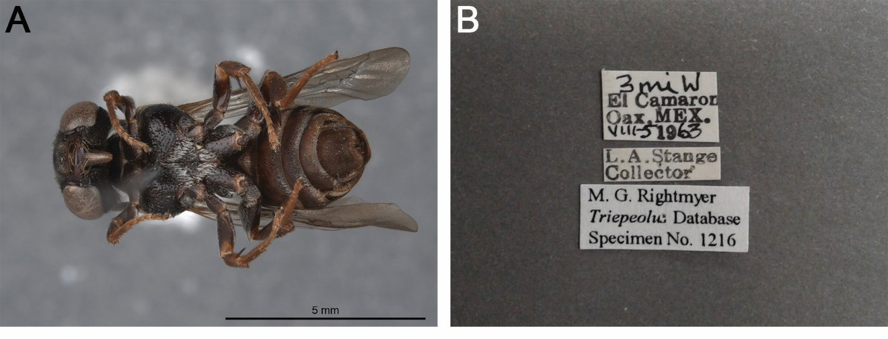

Fig. S16. Triepeolus paucipunctatus sp. nov., holotype, ♀ (UCBME M.G.R. Database No. 1216). A. Habitus, ventral view. B. Associated labels.

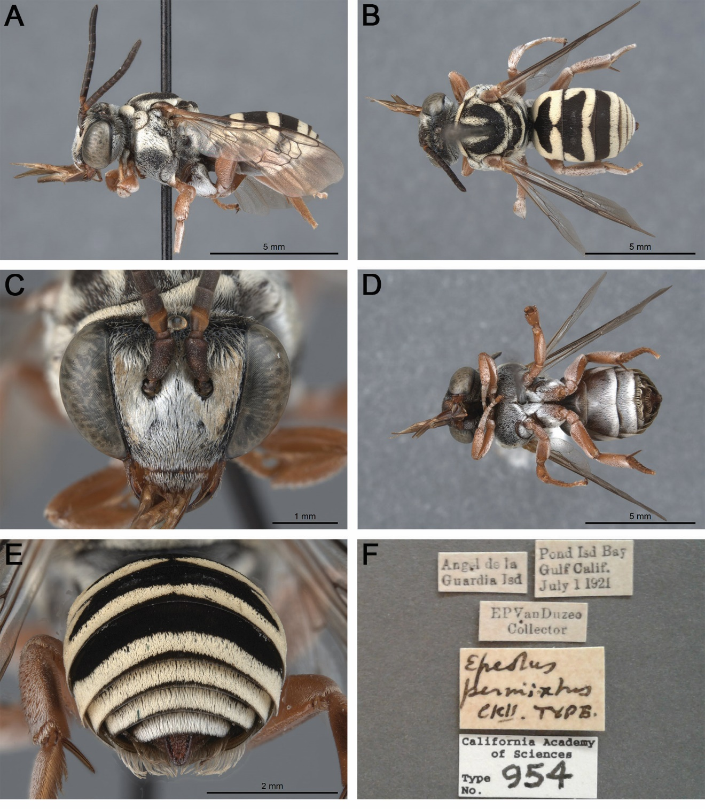

Fig. S17. Epeolus permixtus Cockerell, 1923 holotype, ♂ (CAS 954). A. Habitus, lateral view. B. Habitus, dorsal view. C. Head, frontal view. D. Habitus, ventral view. E. Posterior metasoma, dorsal view. F. Associated labels.

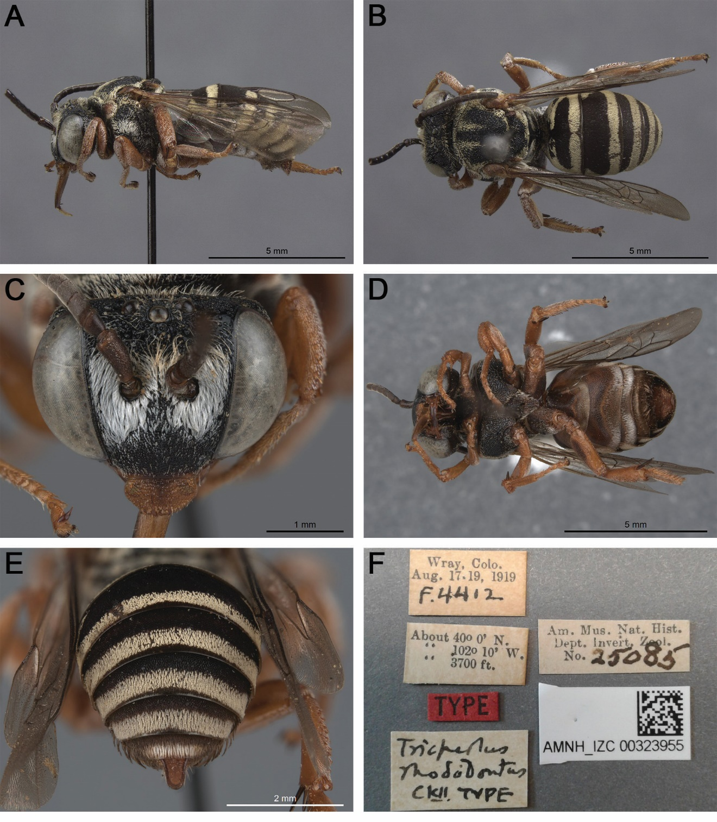

Fig. S18. Triepeolus rhododontus Cockerell, 1921 holotype, ♂ (AMNH AMNH_IZC 00323955). A. Habitus, lateral view. B. Habitus, dorsal view. C. Head, frontal view. D. Habitus, ventral view. E. Posterior metasoma, dorsal view. F. Associated labels.

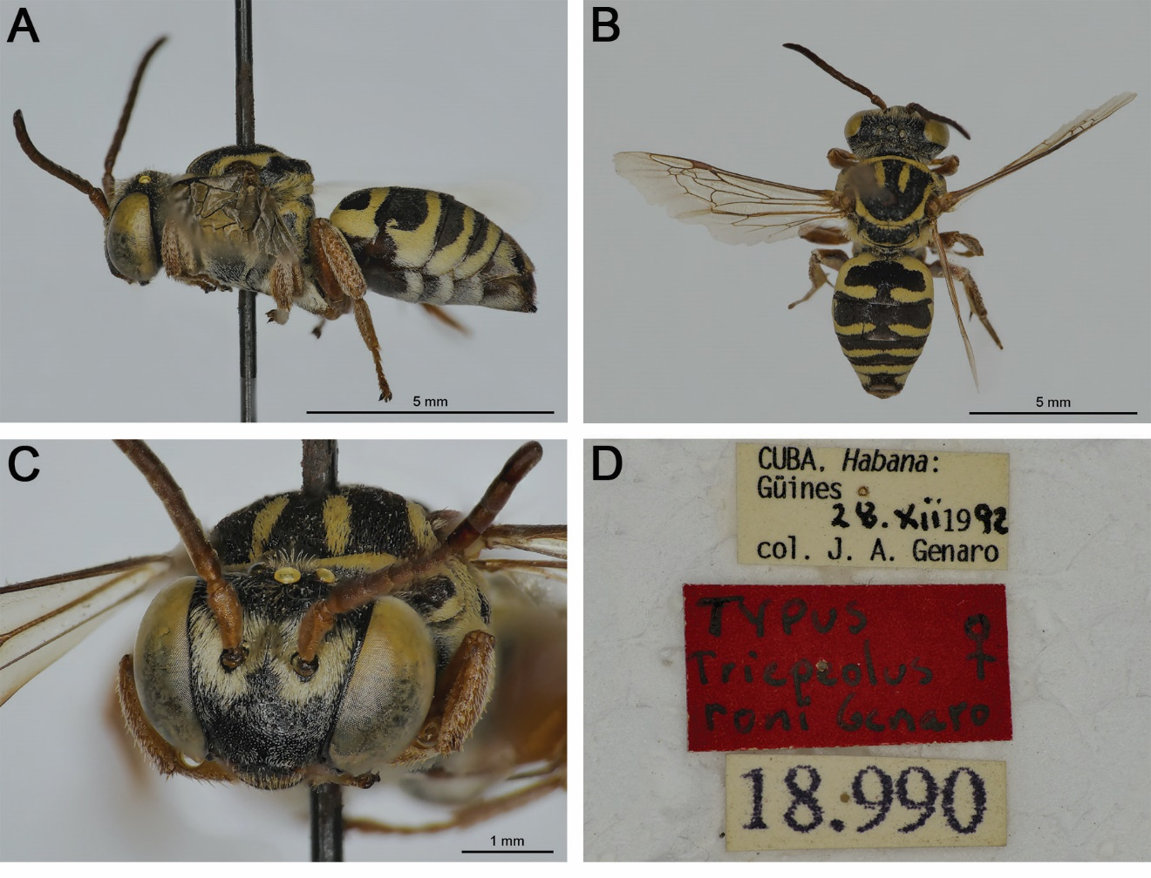

Fig. S19. Triepeolus roni Genaro, 1999 holotype, ♀ (MNHNCU). A. Habitus, lateral view. B. Habitus, dorsal view. C. Head, frontal view. D. Associated labels. Images courtesy of J.M. Acuña.

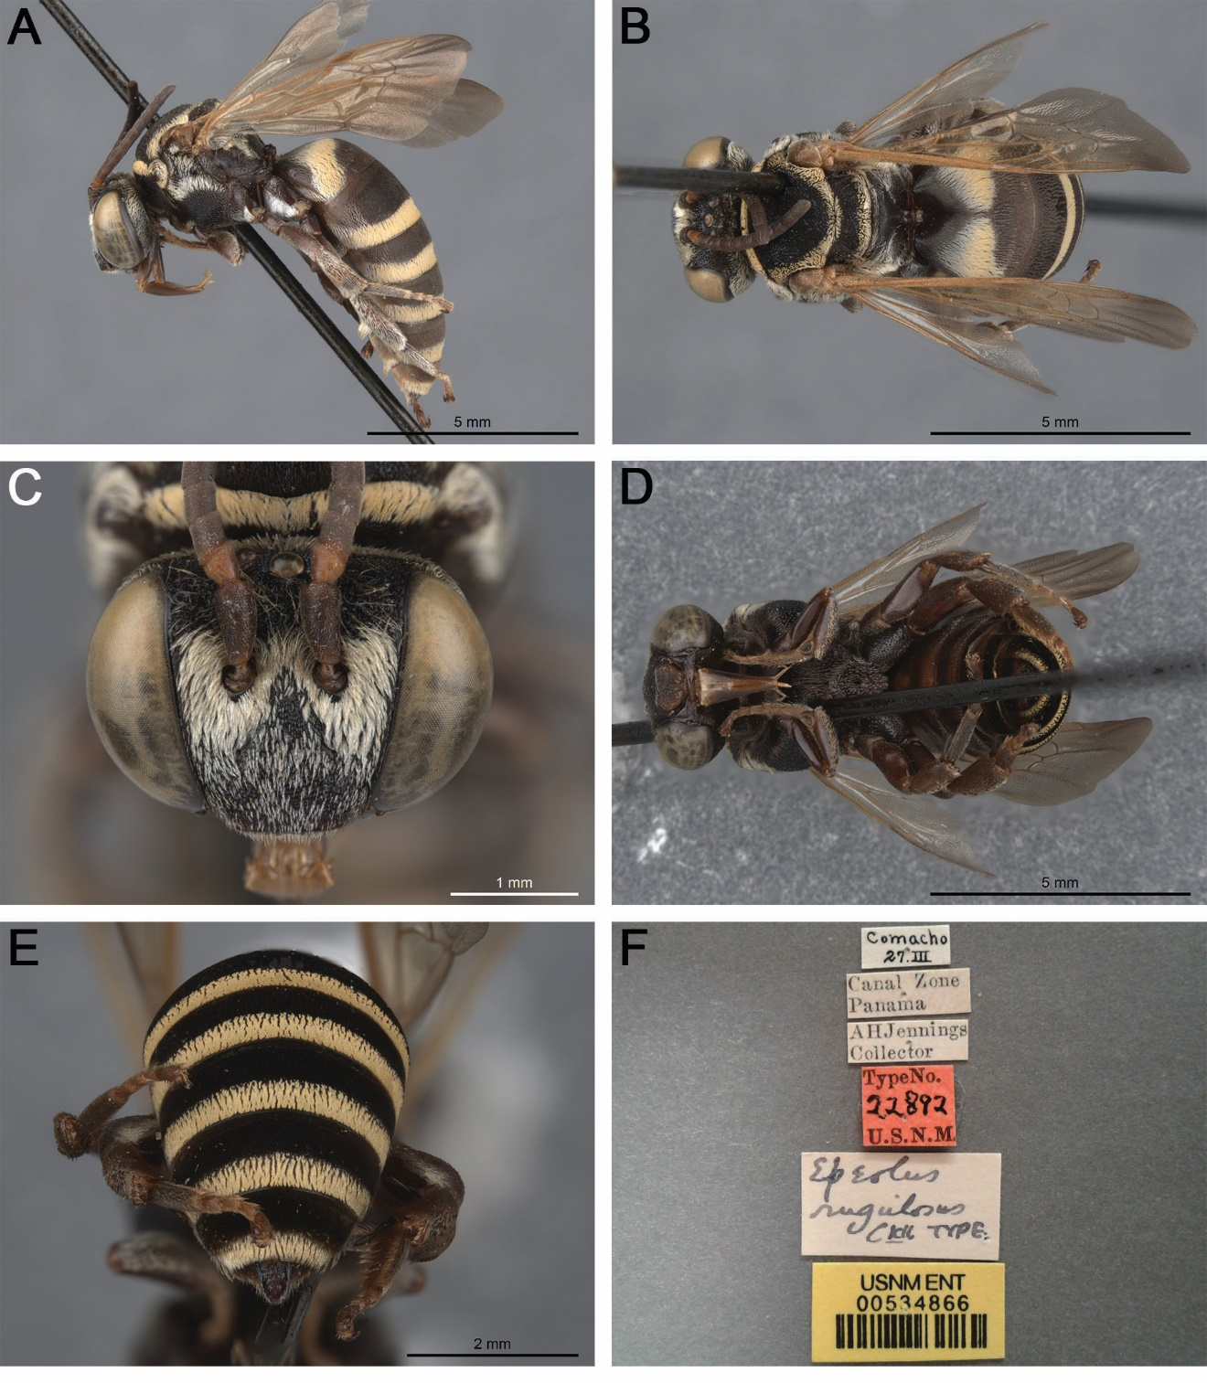

Fig. S20. Epeolus rugulosus Cockerell, 1917 holotype, ♂ (USNM 534866). A. Habitus, lateral view. B. Habitus, dorsal view. C. Head, frontal view. D. Habitus, ventral view. E. Posterior metasoma, dorsal view. F. Associated labels.

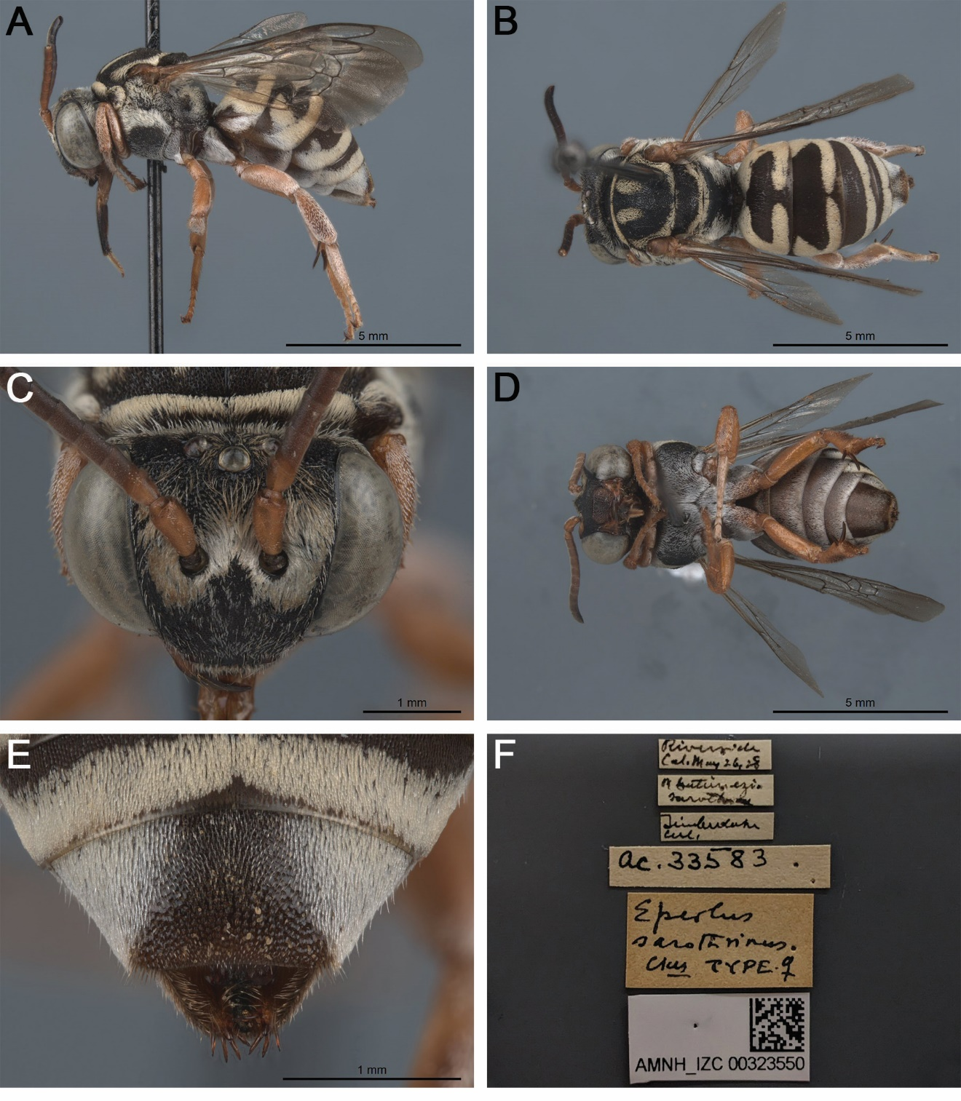

Fig. S21. Epeolus sarothrinus Cockerell, 1929 holotype, ♀ (AMNH AMNH_IZC 00323550). A. Habitus, lateral view. B. Habitus, dorsal view. C. Head, frontal view. D. Habitus, ventral view. E. Pseudopygidial area, dorsal view. F. Associated labels.

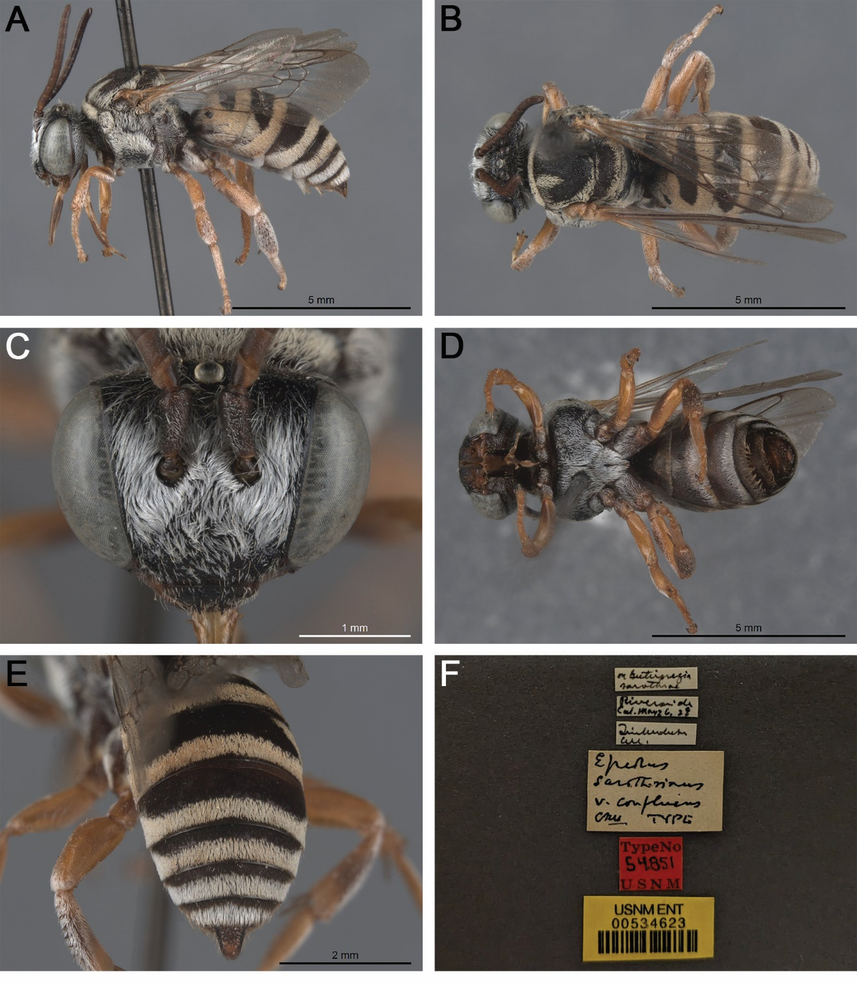

Fig. S22. Epeolus sarothrinus var. confluens Cockerell, 1929 holotype, ♂ (USNM 534623). A. Habitus, lateral view. B. Habitus, dorsal view. C. Head, frontal view. D. Habitus, ventral view. E. Posterior metasoma, dorsal view. F. Associated labels.

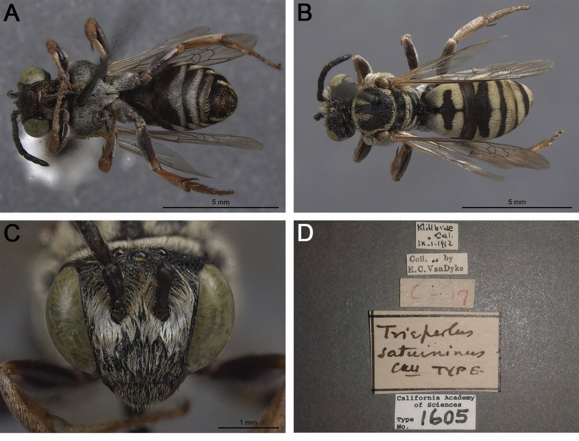

Fig. S23. Triepeolus saturninus Cockerell & Sandhouse, 1924 holotype, ♂ (CAS 1605). A. Habitus, ventral view. B. Habitus, dorsal view. C. Head, frontal view. D. Associated labels.

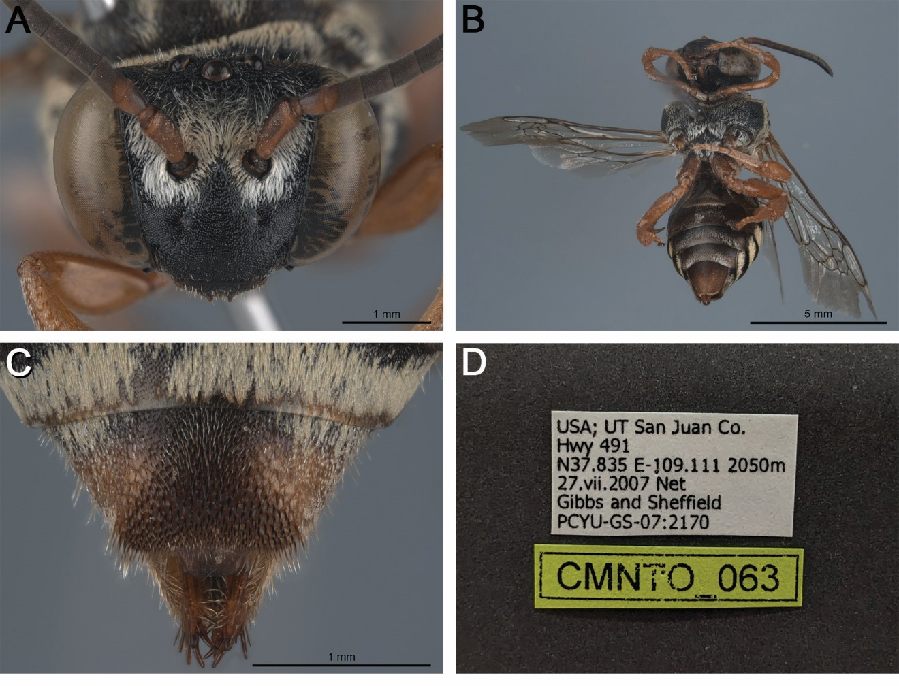

Fig. S24. Triepeolus shoshone sp. nov., holotype, ♀ (BOLD sample ID: CMNTO_063; PCYU PCYU-GS-07:2170). A. Head, frontal view. B. Habitus, ventral view. C. Pseudopygidial area, dorsal view. D. Associated labels.

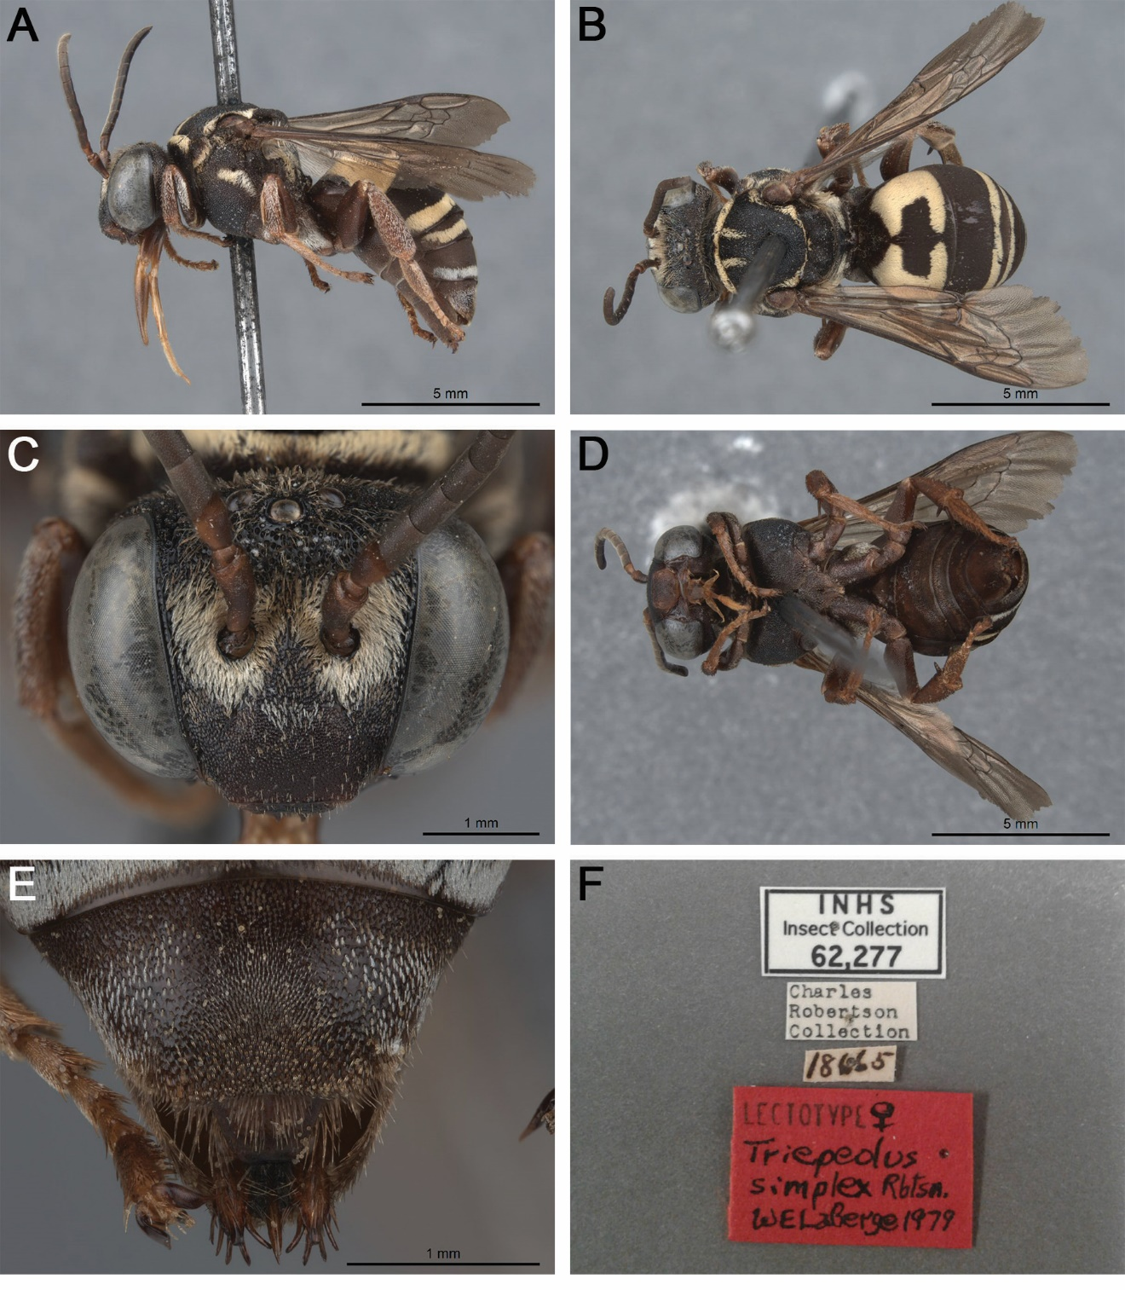

Fig. S25. Triepeolus simplex Robertson, 1903 lectotype, ♀ (INHS 62277). A. Habitus, lateral view. B. Habitus, dorsal view. C. Head, frontal view. D. Habitus, ventral view. E. Pseudopygidial area, dorsal view. F. Associated labels.

