https://doi.org/10.5852/ejt.2025.1011.3023.13559
Supplementary material 3: photos of type locality or collecting localities close to the type locality.
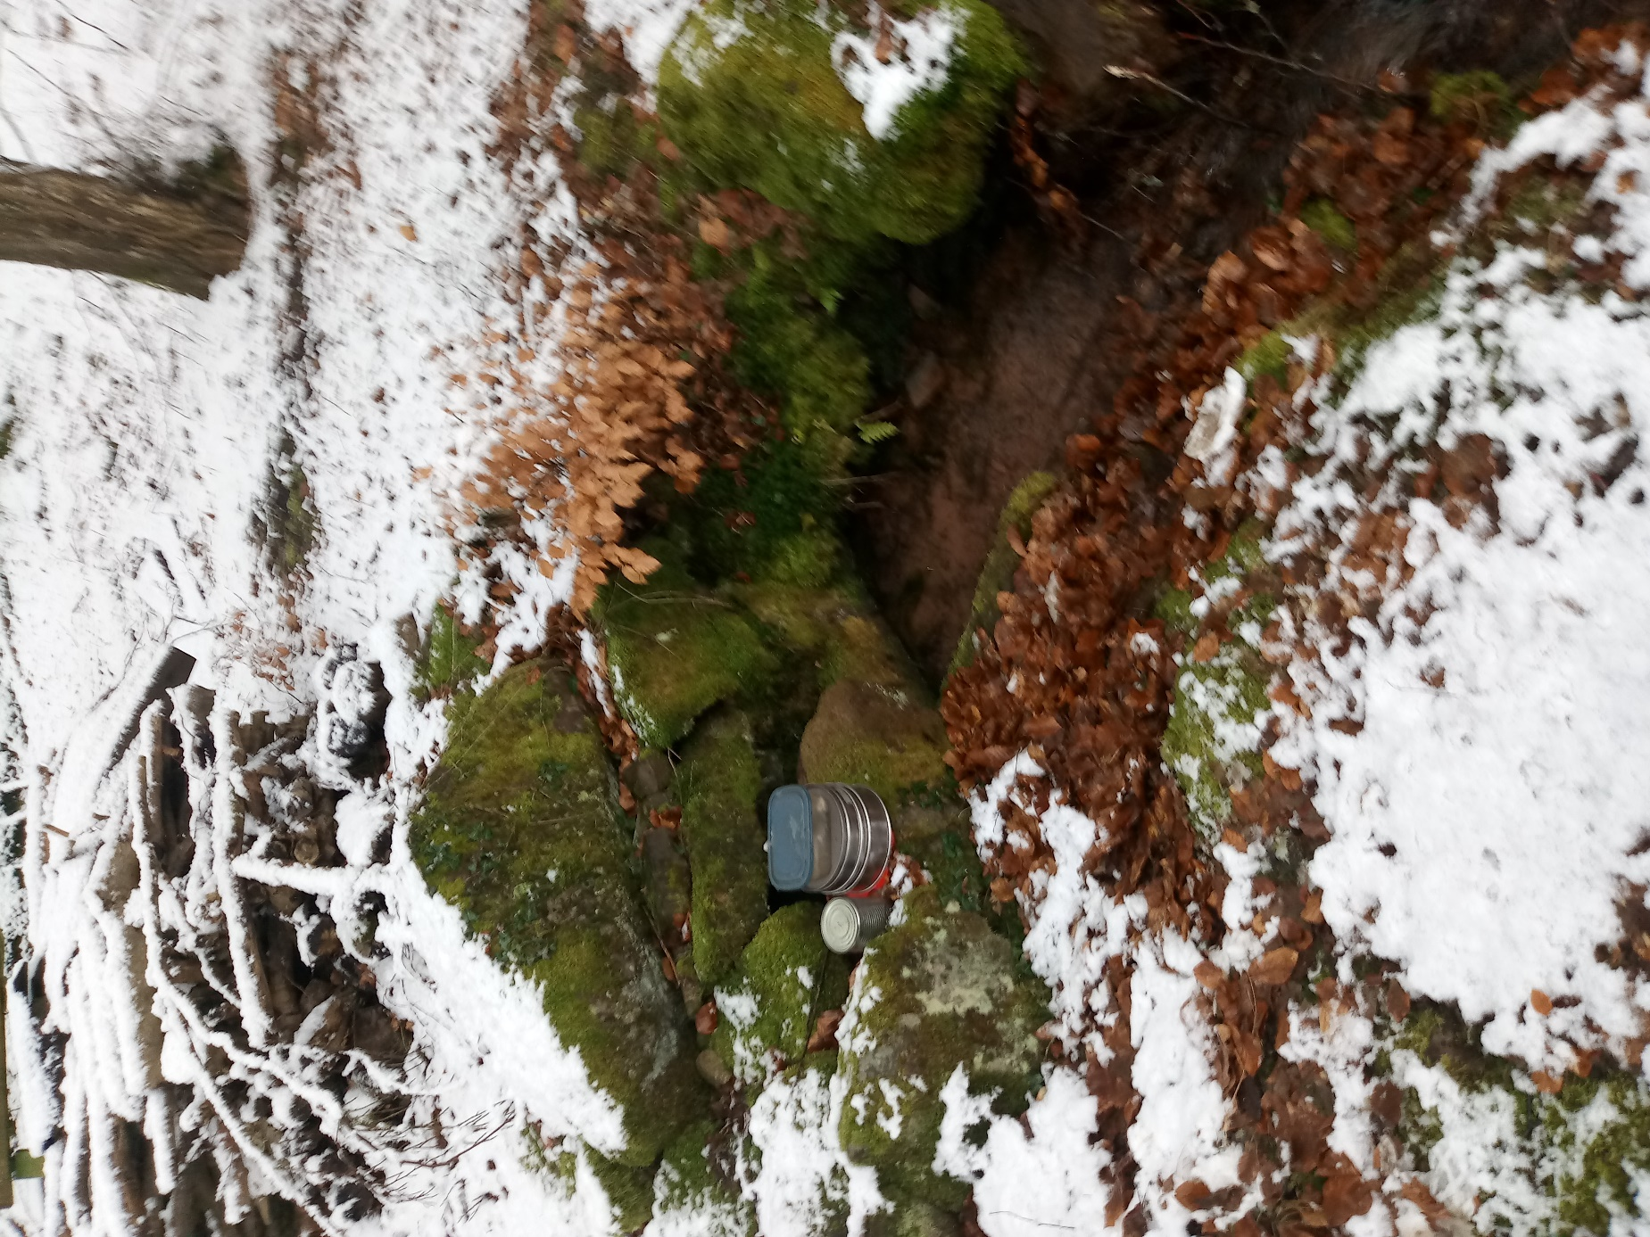
Supplementary material 3.1: The spring called Emmasruh is not the type locality, but the collecting site closest to the type locality of Niphargus schellenbergi, where we successfully collected this species.
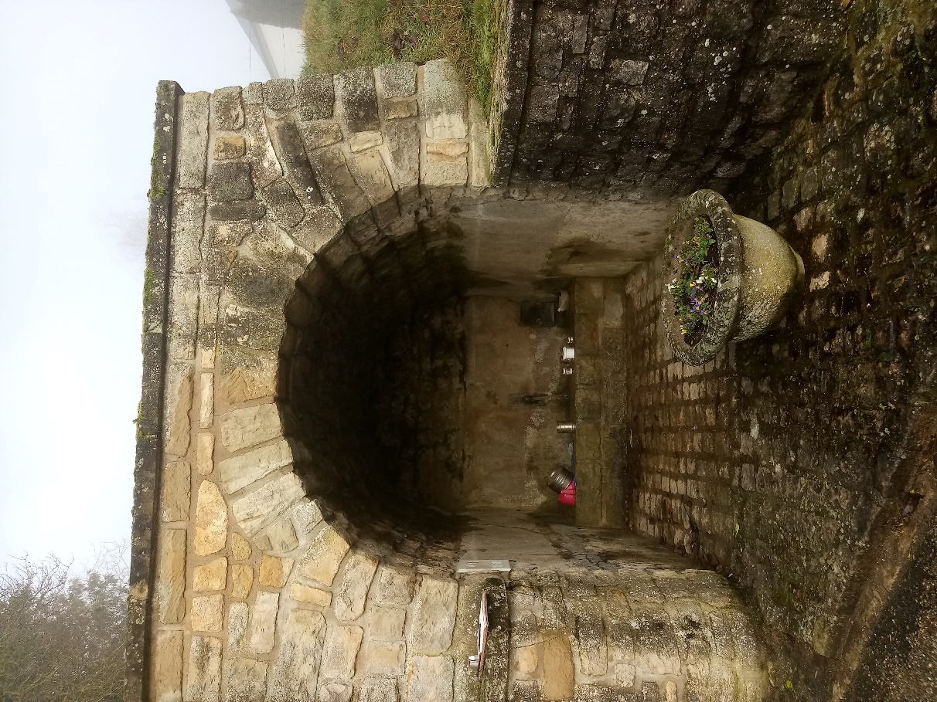
Supplementary material 3.2: Source de Girsterklaus, type locality of Niphargus luxemburgensis.
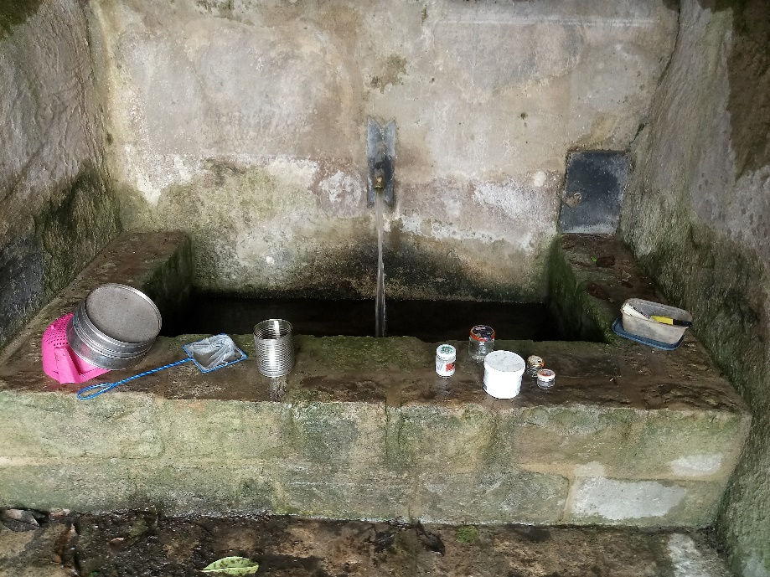
Supplementary material 3.3: Basin of Source de Girsterklaus, type locality of Niphargus luxemburgensis, during a collecting trip.
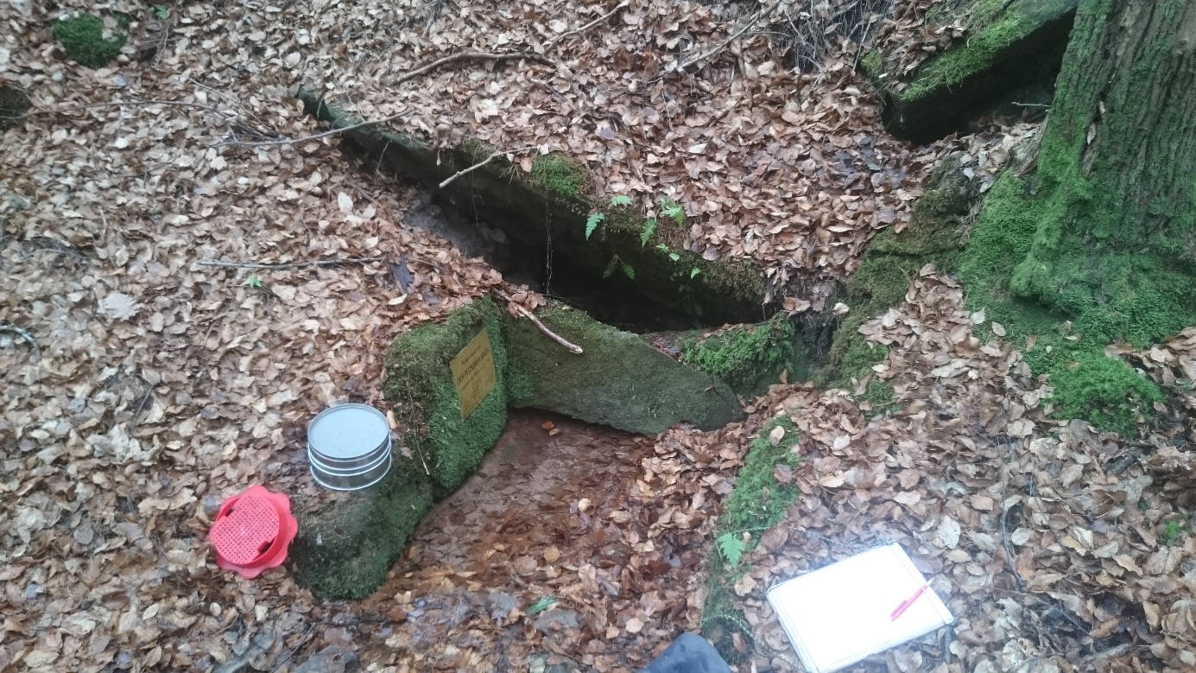
Supplementary material 3.4: Felsenbrunnen, type locality of Niphargus palatinensis.
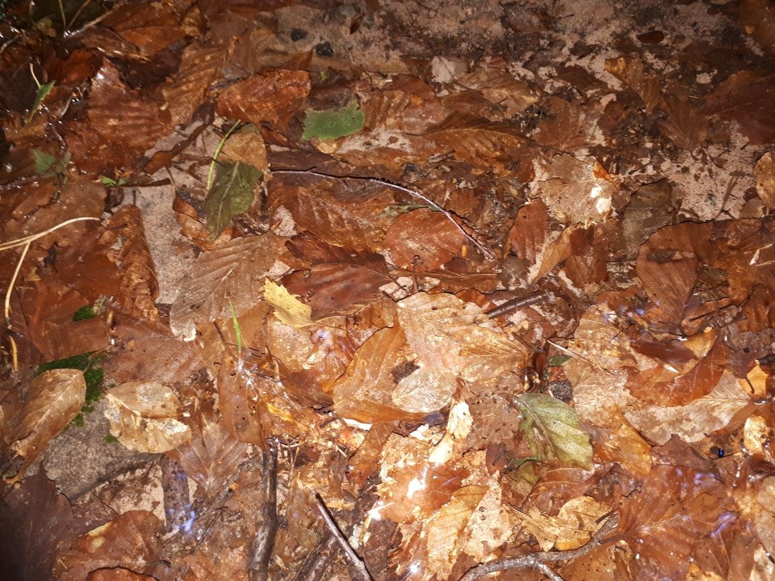
Supplementary material 3.5: Rotting foliage in the Felsenbrunnen, where the niphargids were found.

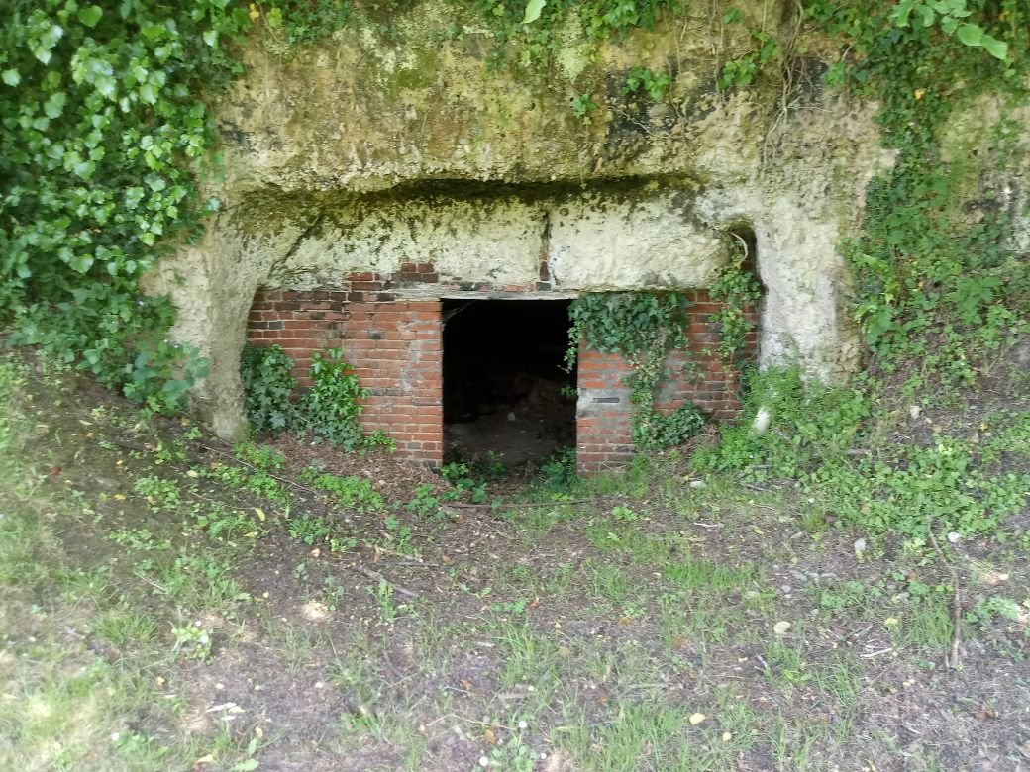 Supplementary material 3.6: Carrière souterrain de Saint-Vaast-en-Auge, type locality of Niphargus normandiensis.

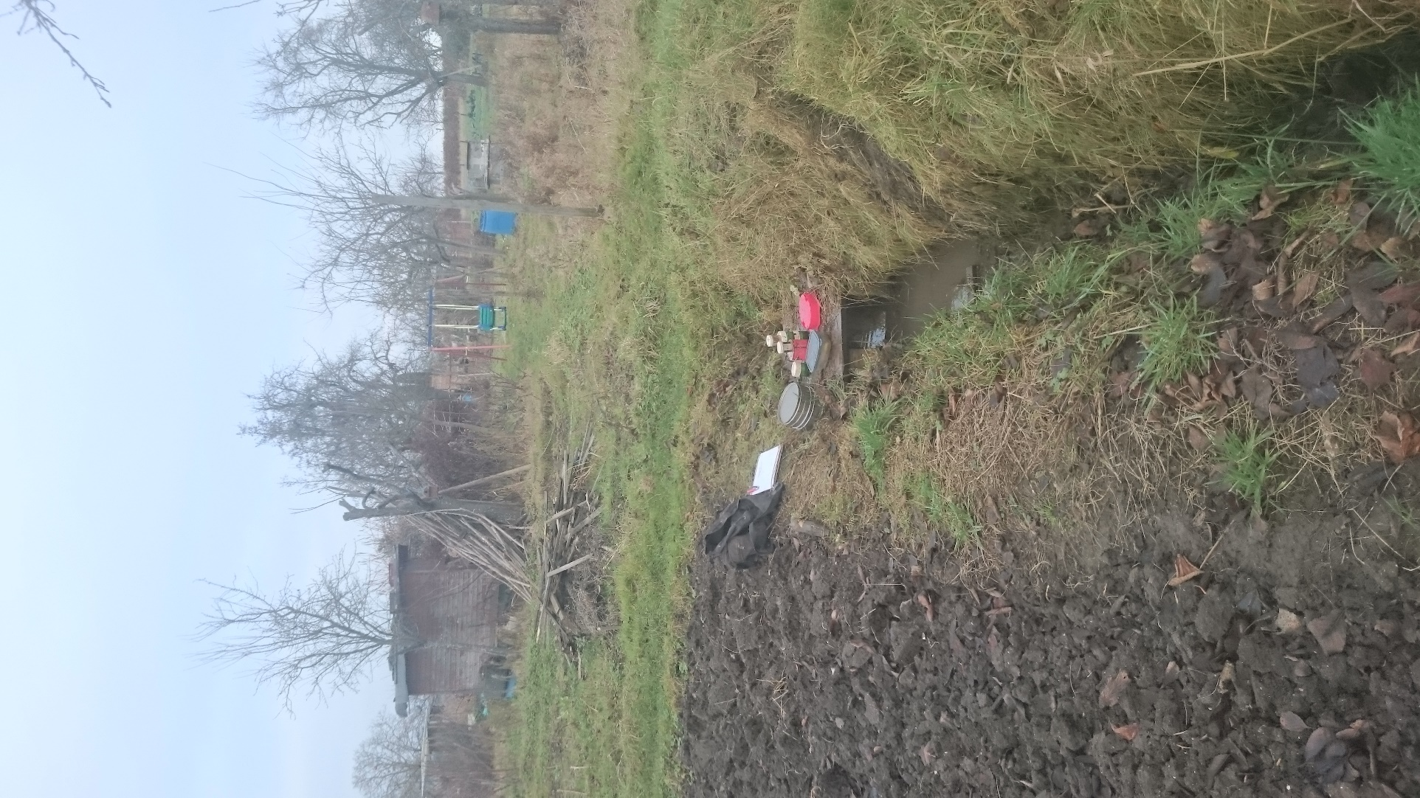
Supplementary material 3.7: Süzlochquelle 2, type locality of Niphargus wasgauensis during collecting trip.

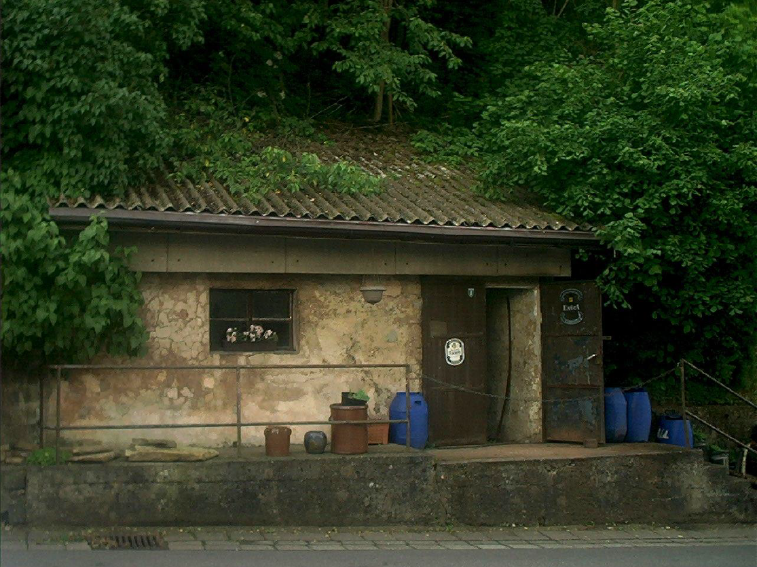
Supplementary material 3.8: Zilla’s Keller, type locality of Niphargus saraviensis.
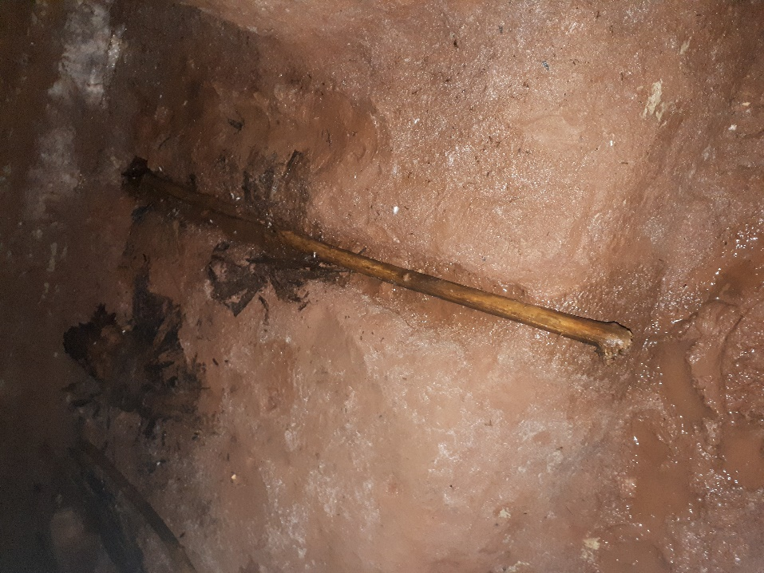
Supplementary material 3.9: Zilla’s Keller, the slightly running spring inside the cellar, containing wood residues, the actual collecting site of Niphargus saraviensis.
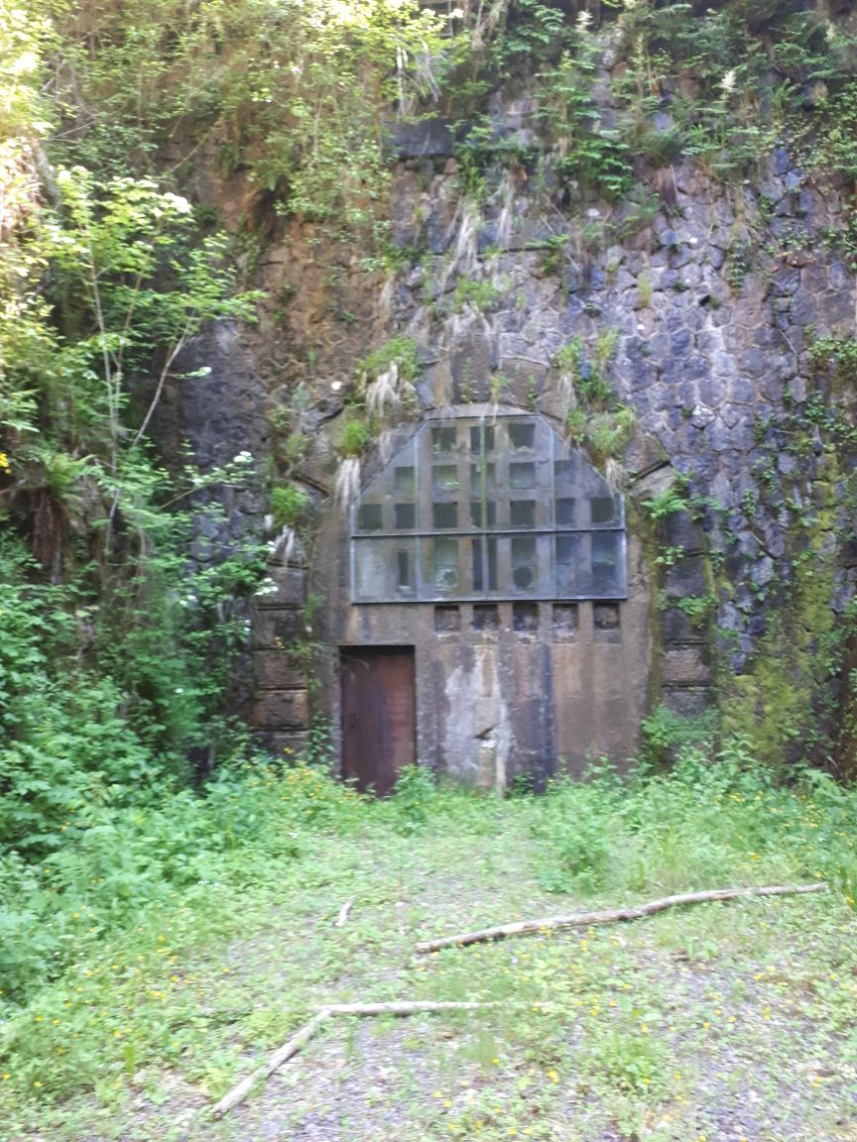
Supplementary material 3.10: Tunnel du Col des Croix, southern entrance type locality of Niphargus lotharingiensis.

