https://doi.org/10.5852/ejt.2025.1011.3023.13561
Supplementary material 4: habitats of the individual species.

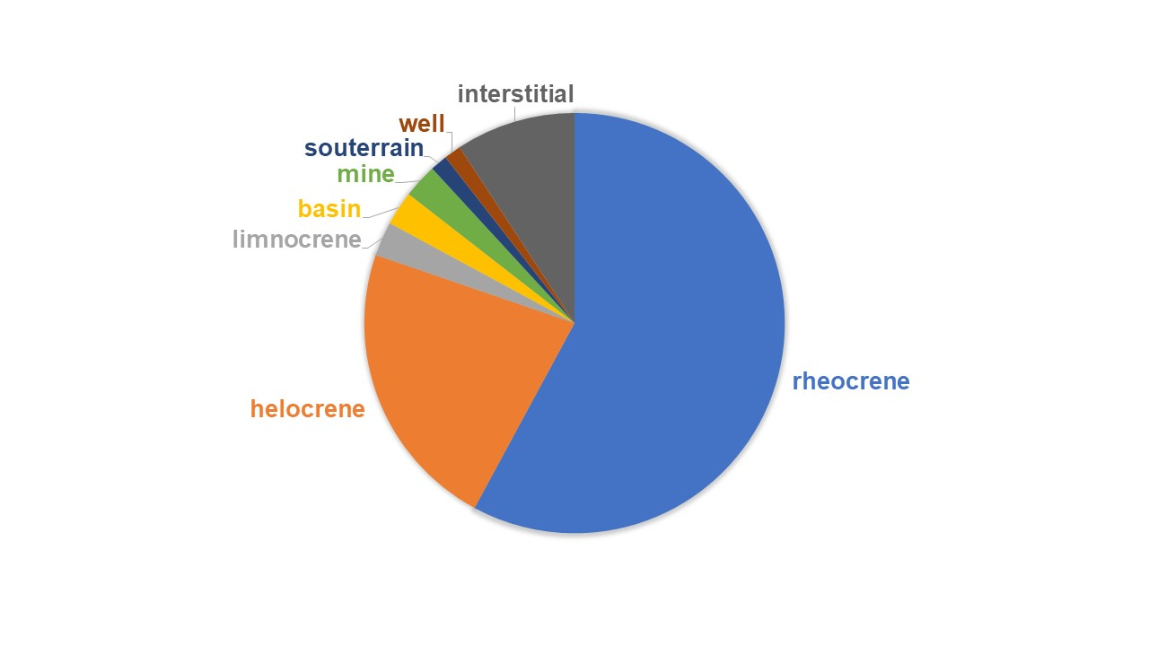 Supplementary material 4.1: Types of collecting sits of Niphargus aquilex (n = 76).
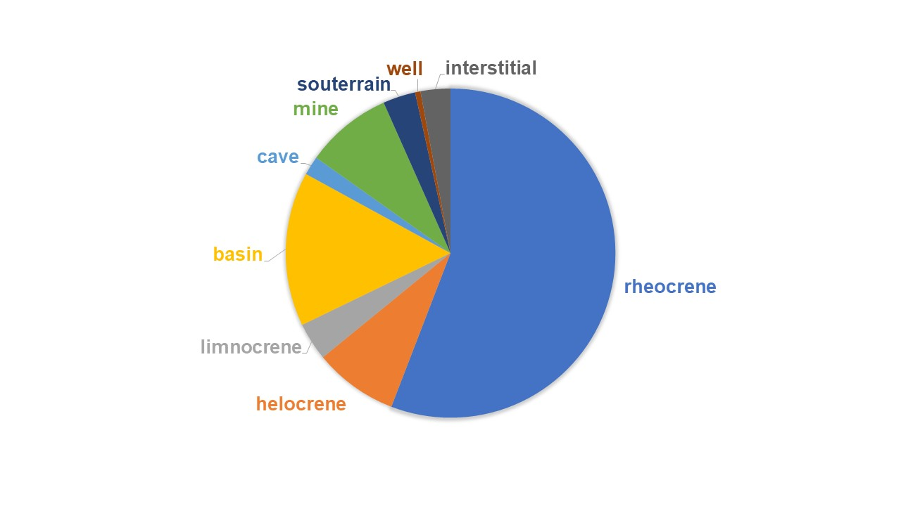
Supplementary material 4.2: Types of collecting sits of Niphargus schellenbergi (n = 376).
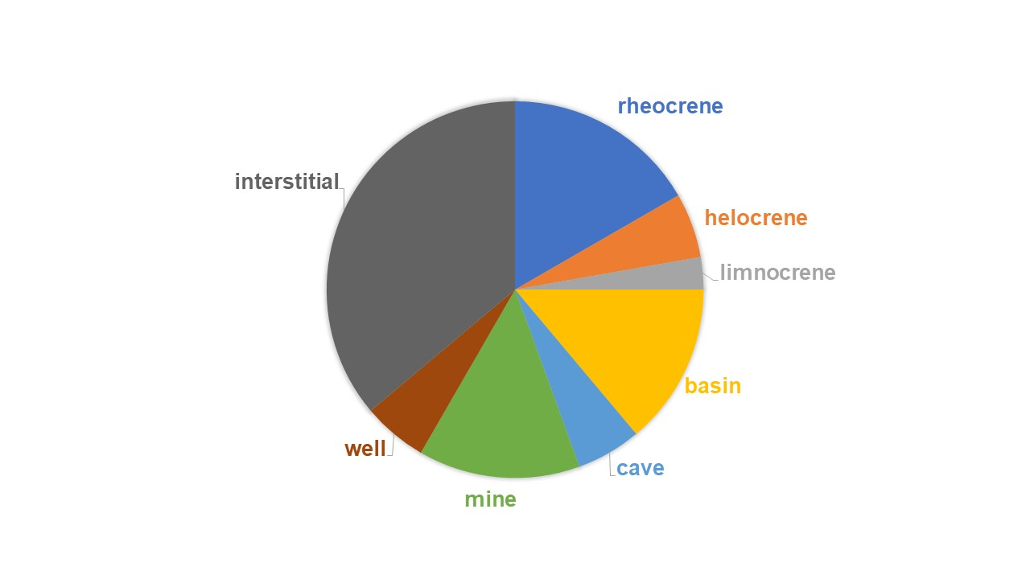 Supplementary material 4.3: Types of collecting sits of Niphargus luxemburgensis (n = 36).
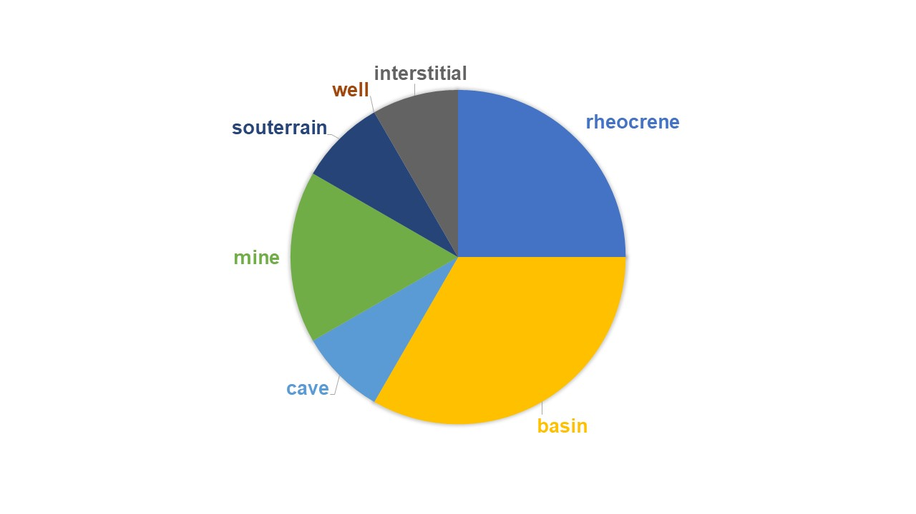
Supplementary material 4.4: Types of collecting sits of Niphargus palatinensis (n = 12).
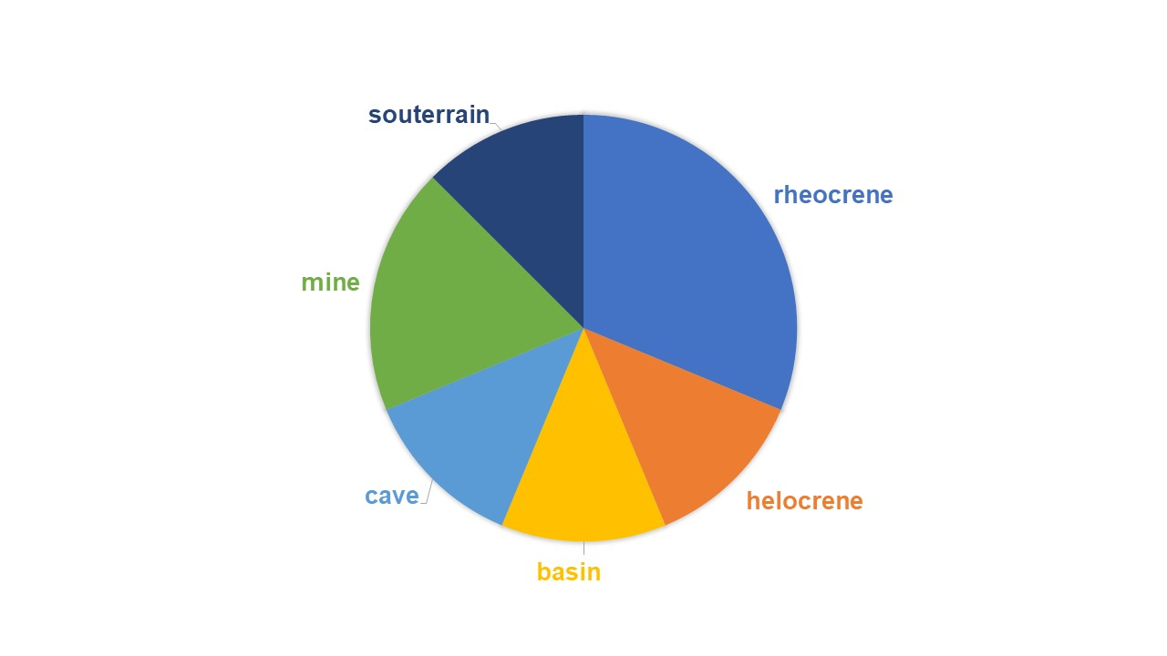
Supplementary material 4.5: Types of collecting sits of Niphargus saraviensis (n = 16).
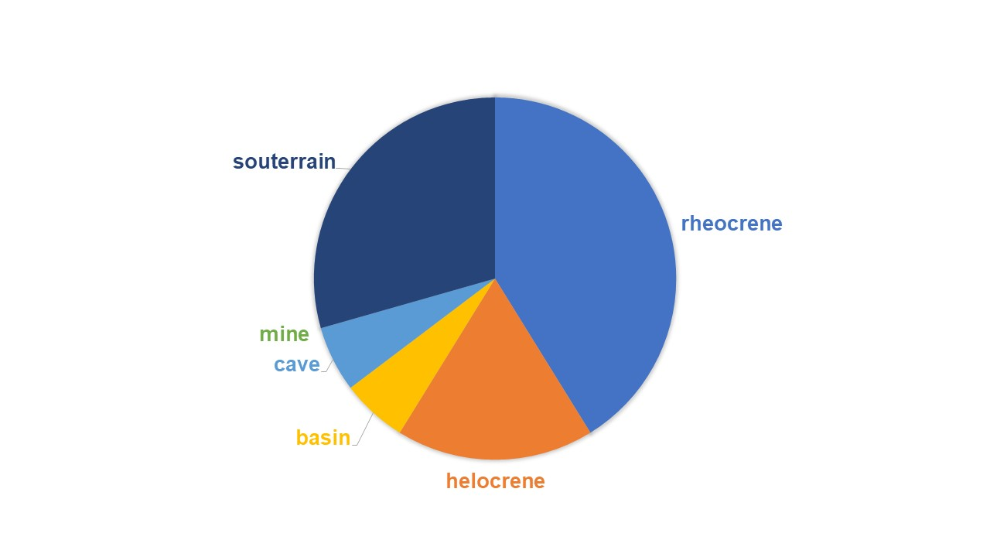 Supplementary material 4.6: Types of collecting sits of Niphargus lotharingiensis (n=26).

