https://doi.org/10.5852/ejt.2025.1031.3133.13961
Supplementary File IX.
Original descriptions of Illidops (Hymenoptera: Braconidae) in Russian by Tobias and Kontenko
I. dauricus Kotenko, 2007
Description in: Kotenko A (2007) Microgastrinae. In: Lelej A (Ed.), Neuropteroidea, Mecoptera, Hymenoptera. Key to the insects of Russia Far East. Dalnauka, Vladivostok, 134–192.
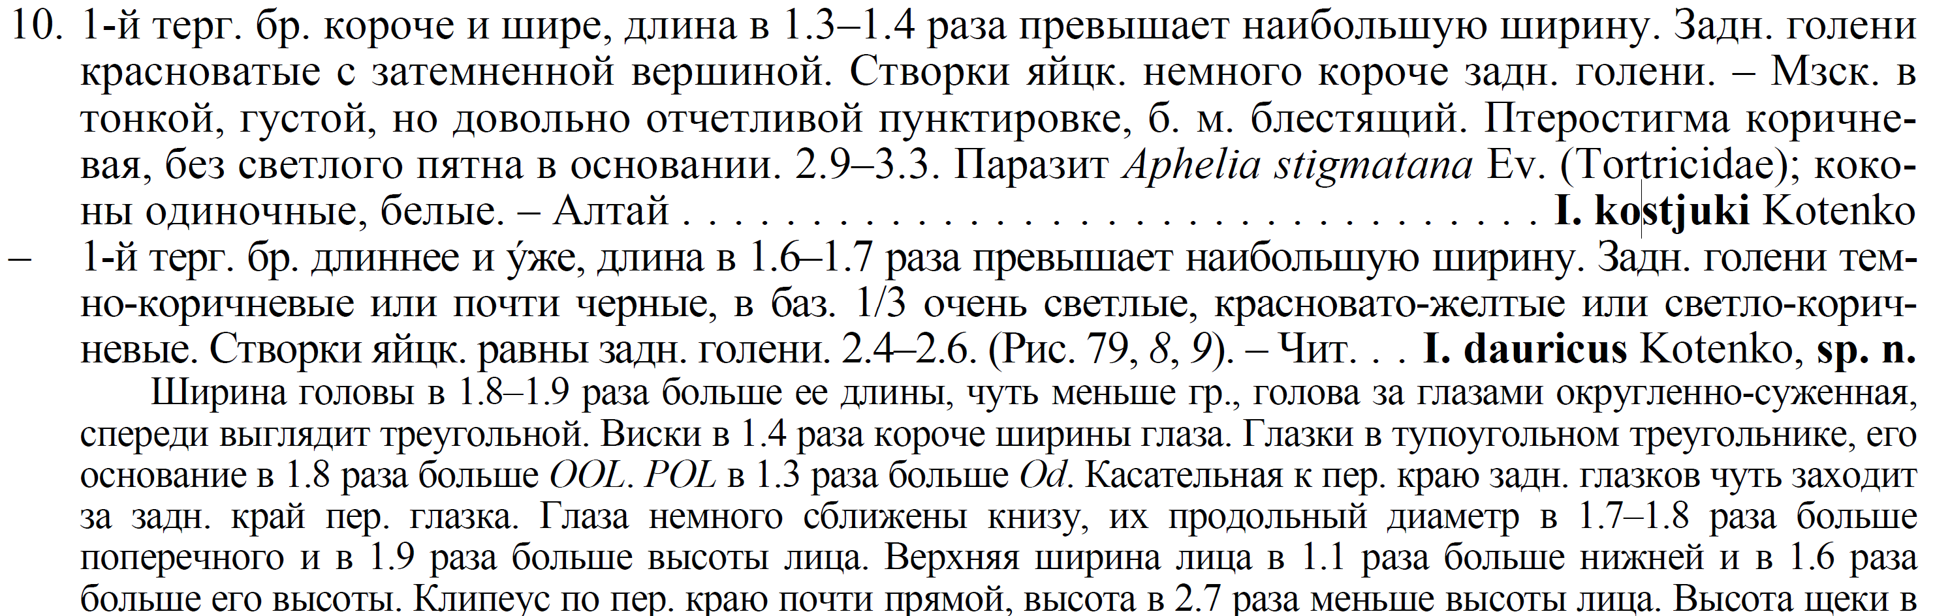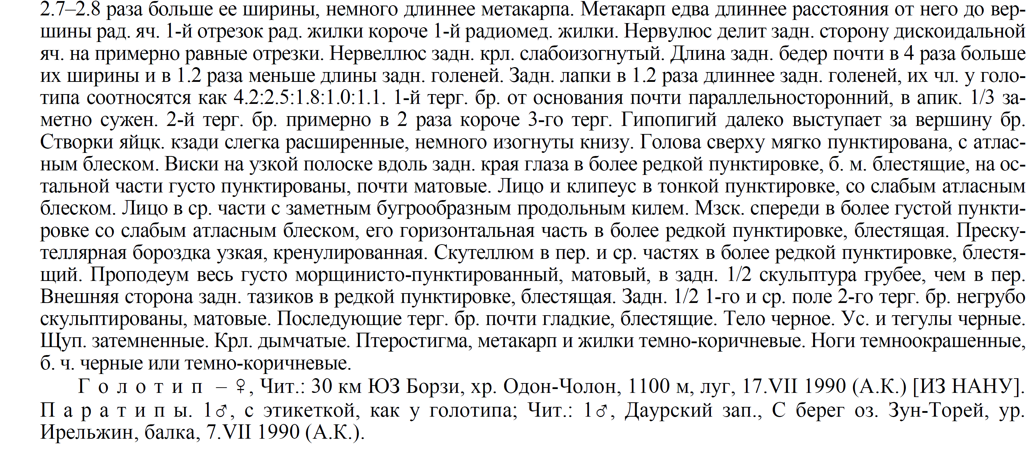

I. planiscapus (Tobias, 1976)
Description in: Tobias V (1976) Braconids of the Caucasus (Hymenoptera, Braconidae). In: Opred. Faune SSSR. Nauka Press, Leningrad, 1–286.
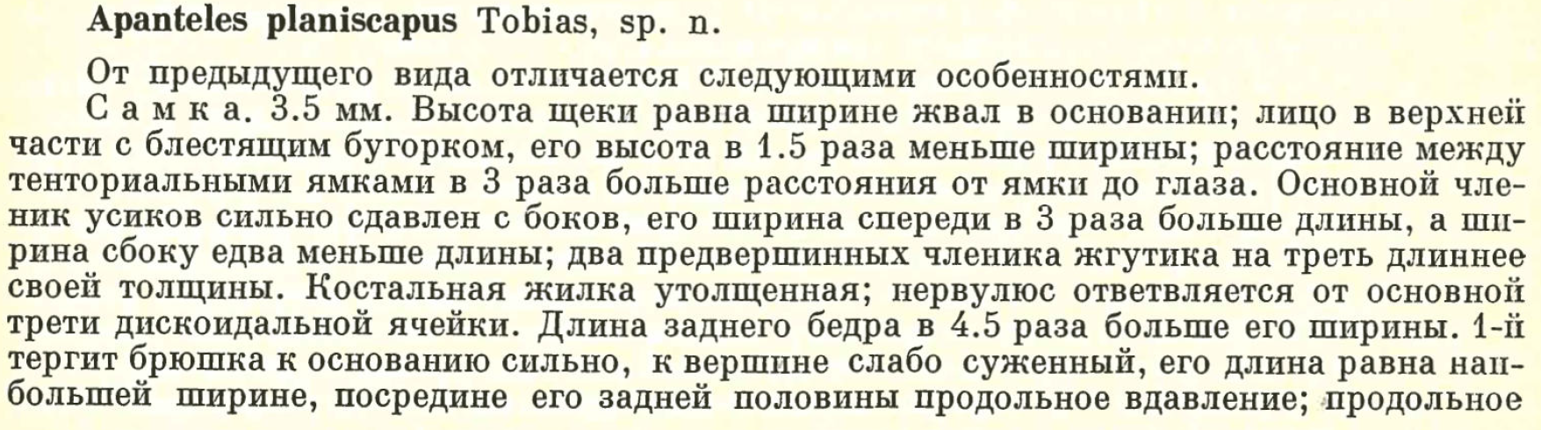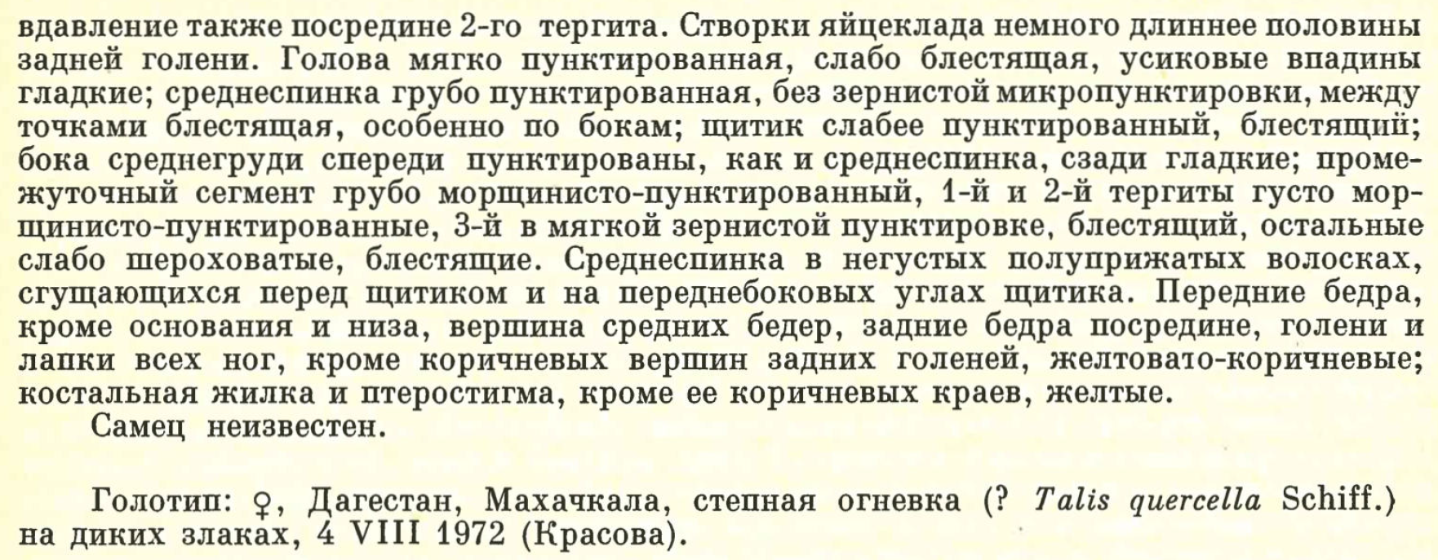

I. rostratus (Tobias, 1976)
Description in: Tobias V (1976) Braconids of the Caucasus (Hymenoptera, Braconidae). In: Opred. Faune SSSR. Nauka Press, Leningrad, 1–286.
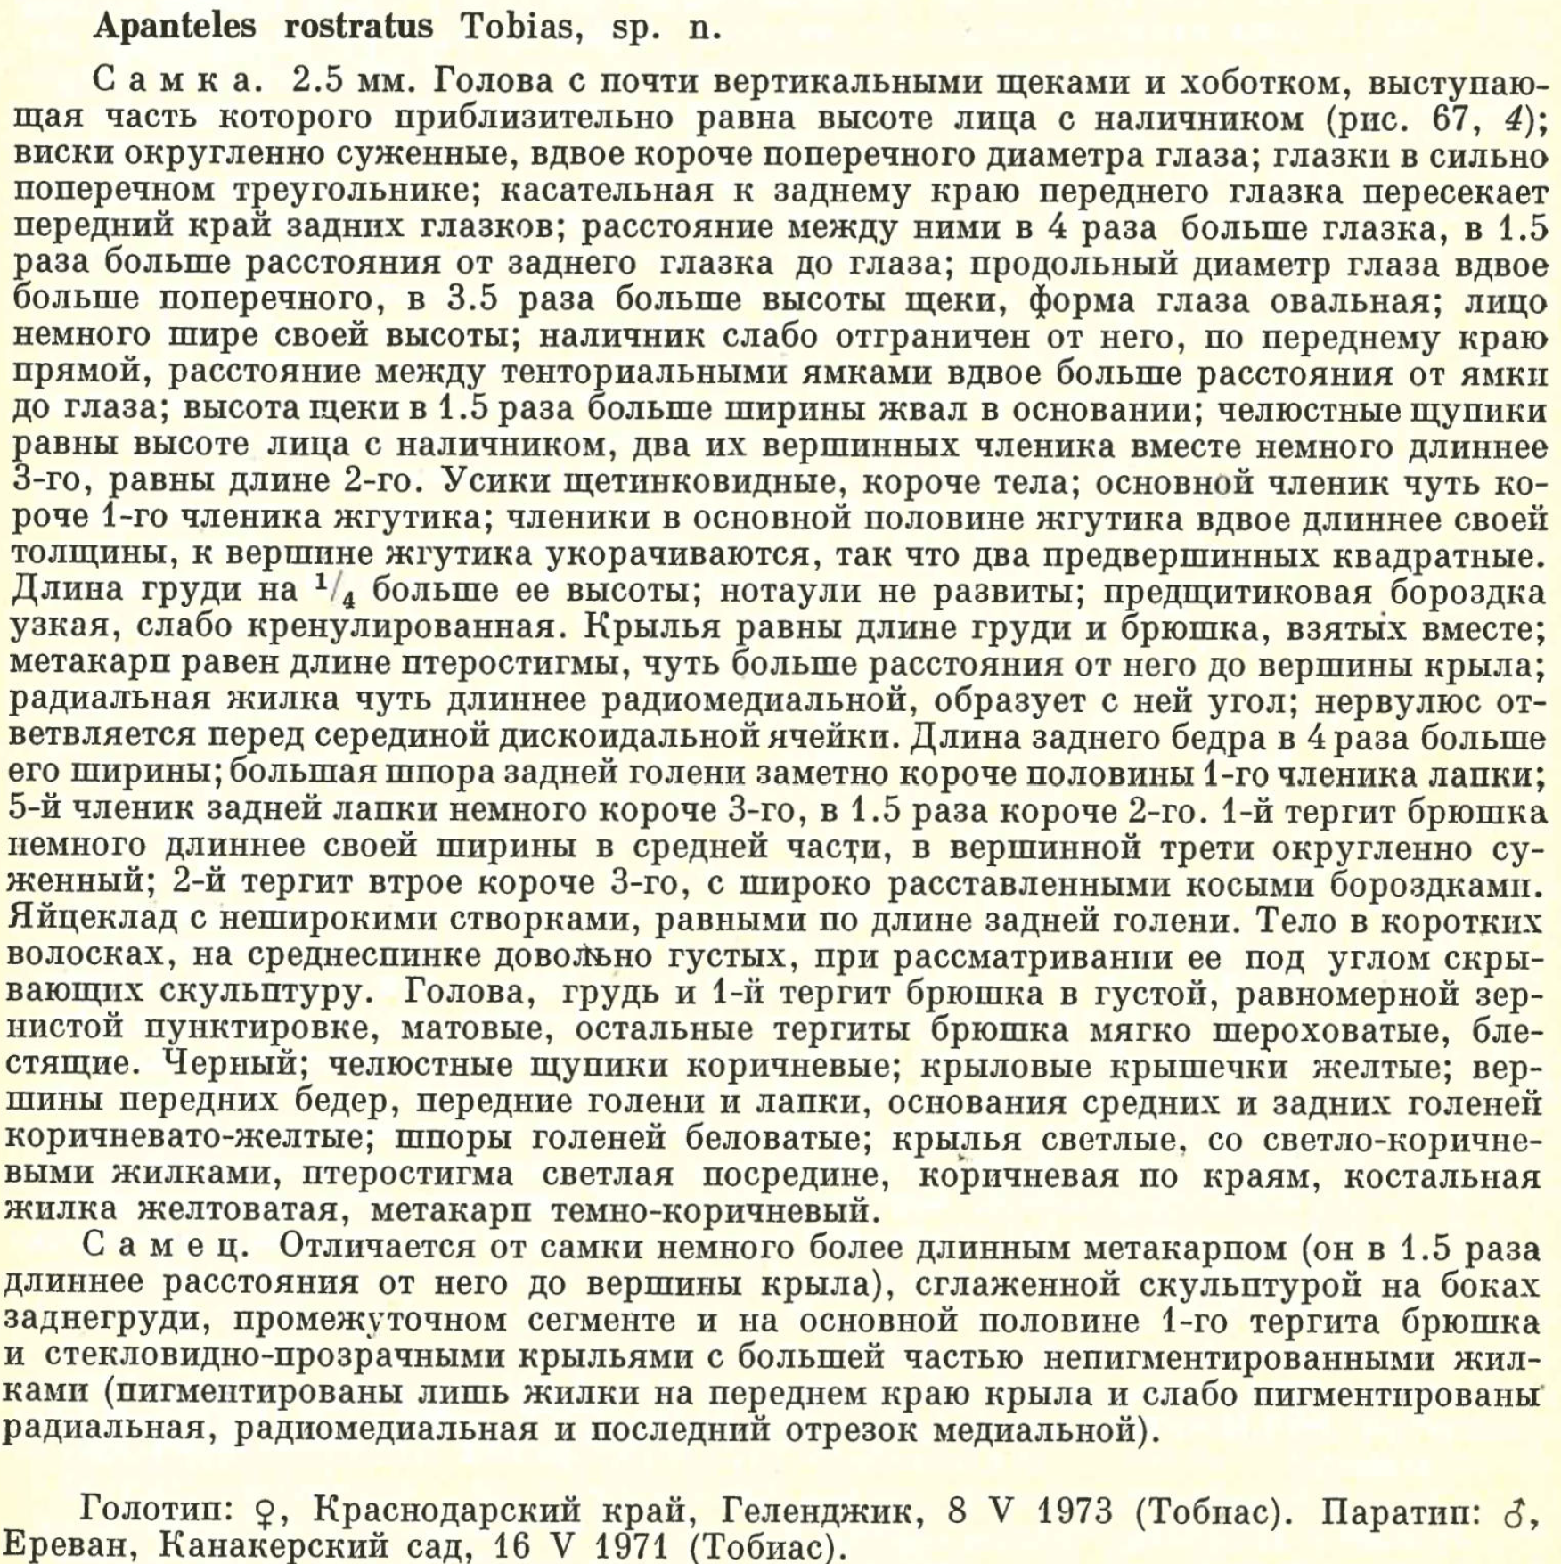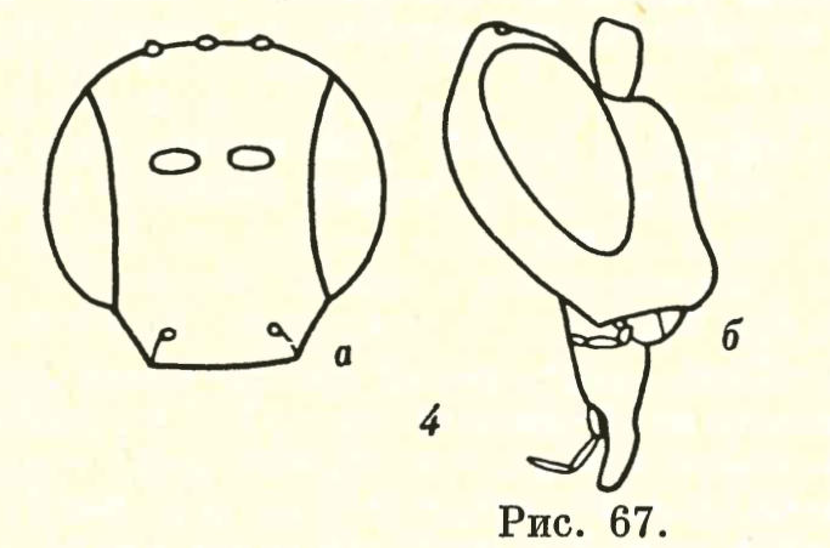
Figure 1. Illidops rostratus head in frontal (a) and lateral (b) view.

I. toreicus Kotenko, 2007
Description in: Kotenko A (2007) Microgastrinae. In: Lelej A (Ed.), Neuropteroidea, Mecoptera, Hymenoptera. Key to the insects of Russia Far East. Dalnauka, Vladivostok, 134–192.
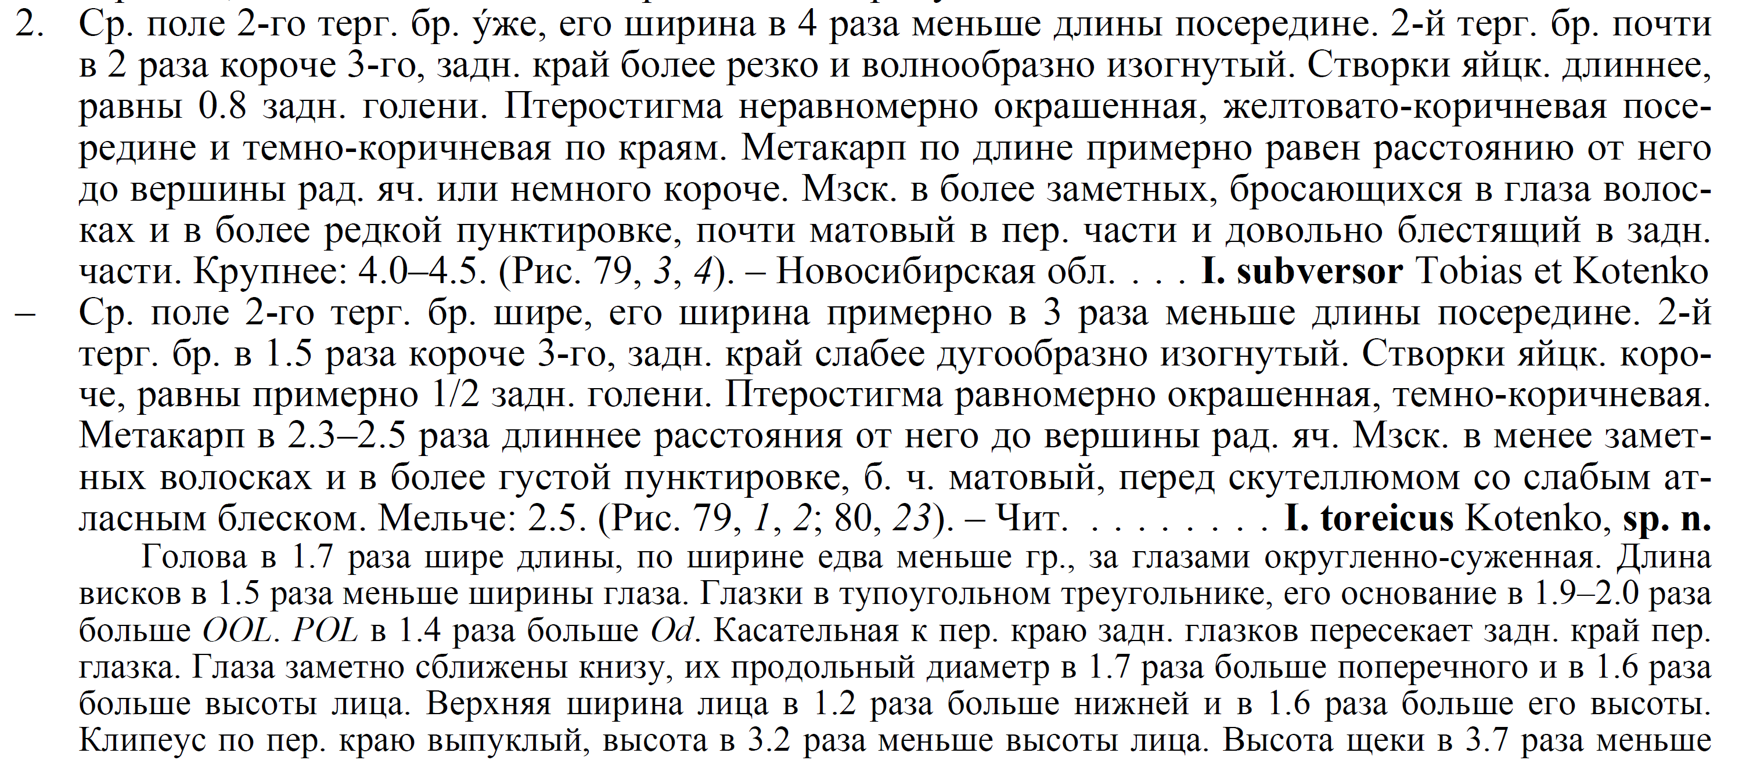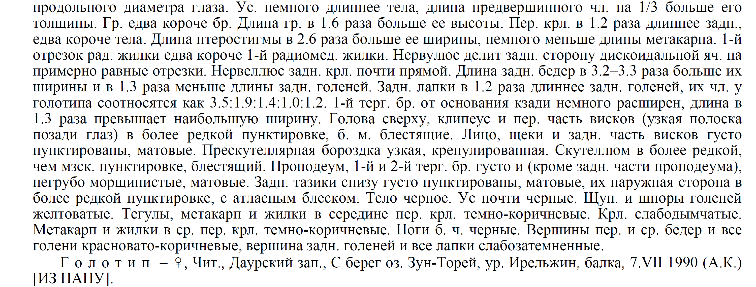

I. urgens Kotenko, 2004
Description in: Kotenko A (2004) Two new species of Illidops Mason (Hymenoptera: Braconidae, Microgastrinae) from Turkmenia, Kazakhstan and Russia. Trudy Russkogo Entomologicheskogo Obshchestva 75: 118–121.
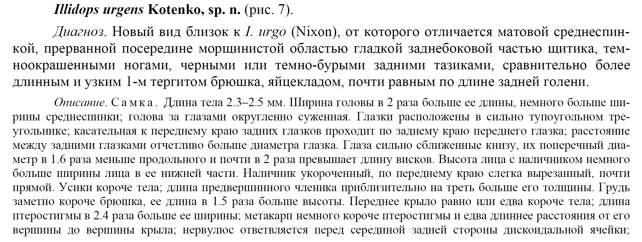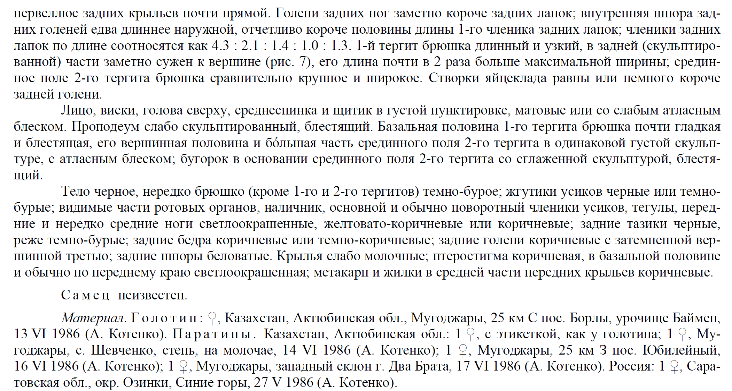

I. vitobiasi Kotenko, 2004
Description in: Kotenko A (2004) Two new species of Illidops Mason (Hymenoptera: Braconidae, Microgastrinae) from Turkmenia, Kazakhstan and Russia. Trudy Russkogo Entomologicheskogo Obshchestva 75: 118–121.
