https://doi.org/10.5852/ejt.2026.1039.3181.14137

Supplementary file
The family Xystodesmidae in the Korean Peninsula (Diplopoda: Polydesmida)
Gyeongmin Kim, Zoltán Korsós & Ui Wook Hwang

Table S1. Summary of respective COI and EF1-a sequence information obtained from this study.
No. | Species | Voucher No. | Accession No. (COI) | Accession No. (EF1-a)
1 | Xystodesmus bifurcus | HNHM diplo-04558 PC14 | PV446397 | PV544262
2 | Xystodesmus bifurcus | LEGOA030038 PC10 | PV446393 | PV544258
3 | Xystodesmus bifurcus | LEGOA030039 PC09 | PV446392 | PV544257
4 | Xystodesmus bifurcus | HNIBRIV8508 PC11 | PV446394 | PV544259
5 | Xystodesmus bifurcus | LEGOA030041 IJ02 24 | PV446395 | PV544260
6 | Xystodesmus bifurcus | LEGOA030042 IJ03 24 | PV446396 | PV544261
7 | Xystodesmus pallidus | HNHM diplo-04554 GJ01 23 | PV446385 | PV544250
8 | Xystodesmus pallidus | LEGOA030011 GJ04 23 | PV446388 | PV544253
9 | Xystodesmus pallidus | LEGOA030010 GH01 | PX471584 | PX516894
10 | Xystodesmus pallidus | LEGOA030014 GJ01 24 | PV446389 | PV544254
11 | Xystodesmus pallidus | LEGOA030015 GJ02 24 | PV446390 | PV544255
12 | Xystodesmus pallidus | LEGOA030016 GJ03 24 | PV446391 | PV544256
13 | Xystodesmus pallidus | LEGOA030021 DY07 | PV446405 | PV544270
14 | Xystodesmus pallidus | LEGOA030022 DY08 | PV446406 | PV544271
15 | Xystodesmus shirozui | HNIBRIV12832 GJ03 23 | PV446387 | PV544252
16 | Xystodesmus shirozui | LEGOA030023 GJ02 23 | PV446386 | PV544251
17 | Xystodesmus shirozui | LEGOA030025 HS11 23 | PV446398 | PV544263
18 | Xystodesmus shirozui | LEGOA030026 HS12 23 | PV446399 | PV544264
19 | Xystodesmus shirozui | LEGOA030027 DY05 | PV446403 | PV544268
20 | Xystodesmus shirozui | LEGOA030028 DY10 | PV446407 | PV544272
21 | Xystodesmus shirozui | LEGOA030029 DY01 | PV446400 | PV544265
22 | Xystodesmus shirozui | LEGOA030030 DY02 | PV446401 | PV544266
23 | Xystodesmus shirozui | LEGOA030031 DY03 | PV446402 | PV544267
24 | Xystodesmus shirozui | LEGOA030033 DY06 | PV446404 | PV544269
25 | Riukiaria koreana | LEGOA030077 YC05 | PV446411 | PV544276
26 | Riukiaria koreana | LEGOA030079 YC07 | PV446412 | PV544277
27 | Parafontaria koreana | LEGOA030101 DG01 | PV446408 | PV544273
28 | Parafontaria koreana | LEGOA030102 DG02 | PV446409 | PV544274
29 | Parafontaria koreana | LEGOA030110 AD03 | PV446410 | PV544275

Table S2. Summary of COI and EF1-a sequence information from NCBI GenBank for genetic distance analysis for respective three Xystodesmid genera, Xystodesmus, Riukiaria, and Parafontaria in this study.
No. | Species | Accession No. | Reference
COI
1 | Xystodesmus martensii | MN699817 | Means et al. (2021)
2 | Xystodesmus serrulatus | MN699818 | Means et al. (2021)
3 | Xystodesmus sp. PM-2015 | KR136041 | Marke and Morre (2015)
4 | Xystodesmus sp. YD-2016 | KU721886 | Dong et al. (2016)
5 | Riukiaria cornuta | MN699797 | Means et al. (2021)
6 | Riukiaria falcifera | MN699798 | Means et al. (2021)
7 | Riukiaria holstii | KR136017 | Marke and Morre (2015)
8 | Riukiaria maculata | MN699799 | Means et al. (2021)
9 | Riukiaria montana | MN699800 | Means et al. (2021)
10 | Riukiaria semicircularis | MN699801 | Means et al. (2021)
11 | Riukiaria uncata | MN699802 | Means et al. (2021)
12 | Parafontaria crenata | MN699783 | Means et al. (2021)
13 | Parafontaria erythrosoma | MN699784 | Means et al. (2021)
14 | Parafontaria ishiii | MN699785 | Means et al. (2021)
15 | Parafontaria longa | MN699786 | Means et al. (2021)
16 | Parafontaria tokaiensis | MN699788 | Means et al. (2021)
EF1-a
1 | Xystodesmus martensii | MN719712 | Means et al. (2021)
2 | Xystodesmus serrulatus | FJ775333 | Sota and Tanabe (2010)
3 | Xystodesmus sp. PM-2015 | KR136081 | Marke and Morre (2015)
4 | Riukiaria chelifera | FJ775332 | Sota and Tanabe (2010)
5 | Riukiaria chelifera | MN719713 | Means et al. (2021)
6 | Riukiaria cornuta | FJ775329 | Sota and Tanabe (2010)
7 | Riukiaria cornuta | MN719722 | Means et al. (2021)
8 | Riukiaria falcifera | MN719724 | Means et al. (2021)
9 | Riukiaria holstii | KR136062 | Marke and Morre (2015)
10 | Riukiaria maculata | MN719716 | Means et al. (2021)
11 | Riukiaria montana | MN719714 | Means et al. (2021)
12 | Riukaria mundyi | MN719717 | Means et al. (2021)
13 | Riukiaria puella | MN719715 | Means et al. (2021)
14 | Riukiaria semicircularis | FJ775330 | Sota and Tanabe (2010)
15 | Riukiaria semicircularis | MN719723 | Means et al. (2021)
16 | Parafontaria creanata | FJ775353 | Sota and Tanabe (2010)
No. | Species | Accession No. | Reference
17 | Parafontaria doenitzi | FJ775358 | Sota and Tanabe (2010)
18 | Parafontaria erythrosoma | FJ775354 | Sota and Tanabe (2010)
19 | Parafontaria falcifera | FJ775365 | Sota and Tanabe (2010)
20 | Parafontaria ishiii | FJ775356 | Sota and Tanabe (2010)
21 | Parafontaria laminata | FJ775350 | Sota and Tanabe (2010)
22 | Parafontaria longa | FJ775342 | Sota and Tanabe (2010)
23 | Parafontaria tokaiensis | FJ775360 | Sota and Tanabe (2010)
24 | Parafontaria tonominea | FJ775524 | Sota and Tanabe (2010)

Table S3. Summary of respective COI and EF1-a sequence information for Xystodesmid phylogeny from NCBI GenBank and outgroups in this study.
No. | Species | Accession No. (COI) | Accession No. (EF1-a) | Reference
1 | Xystodesmus sp. PM-2015 | KR136041 | KR136081 | Marek and Moore (2015)
2 | Riukiaria holstii | KR136017 | KR136062 | Marek and Moore (2015)
Outgroup
3 | Melaphe vestita | KR135996 | KR136046 | Marek and Moore (2015)

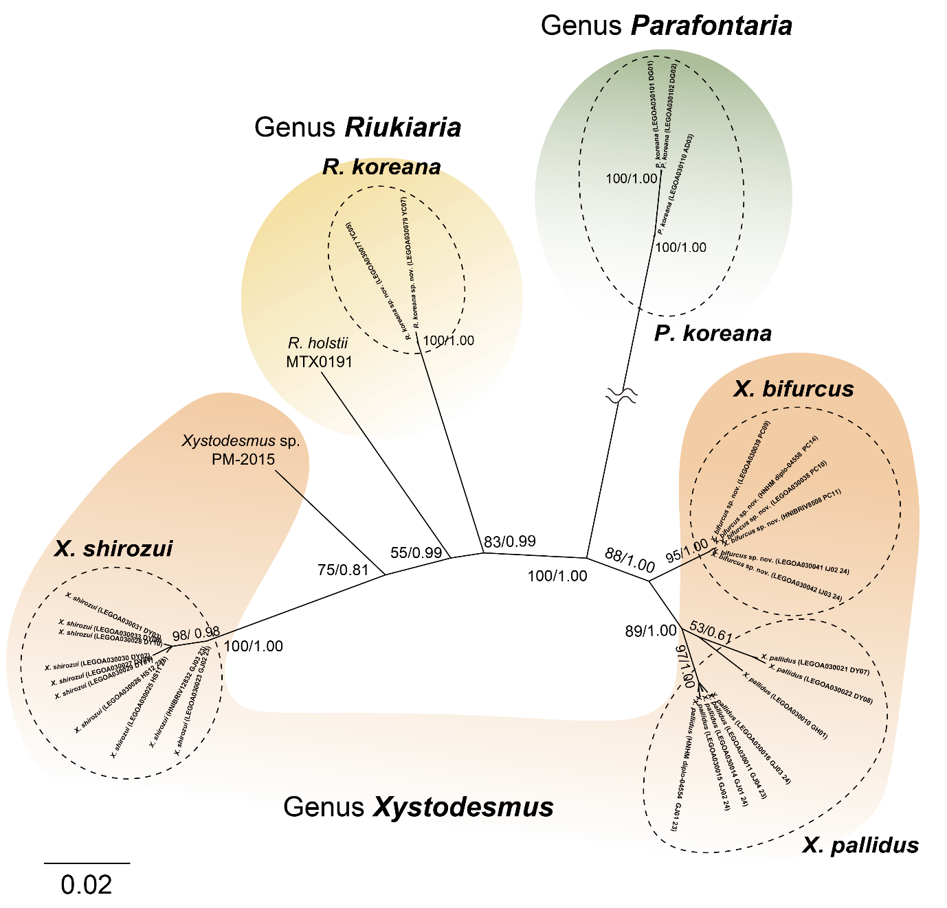
Fig. S1. An unrooted maximum likelihood phylogeny based on sequences that combine mitochondrial COI and nuclear EF1-a including three Xystodesmid genera. The phylogeny included six sequences of Xystodesmus bifurcus, eight of X. pallidus, nine of X. shirozui, two of Riukiaria koreana, and three of Parafontaria koreana obtained in this study, and two sequences of closely related species, Xystodesmus sp. PM-2015 and R. holstii which were retrieved from NCBI GenBank. The numbers on branches indicate bootstrap values (BP in ML phylogeny) and posterior probabilities (BPP in BI phylogeny) being separated by slash.

