Supplementary material

Study Areas
Belize: Located on the east side of the Coastal Highway approximately 16 km south by southeast of La Democracia village, Runaway Creek Nature Reserve (RCNR) is a 2,428.11-hectare private reserve in the Belize District, Belize, Central America. Vegetation is characterized as tropical evergreen seasonal broad-leaved lowland forest on the rolling karst hills, deciduous broad-leaved lowland riparian shrubland on the plains, and short-grass pine savanna (Meerman 2017). RNCR is within the Peccary Hills biodiversity area (Meerman 2007) and is considered a core protected area within the Maya Forest Corridor (Martinez et al. 2021).

Guatemala: Guatemala supports a diverse range of environmental conditions in a relatively small geographic area (Strinati, 1994). The country encompasses three distinct climate types: Equatorial Monsoon, Equatorial Savannah with dry winter, and Warm Temperate Climate with dry winter (Kottek et al., 2006; Peel et al., 2007) and has an average annual rainfall of 3,000 to 4,000 mm concentrated between May and October (Kottek et al., 2006; Peel et al., 2007). The country also features extensive limestone karstic landscapes that cover approximately one-third of its area and is divided into four primary geologic domains, predominantly located in the northern region: Huehuetenango, Alta Verapaz, Izabal, and Petén (Strinati, 1994). Specimens from this study were found in limestone caves located in two of these karstic regions, specifically Alta Verapaz and Petén which is within a geographic region known as the Northern Lowlands.

Habitat and management of Juxtlacampa gabrielleae sp. nov.
Specimens of Juxtlacampa gabrielleae sp. nov. (Fig. S1D) were observed in caves in both Guatemala (near Raxruhá and Flores) and Belize (Cayo District). All caves were used for tourism, although these activities impact cave resources to varying degrees depending on the intensity of human use. Three caves were used for adventure tourism (i.e., no built infrastructure). The most impacted cave was Actun Kan Cave, which contained stairs built in some passages. As most of the galleries in this cave were accessible to visitors, the soil in many areas has been compacted. Soil compaction degrades cave sediments (refs, just in case) and high human traffic increases the risk of trampling fauna (Watson, 1997; Pacheco et al., 2021). Since this cave was close to the city of Flores, tourism can be intensive, which could negatively impact both the J. grabielleae population and other cave-restricted fauna. In Raxruhá municipality, although there were several show caves, they did not receive as many visitors as Actun Kan cave. Furthermore, due to the large number of caves open to tourism, this may reduce visitation intensity as tourism was spread over numerous caves in the area. Additionally, the lack of built infrastructure for tourism (i.e., stairs and artificial lighting), likely benefits subterranean populations, save for heavily used and trampled pathways. Although eight caves were sampled in this area, J. gabrielleae sp. nov. was observed only in Cueva Blanca and Cueva del Rostro caves (Fig. S1B). However, given that the regional karst landscape is highly fractured (Lebedeva, 2015) and that cave-adapted taxa likely used the entire fractured karst network as movement corridors (Howarth, 1983), we suggest this species occurs elsewhere regionally.
Finally, this species also occurs in the Actun Tunichil Muknal (ATM), Belize (Fig. S1A, C). This cave can be characterized as a stream cave, whereas the other caves where the species occurs were dry and devoid of streams or perennial pools. ATM is located on a tributary of Roaring Creek and extends into a portion of the Tapir Mountain Forest Reserve, near Teakettle village (Moyes, 2001). One of the entrances contains an underground stream that exits from deep within the cave (Fig. S1A); however, there is also extensive terrestrial habitats. Additionally, there were several large chambers with extensive speleothems (e.g., Fig. S1C). Specimens of J. gabrielleae sp. nov. were found both in the larger upper chamber and in some of the smaller upper chambers along the main passage. Given the importance of this cave for tourism and that the Belize Institute of Archaeology strictly regulates visitor access, impacts are presently limited to a small portion of the cave—along an established and highly regulated route.

Figure S1. Habitat of Juxtlacampa gabrielleae Sendra & Ferreira sp. nov. (A) Stream entrance of the Actun Tunichil Muknal (ATM) cave, located in Cayo District, Belize; (B) Researchers surveying for invertebrates in Cueva del Rostro cave, Guatemala; (C) Inner chamber of ATM cave where Juxtlacampa gabrielleae specimens were collected; (D) In vivo specimen from Cueva del Rostro cave.

Habitat and management of Juxtlacampa hauseri
Gruta de Lanquín is a two-entrance limestone cave located in Lanquín Caves National Park, Lanquín municipality, Alta Verapaz, Guatemala. Surface disturbance, which has occurred in the surrounding areas directly in the vadose zone of the cave, includes road development and deforestation. The largest entrance consists of a spring, which represent the headwaters of the Lanquín River. One of the entrances (the one without a spring) was modified for tourism and included a stairway to improve accessibility. The cave is about 2,300 meters in length (Strinati, 1994) with approximately 500 meters of passage developed for tourism.
The tourist section consists of dilapidated infrastructure and defunct electric lighting and paved walkways. Given the challenges of navigating this cave without light infrastructure, tourism is now largely constrained to areas with established walkways. Even in these areas, a variety of invertebrates were observed, including crickets, whip scorpions, spiders, pill bugs, and millipedes. A substantial food resource for cave fauna is bat guano (produced by insectivorous species), which occurred in large concentrations in some areas.
Juxtlacampa hauseri was observed and collected from a chamber located at the end of the modified walkway, approximately 500 meters from the entrance. Based upon the relatively undisturbed condition of the area, it seemed humans infrequently access this section of the cave. Specimens were collected on flowstone floors within wet areas containing percolating water. During the three-day expedition, many tourists, both guided and unguided, were observed in the cave. Unguided visitants ventured off established pathways; thus, it is possible unregulated tourism may pose a threat to J. hauseri. We recommend forming a collaboration with local guides and emplacing a register within the cave to better gauge visitation to areas supporting this species; additionally, photo-monitoring stations should be established within areas known to support J. hauseri.

Habitat and management of Juxtlacampa xkiqi sp. nov.
Specimens were observed and collected on saturated mud floors approximately 20 m from the entrance within the main trunk passage of Crocodile Cave 1 (Fig. S2). Insectivorous and frugivorous bats roost sporadically throughout the upper reaches of the cave (i.e., twilight to transition zone) and were found roosting primarily within vug formations in the ceiling. Their guano likely provides a nutrient source for prey species.

This cave is typically flooded throughout most of the year. The July 2019 work was conducted amid an extensive drought that extended across Central America. During this time, only the deepest reaches of Crocodile Cave 1 were flooded. In February 2022, one of the authors (JJW) returned to Crocodile Cave 1 and noted that although the cave was flooded, exposed mud banks supported cave-adapted species including J. xkiqi. The upper reaches feature were also dry during in June 2023 and June 2024 (Wynne pers. ob.). Runaway Creek resource managers indicated the extent of flooding observed in February 2022 was typical and thus the availability of mud banks above waterline will likely remain available for this cave-adapted species during the rainy season as well. However, in the event of extensive flooding, we suggest this species retreats into the mesocaverns (sensu Howarth, 1983). Conversely, during a drought period, J. xkiqi may exploit the infrequently available habitat throughout the floor of the main trunk passageway.
Runaway Creek Nature Reserve is a private reserve and is currently only being used only for educational and research purposes, while Crocodile Cave 1 is only used for research purposes. Subsequently, human impacts are expected to be limited to intermittent access by researchers.
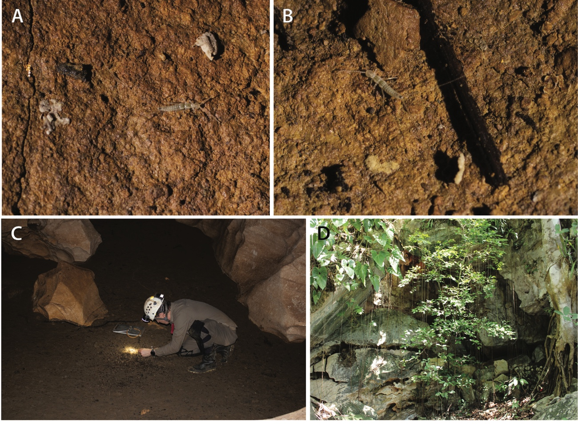
Figure S2. (A, B) In vivo examples of Juxtlacampa xkiqi sp. nov.; (C) Representation of mud floor habitat with Wynne collecting arthropods within Crocodile Cave 1; (D) Entrance to Crocodile Cave 1.

Habitat and management of Juxtlacampa juxtlahuacensis
Grutas Juxtlahuaca is located within a within a natural reserve, 52 km southeast of Chilpancingo de los Bravo, Guerrero, México. This is a two-entrance cave. The main entrance (Fig. S3A) is located at 938 m elevation within tropical deciduous scrub forest. The main cave passage (Fig. S3B) is approximately 1,900 m long, with several lateral branches (Montaño-Moreno & Francke, 2009). Specimens of J. juxtlahuacensis were found primarily in the deeper and wetter reaches of the cave and usually associated to allochthonous deposits such as bat guano. However, it is worth noting that individuals were observed only near small guano deposits, and not amid the larger guano piles within the cave. Specimens were also found on speleothems or on naturally compacted sediments (Fig. S3D). Potential predators include spiders, whip scorpions, and schizomids. This cave contained archaeological materials (Fig. S3C) including cave paintings related to the Olmec iconography, which are tourist attractions. Subsequently, the cave is a tourist destination, which results in the associated impacts to the cave, including the trampling of sediments by visitants. Therefore, until this species can be identified elsewhere, this population may be at risk due to intensive human activities.
Figure S3. Juxtlacampa juxtlahuacensis Wygodzinsky, 1944, Grutas de Juxtlahuaca Quechultnango, Guerrero, México. (A) Main entrance of Juxtlahuaca cave; (B) Large trunk passage; (C) Calcite-covered human skull on cave floor; D) In vivo specimen of J. juxtlahuacensis.

Habitat and management of Juxtlacampa carlosjuarezi
Cueva San Juan Tlacotenco consists of a large lava tube system within a protected area known as the biocorridor of the Chichinautzin volcanic field. It is located between the boundary of the central and western parts of the Transmexican Volcanic Belt in Morelos State near the San Juan de Tlacotenco village, Morelos, México. This small village has a population of ~2,300 people. Since 1978, the population has grown and now some of the cave entrances occur on private property. However, large sections of the lava tube remain well-preserved.
Cueva San Juan Tlacotenco is found near the México-Cuautla railroad line, which has been removed. The lava tube system has several entrances (Fig. S4A) (Hoffmann et al., 1986). The Chimalacatepec Master Tube is characterized by over 3.2 km of galleries and composed of three volcanic caves: Arbol Cave, Potrero Cave and Chimalacatepec lava tube.
The Chimalacatepec system is characterized by cylindrical or ellipsoidal sections (Fig. S4B). Several primary structures formed of lava and small secondary structures (Fig. S4C), such as small opaline stalactites and flowstones occur throughout this system. This system is characterized by large fractures and extensive breakdown—a result of the last cooling stage of the Chimalacatepec lava tube system, which can be observed in various parts of the cave.
Furthermore, this lava tube system contains well-preserved material culture in some entrances including ceramics, ollas, and small bottles. The biology of the cave is notable including a variety of invertebrate fauna found throughout the system.
This lava tube may be at risk due to human development. Sections of this tube are now below several houses in the expanding town of San Juan Tlacotenco. These lava tube sections may be affected by sewage, garbage, and improper disposal of livestock, as well as increased human use and accelerated collapses. Additionally, this lava tube system is a field trip destination for several area universities; students are brought to this system to study various facets of speleology—so, there may also be research-related impacts.

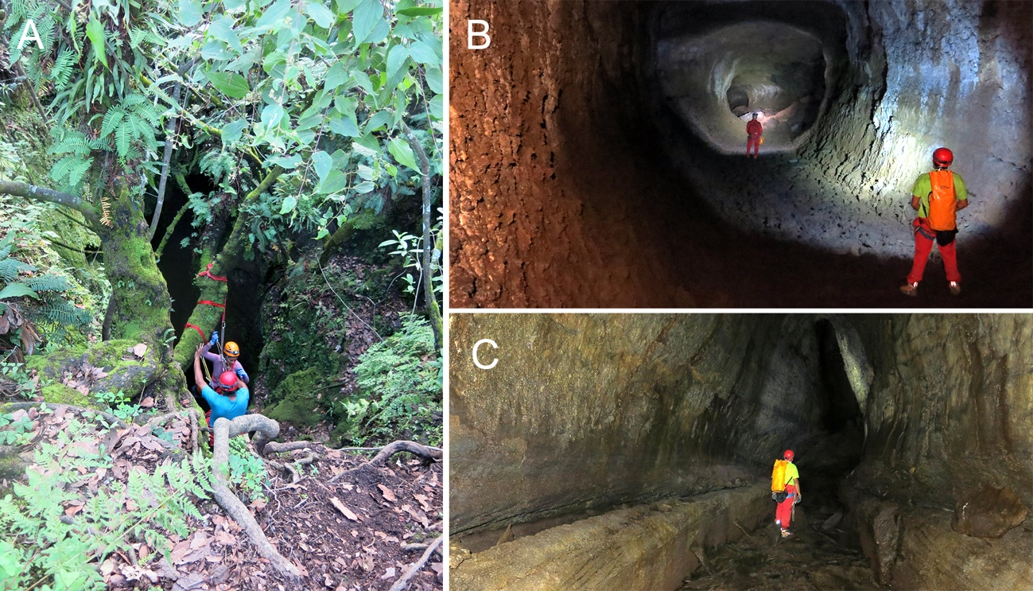
Figure S4. Lava tube system in San Juan Tlacotenco, Morelos, México. (A) View of the Itzaxiatla entrance of Chimalacatepec lava tube system; (B) Cylindrical and ellipsoidal morphologies of a lava tube; (C) Primary structures formed of lava with detail of large and continuous lava balconies.

References
Hoffmann A., Palacios-Vargas J-G. Morales J.B. 1986. Manual de Bioespeleologia (con nuevas aportaciones de Morelos y Guerrero, México). Direc. Gral. Publ. UNAM, México. 274 pp.
Howarth F.G. 1983. Ecology of Cave Arthropods. Annual Review of Entomology 28: 365–389.
Kottek M., Grieser J., Beck C., Rudolf B., Rubel F., 2006. World map of the Köppen-Geiger climate classification updated. Meteorologische Zeitschrift 15: 259–263. https://doi.org/10.1127/0941-2948/2006/0130
Lebedeva E.V. 2015. Karst terrain of the Yucatan Peninsula and its mountain frame (Mexico, Guatemala, Belize). Geomorfologiya 4: 60–79.
Martinez W.E., Reyna-Hurtado R.A., Naranjo E.J., Thornton D., Cal, R.N. Figueroa, O.A. 2021. Occupancy rate and observations of Baird’s tapir (Tapirella bairdii) near waterholes in the Maya Forest corridor, Belize. Therya 12: 37–43.
Meerman J.C. 1999. Rapid ecological assessment Runaway Creek, Belize. Belize Environmental Consultancies, Ltd., Belize City, Belize. Pp. 40.
Montaño Moreno H., Francke O.F. 2009. A new species of Agastoschizomus (Schizomida: Protoschizomidae) from Guerrero, Mexico [Nueva especie de Agastoschizomus (Schizomida: Protoschizomidae) de Guerrero, México]. Texas Memorial Museum Speleological Monographs, 7. Studies on the cave and endogean fauna of North America, V. Pp. 33–36.
Moyes H. 2001. The cave as a cosmogram: The use of GIS in an intrasite spatial analysis of the main chamber of Actun Tunichil Muknal, a Maya ceremonial cave in Western Belize. Florida Atlantic University.
Pacheco G.S.M., de Oliveira M.P.A., Cano E., Souza Silva M., Ferreira R.L. 2021. Tourism effects on the subterranean fauna in a Central American cave. Insect Conservation and Diversity 14: 294–306.
Peel, M.C., Finlayson, B.L., McMahon, T.A., 2007. Updated world map of the Köppen–Geiger climate classification. Hydrology and Earth System Sciences, 11, 1633–1644. https://doi.org/10.5194/hess-11-1633-2007
Strinati, P. 1994. Guatemala. In: Juberthie C., Decu V. (Eds.), Encyclopaedia Biospeologica. Société de Biospéologie, p. 437–442.
Watson J. 1997. Guidelines for cave and karst protection. International Union for the Conservation of Nature, Cambridge, UK, pp. 53.

