Supplementary Figures of “Revision of the genus Velarifictorus Randell, 1964 from China (Orthoptera: Ensifera: Grylloidea: Gryllidae: Gryllinae: Gryllini)”

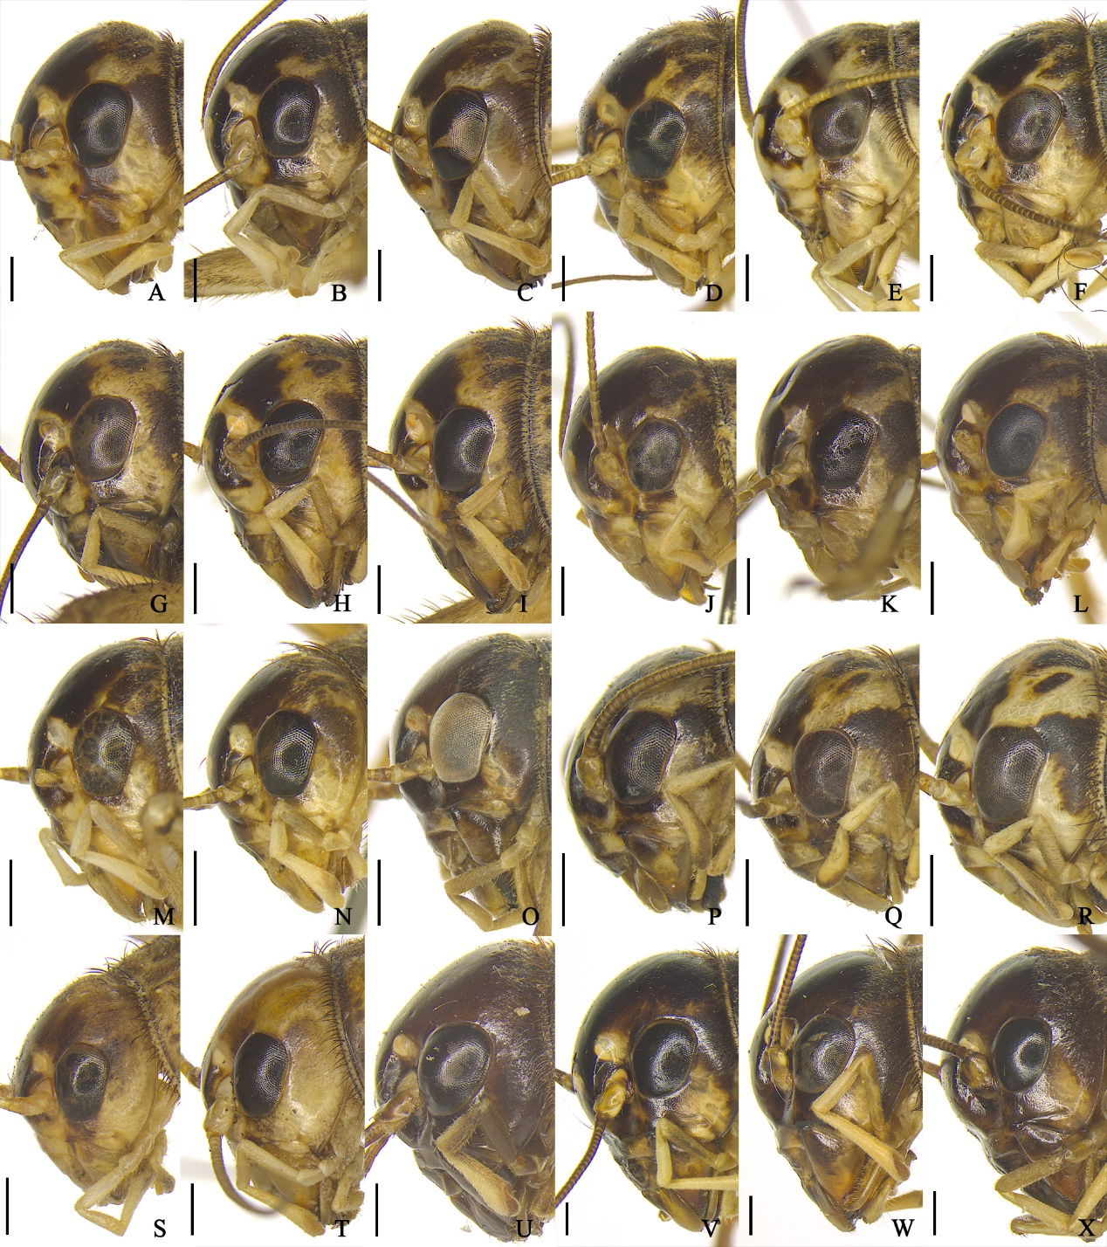
Fig. S1 Heads of female Velarifictorus Randell, 1964 in lateral views. A–C. V. (V.) micado (Saussure, 1877). D–F. V. (V.) flavifrons Chopard, 1966. G–I. V. (V.) aspersus (Walker, 1869). J–L. V. (V.) ornatus (Shiraki, 1911). M–N. V. (V.) agitatus Ma, 2019. O. V. (V.) bannaensis Zhang, Liu & Shi, 2017. P–R. V. (V.) dianxiensis He, 2018. S–T. V. (V.) beybienkoi Gorochov, 1985. U. V. (V.) liuxianwei Di & He, 2025. V–X. V. (V.) brunneri (Chopard, 1969). A. ECNU DM063 B. ECNU DM065. C. ECNU 884-DM498. D. ECNU DM074. E. ECNU DM075. F. ECNU 534-DM182. G. ECNU 2245-DM040. H. ECNU 2237-DM066. I. ECNU 2236-DM095. J. ECNU DM287. K. ECNU DM288. L. ECNU DM289. M. ECNU 1536-DM114. N. ECNU 490-DM113. O. ECNU DM508. P. ECNU 1044-DM045. Q. ECNU DM046. R. ECNU DM047. S. ECNU 4509-DM118. T. ECNU 2091-DM119. U. ECNU 1429-DM027. V. ECNU 1432-DM032. W. ECNU 2114-DM022. X. ECNU 2112-DM030. Scale bars = 1 mm.

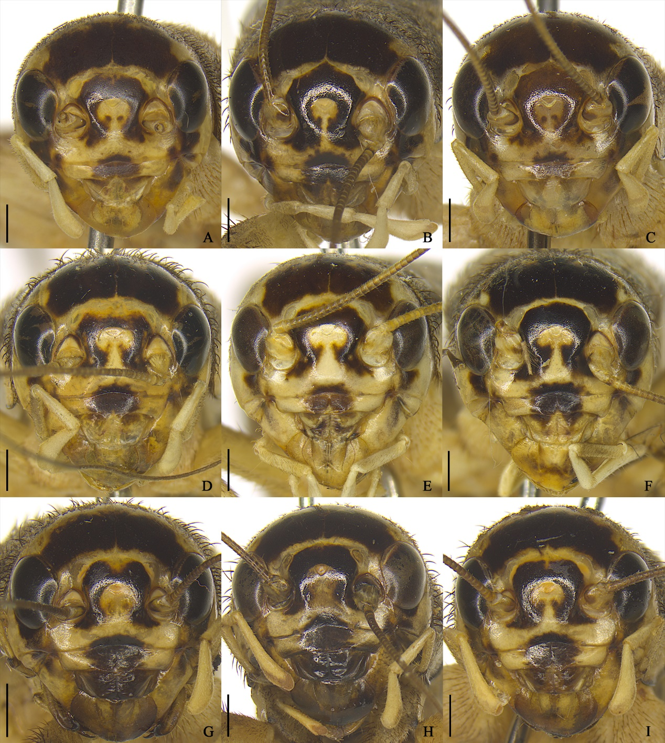
Fig. S2 Heads of female Velarifictorus Randell, 1964 in frontal views. A–C. V. (V.) micado (Saussure, 1877). D–F. V. (V.) flavifrons Chopard, 1966. G–I. V. (V.) aspersus (Walker, 1869). A. ECNU DM063. B. ECNU DM065. C. ECNU 884-DM498. D. ECNU DM074. E. ECNU DM075. F. ECNU 534-DM182. G. ECNU 2245-DM040. H. ECNU 2237-DM066. I. ECNU 2236-DM095. Scale bars = 1 mm.
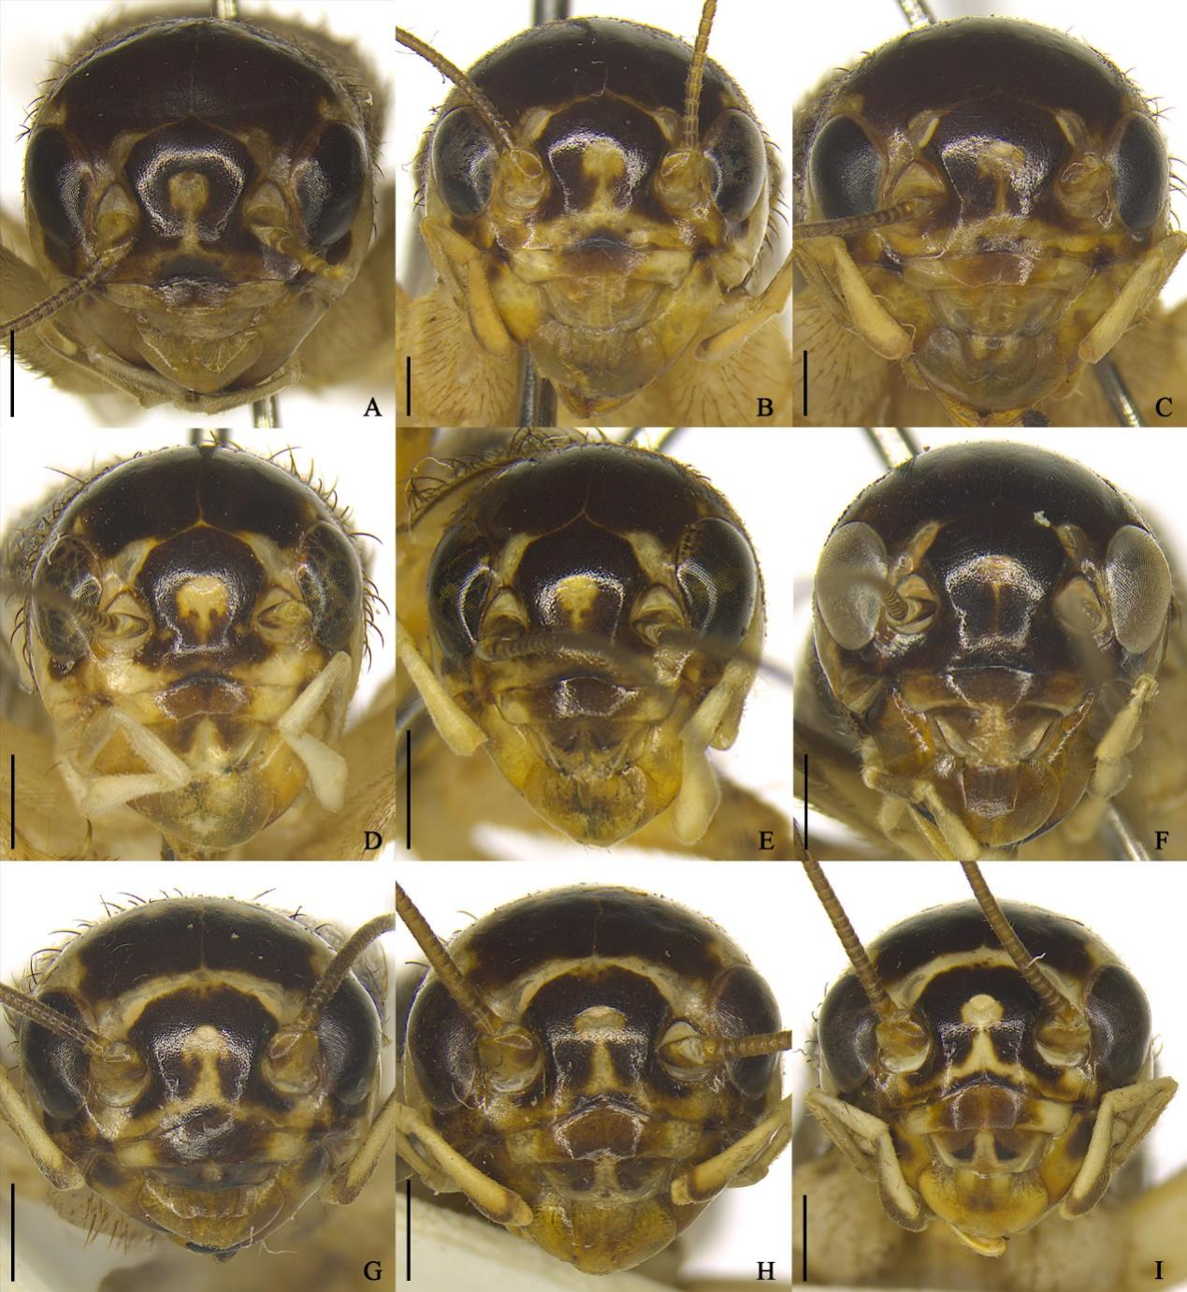
Fig. S3 Heads of female Velarifictorus Randell, 1964 in frontal views. A–C. V. (V.) ornatus (Shiraki, 1911). D–E. V. (V.) agitatus Ma, 2019. F. V. (V.) bannaensis Zhang, Liu & Shi, 2017. G–I. V. (V.) dianxiensis He, 2018. A. ECNU DM287. B. ECNU DM288. C. ECNU DM289. D. ECNU 1536-DM114. E. ECNU 490-DM113. F. ECNU DM508. G. ECNU 1044-DM045. H. ECNU DM046. I. ECNU DM047. Scale bars = 1 mm.
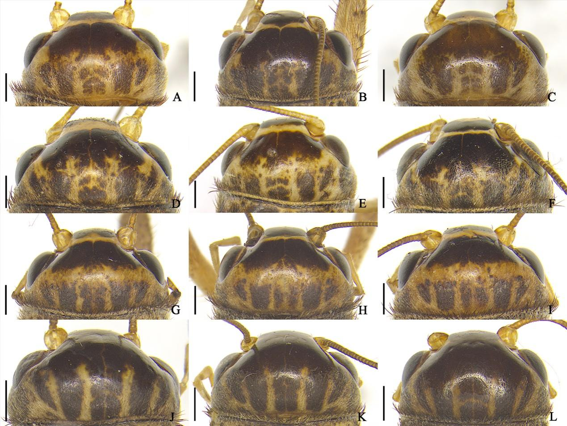
Fig. S4 Heads of female Velarifictorus Randell, 1964 in dorsal views. A–C. V. (V.) micado (Saussure, 1877). D–F. V. (V.) flavifrons Chopard, 1966. G–I. V. (V.) aspersus (Walker, 1869). J–L. V. (V.) ornatus (Shiraki, 1911). A. ECNU DM063. B. ECNU DM065. C. ECNU 884-DM498. D. ECNU DM074. E. ECNU DM075. F. ECNU 534-DM182. G. ECNU 2245-DM040. H. ECNU 2237-DM066. I. ECNU 2236-DM095. J. ECNU DM287. K. ECNU DM288. L. ECNU DM289. Scale bars = 1 mm.
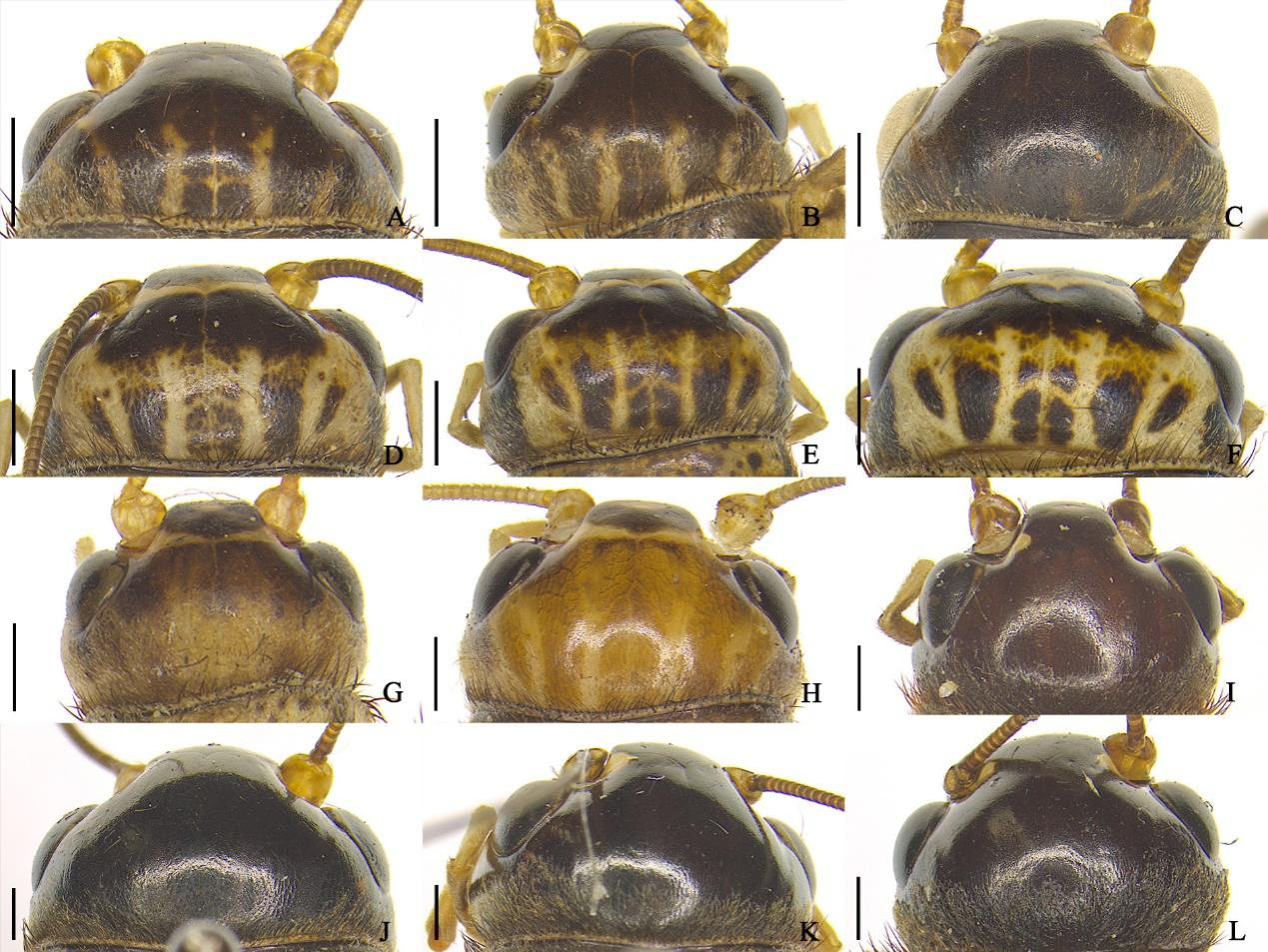
Fig. S5 Heads of female Velarifictorus Randell, 1964 in dorsal views. A–B. V. (V.) agitatus Ma, 2019. C. V. (V.) bannaensis Zhang, Liu & Shi, 2017. D–F. V. (V.) dianxiensis He, 2018. G–H. V. (V.) beybienkoi Gorochov, 1985. I. V. (V.) liuxianwei Di & He, 2025. J–L. V. (V.) brunneri (Chopard, 1969). A. ECNU 1536-DM114. B. ECNU 490-DM113. C. ECNU DM508. D. ECNU 1044-DM045. E. ECNU DM046. F. ECNU DM047. G. ECNU 4509-DM118. H. ECNU 2091-DM119. I. ECNU 1429-DM027. J. ECNU 1432-DM032. K. ECNU 2114-DM022. L. ECNU 2112-DM030. Scale bars = 1 mm.

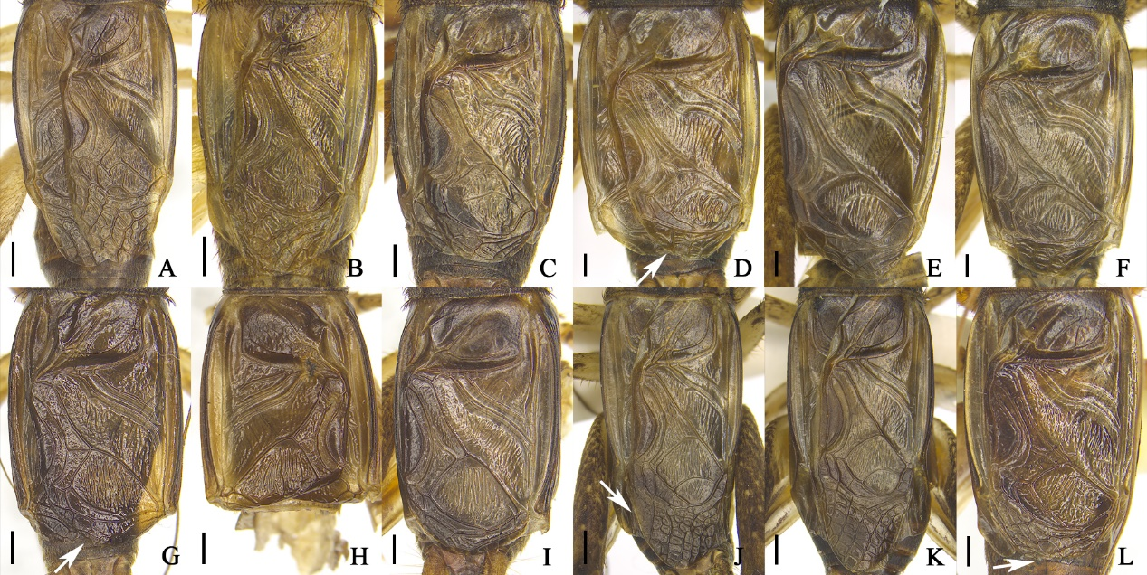
Fig. S6 Tegmina of male Velarifictorus Randell, 1964 in dorsal views. A–B. V. (V.) beybienkoi Gorochov, 1985. C. V. (V.) yinhaisheng Di & He, 2024. D–F. V. (V.) brunneri (Chopard, 1969). G–H. V. (V.) zhengi Zheng & Ma, 2022. I. V. (V.) triangularis Ingrisch, 1998. J–K. V. (V.) bannaensis Zhang, Liu & Shi, 2017. L. V. (V.) liuxianwei Di & He, 2025. A. ECNU 2092-DM117. B. ECNU DM504. C. ECNU 4514-DM009. D. ECNU DM002. E. ECNU 2123-DM013. F. ECNU DM014. G. ECNU 4250-DM004. H. ECNU 2022-DM035. I. ECNU 4515-DM005. J. ECNU DM506. K. ECNU DM507. L. ECNU 1212-DM509. White arrows indicate: D, G, L. apical field rather narrow; J. apical field rather prolonged. Scale bars = 1 mm.

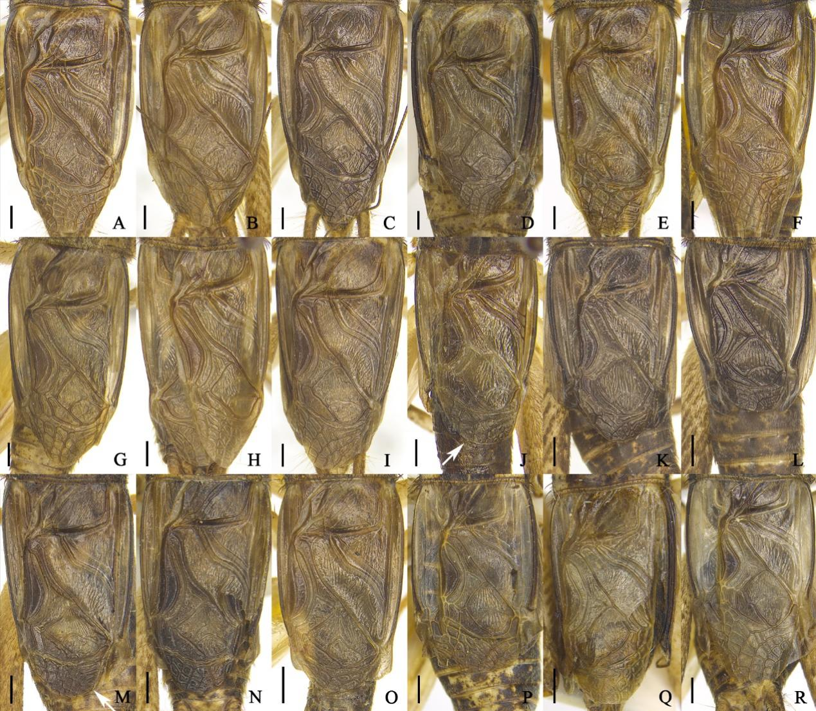
Fig. S7 Tegmina of male Velarifictorus Randell, 1964 in dorsal views. A–C. V. (V.) micado (Saussure, 1877). D–F. V. (V.) flavifrons Chopard, 1966. G–I. V. (V.) aspersus (Walker, 1869). J–L. V. (V.) ornatus (Shiraki, 1911). M–O. V. (V.) agitatus Ma, 2019. P–R. V. (V.) dianxiensis He, 2018. A. ECNU 1011-DM055. B. ECNU 749-DM062. C. ECNU 4501-DM061. D. ECNU DM071. E. ECNU 405-DM052. F. ECNU 378-DM169. G. ECNU 691-DM036. H. ECNU 261-DM037. I. ECNU 2238-DM038. J. ECNU 4784-DM067. K. ECNU 3943-DM051. L. ECNU 4785-DM068. M. ECNU 1482-DM048. N. ECNU 1387-DM049. O. ECNU DM112. P. ECNU 1045-DM043. Q. ECNU DM044. R. ECNU DM111. White arrows indicate: apical field rather narrow. Scale bars = 1 mm.

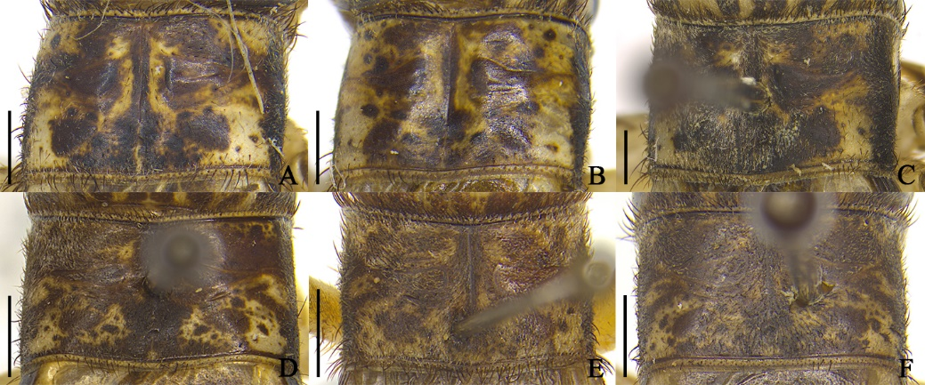
Fig. S8 Pronota of male Velarifictorus Randell, 1964 in dorsal views. A–C. V. (V.) dianxiensis He, 2018. D–F. V. (V.) micado (Saussure, 1877). A. ECNU 1045-DM043. B. ECNU DM044. C. ECNU DM111. D. ECNU 1011-DM055. E. ECNU 749-DM062. F. ECNU 4501-DM061. Scale bars = 1 mm.

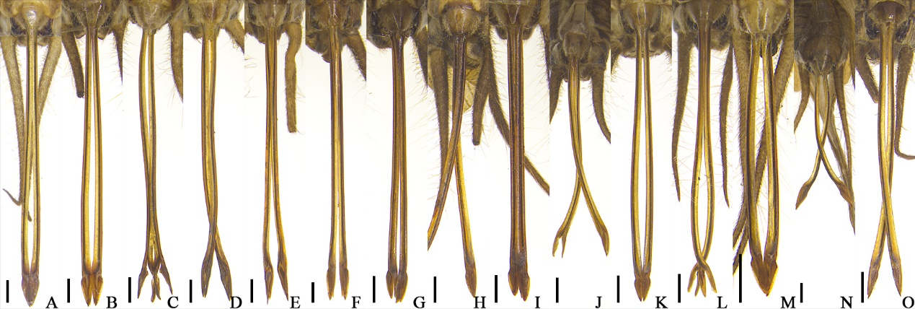
Fig. S9 Ovipositors of female Velarifictorus Randell, 1964 in ventral views. A–C. V. (V.) micado (Saussure, 1877). D–F. V. (V.) flavifrons Chopard, 1966. G–I. V. (V.) aspersus (Walker, 1869). J–L. V. (V.) ornatus (Shiraki, 1911). M–N. V. (V.) agitatus Ma, 2019. O. V. (V.) bannaensis Zhang, Liu & Shi, 2017. A. ECNU DM063. B. ECNU DM065. C. ECNU 884-DM498. D. ECNU DM074. E. ECNU DM075. F. ECNU 534-DM182. G. ECNU 2245-DM040. H. ECNU 2237-DM066. I. ECNU 2236-DM095. J. ECNU DM287. K. ECNU DM288. L. ECNU DM289. M. ECNU 1536-DM114. N. ECNU 490-DM113. O. ECNU DM508. Scale bars = 1 mm.

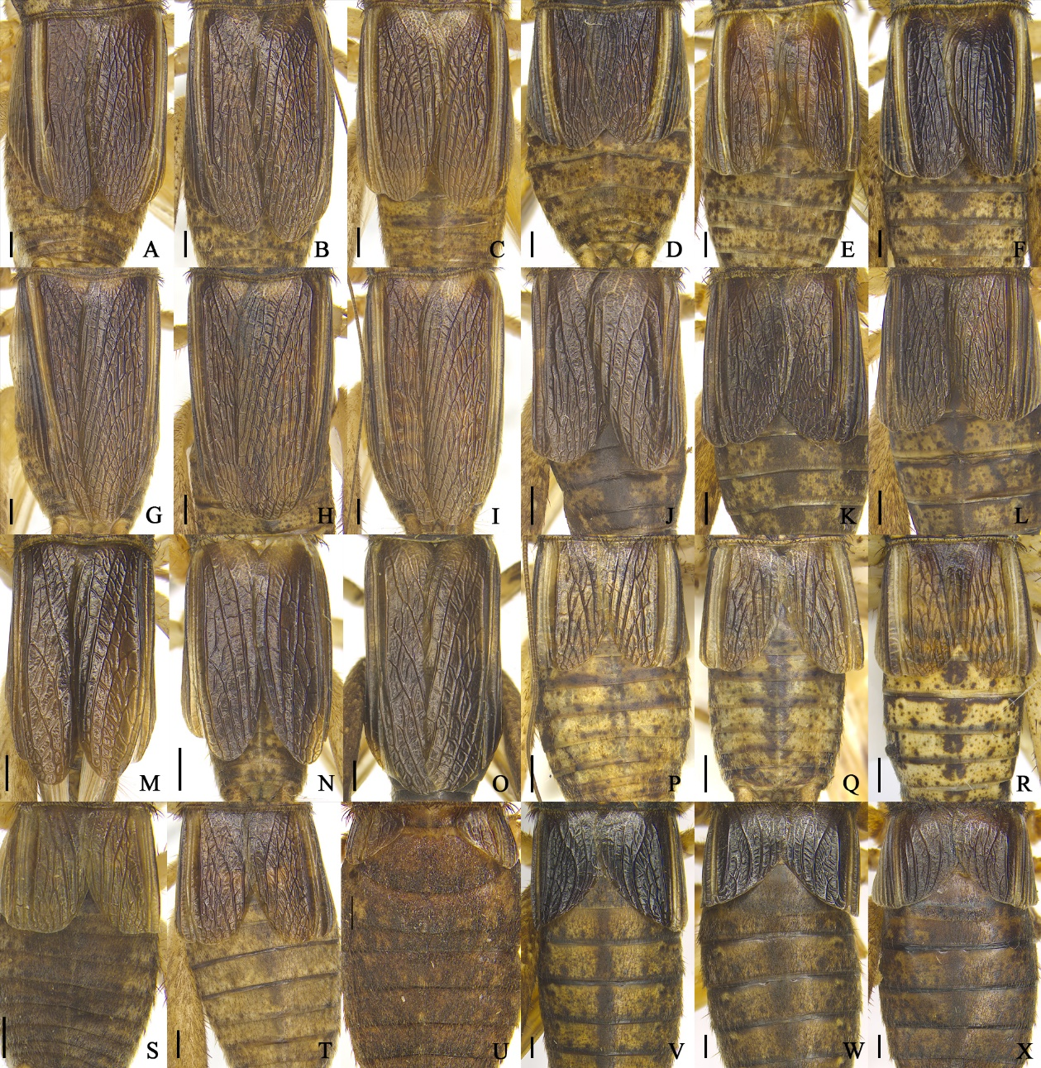
Fig. S10 Tegmina of female Velarifictorus Randell, 1964 in dorsal views. A–C. V. (V.) micado (Saussure, 1877). D–F. V. (V.) flavifrons Chopard, 1966. G–I. V. (V.) aspersus (Walker, 1869). J–L. V. (V.) ornatus (Shiraki, 1911). M–N. V. (V.) agitatus Ma, 2019. O. V. (V.) bannaensis Zhang, Liu & Shi, 2017. P–R. V. (V.) dianxiensis He, 2018. S–T. V. (V.) beybienkoi Gorochov, 1985. U. V. (V.) liuxianwei Di & He, 2025. V–X. V. (V.) brunneri (Chopard, 1969). A. ECNU DM063. B. ECNU DM065. C. ECNU 884-DM498. D. ECNU DM074. E. ECNU DM075. F. ECNU 534-DM182. G. ECNU 2245-DM040. H. ECNU 2237-DM066. I. ECNU 2236-DM095. J. ECNU DM287. K. ECNU DM288. L. ECNU DM289. M. ECNU 1536-DM114. N. ECNU 490-DM113. O. ECNU DM508. P. ECNU 1044-DM045. Q. ECNU DM046. R. ECNU DM047. S. ECNU 4509-DM118. T. ECNU 2091-DM119. U. ECNU 1429-DM027. V. ECNU 1432-DM032. W. ECNU 2114-DM022. X. ECNU 2112-DM030. Scale bars = 1 mm.

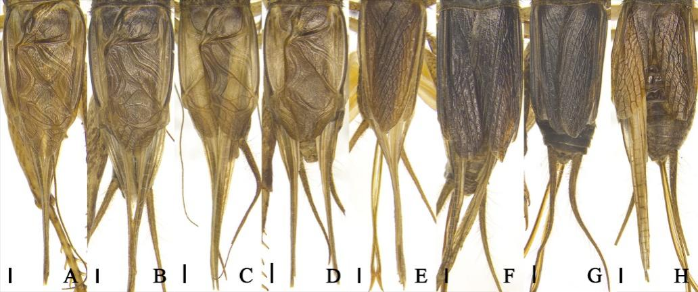
Fig. S11 Tegmina of macropterous Velarifictorus Randell, 1964 in dorsal views. A–D. male; E–H. female. A, E. V. (V.) micado (Saussure, 1877). B, F. V. (V.) flavifrons Chopard, 1966. C. V. (V.) aspersus (Walker, 1869). D, G. V. (V.) ornatus (Shiraki, 1911). H. V. (V.) beybienkoi Gorochov, 1985. Scale bars = 1 mm.

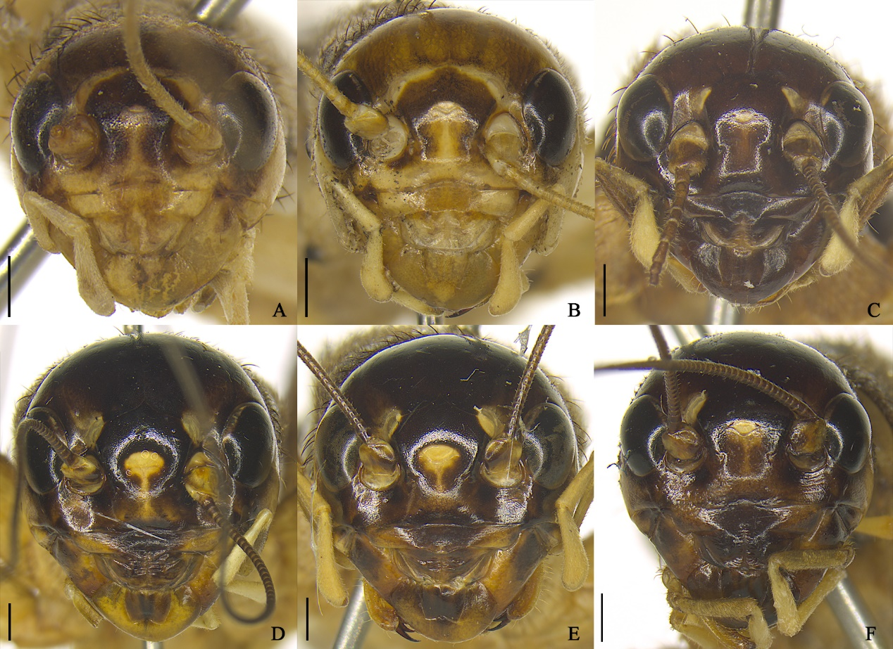
Fig. S12 Heads of female Velarifictorus Randell, 1964 in frontal views. A–B. V. (V.) beybienkoi Gorochov, 1985. C. V. (V.) liuxianwei Di & He, 2025. D–F. V. (V.) brunneri (Chopard, 1969). A. ECNU 4509-DM118. B. ECNU 2091-DM119. C. ECNU 1429-DM027. D. ECNU 1432-DM032. E. ECNU 2114-DM022. F. ECNU 2112-DM030. Scale bars = 1 mm.

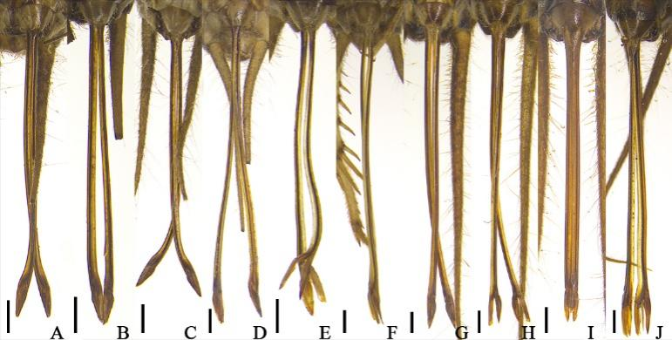
Fig. S13 Ovipositors of female Velarifictorus Randell, 1964 in ventral views. A–C. V. (V.) dianxiensis He, 2018. D–F. V. (V.) beybienkoi Gorochov, 1985. G–I. V. (V.) brunneri (Chopard, 1969). J. V. (V.) liuxianwei Di & He, 2025. A. ECNU 1044-DM045. B. ECNU DM046. C. ECNU DM047. D. ECNU 4509-DM118. E. ECNU 2091-DM119. F. ECNU 288-DM120. G. ECNU 1432-DM032. H. ECNU 2114-DM022. I. ECNU 2112-DM030. J. ECNU 1429-DM027. Scale bars = 1 mm.

