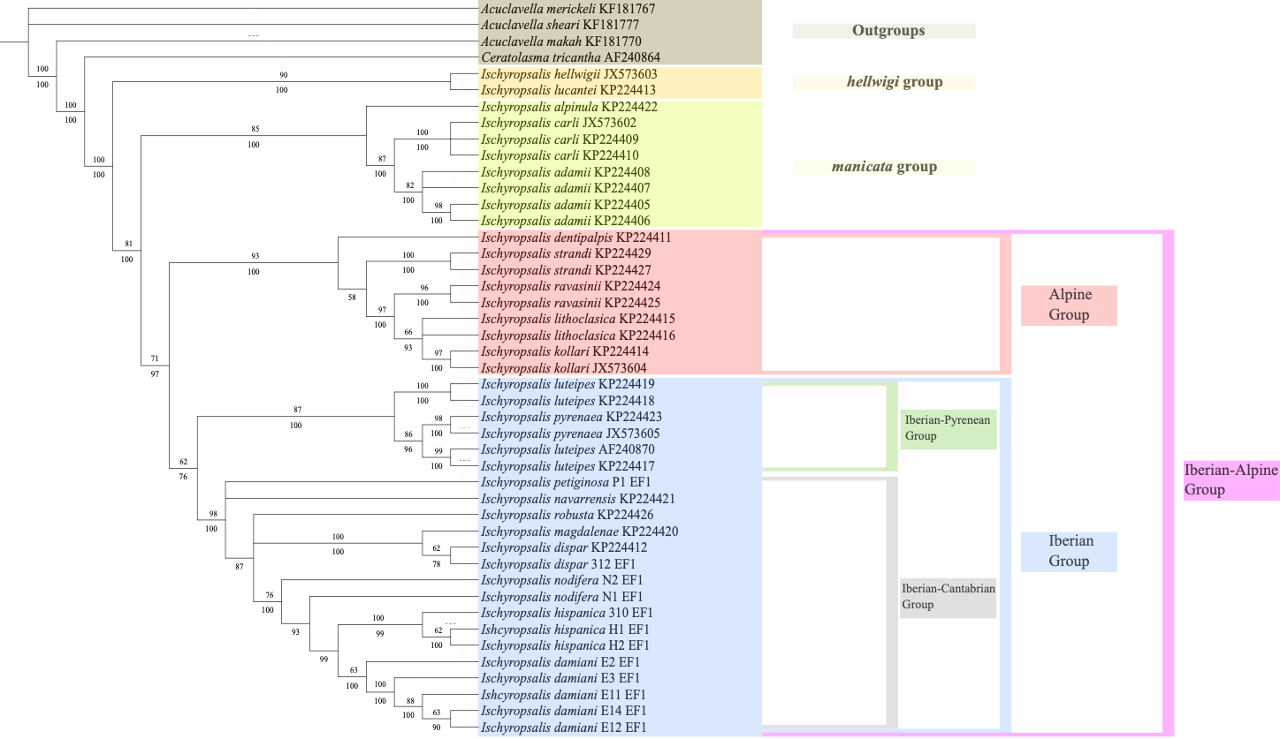
Figure 1: Consensus topology obtained from the Maximum Likelihood (ML) and Bayesian Inference (BI) analyses of the EF1-α exon only dataset. Values beneath the branches indicate the Posterior Probability (PP) support from the BI analysis, while values above the branches represent the ultrafast bootstrap (BT) support from the ML analysis.

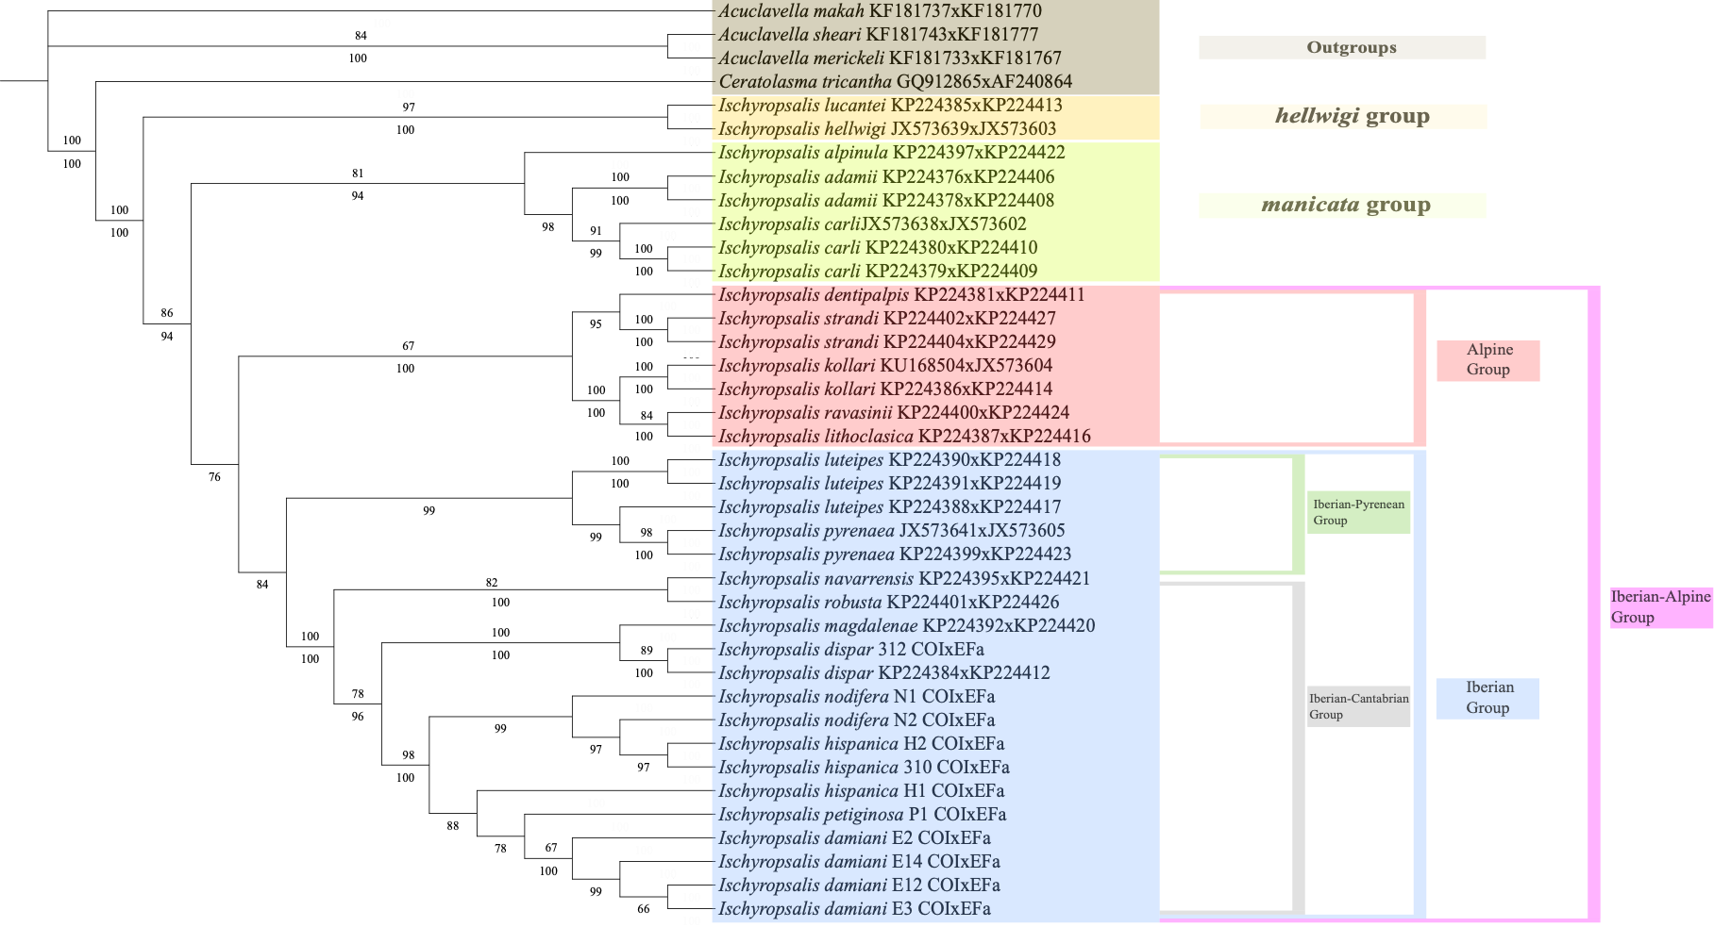
Figure 2: Consensus topology obtained from the Maximum Likelihood (ML) and Bayesian Inference (BI) analyses of the COIxEF1-α exon only dataset. Values beneath the branches indicate the Posterior Probability (PP) support from the BI analysis, while values above the branches represent the ultrafast bootstrap (BT) support from the ML analysis.

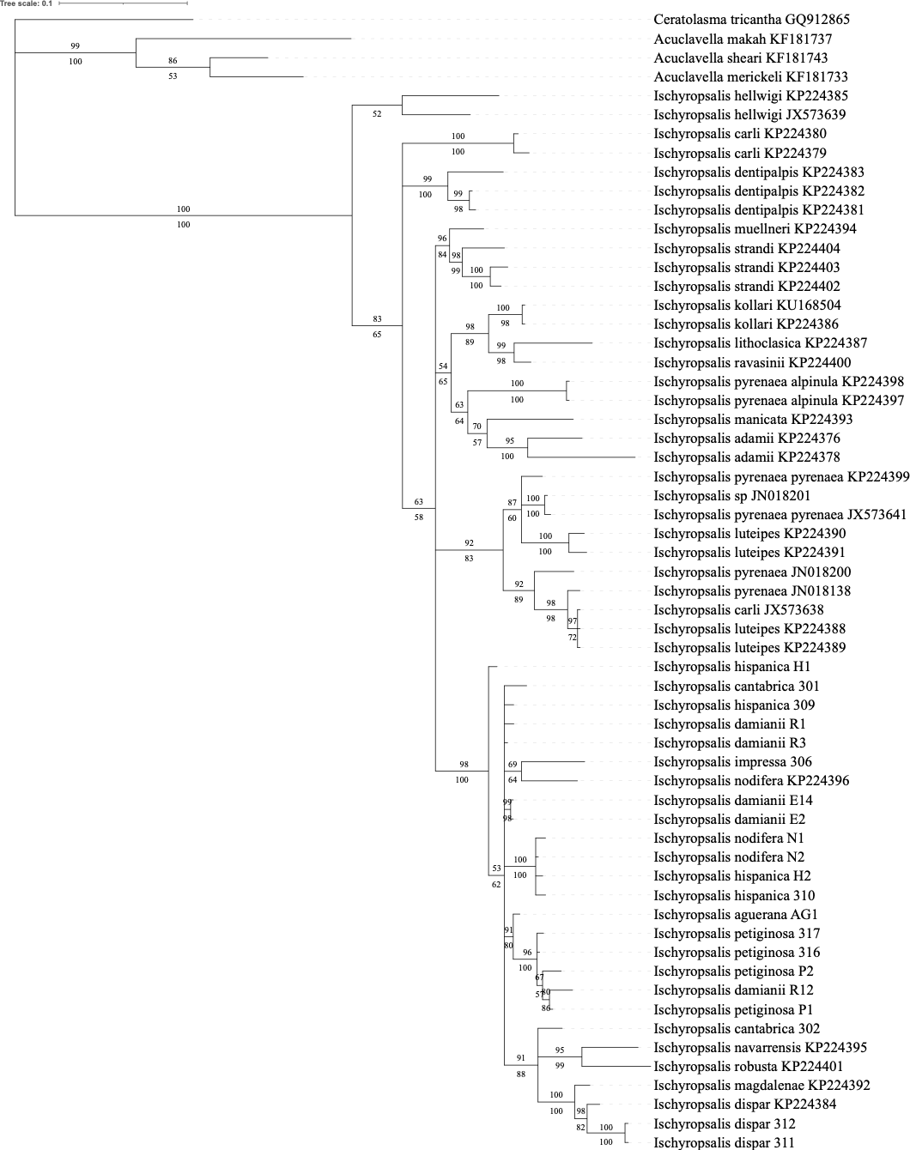
Figure 3: Consensus topology obtained from the Maximum Likelihood (ML) and Bayesian Inference (BI) analyses of the COI dataset showing branchs length. Values beneath the branches indicate the Posterior Probability (PP) support from the BI analysis, while values above the branches represent the ultrafast bootstrap (BT) support from the ML analysis.
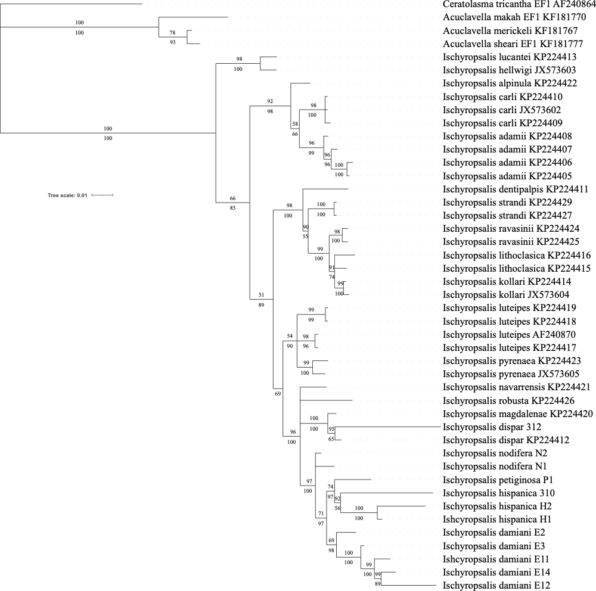
Figure 4: Consensus topology obtained from the Maximum Likelihood (ML) and Bayesian Inference (BI) analyses of the EF1-α dataset showing branchs length. Values beneath the branches indicate the Posterior Probability (PP) support from the BI analysis, while values above the branches represent the ultrafast bootstrap (BT) support from the ML analysis.

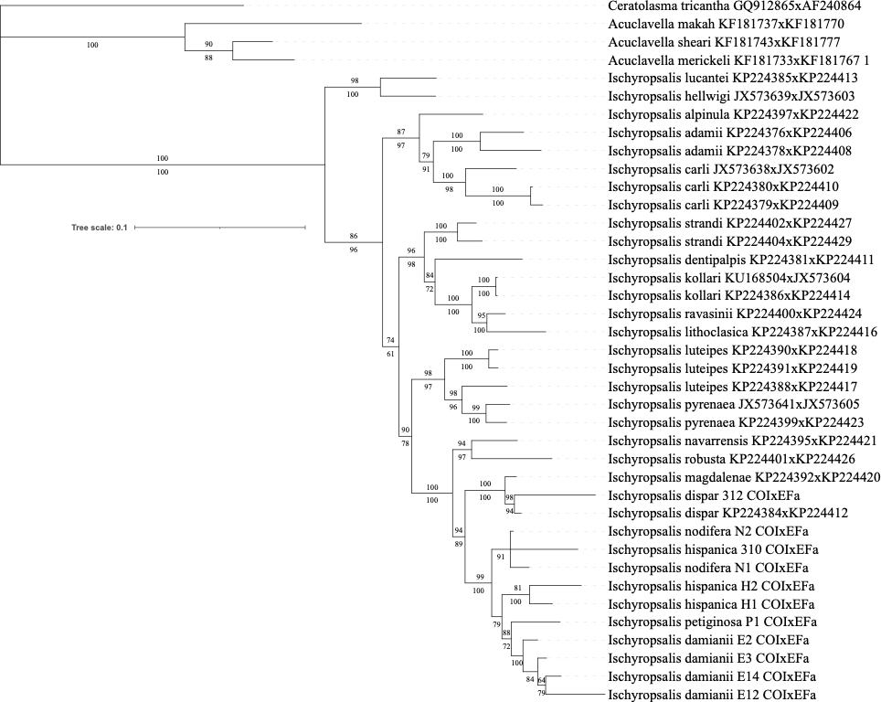
Figure 5: Consensus topology obtained from the Maximum Likelihood (ML) and Bayesian Inference (BI) analyses of the COIxEF1-α dataset showing branchs length. Values beneath the branches indicate the Posterior Probability (PP) support from the BI analysis, while values above the branches represent the ultrafast bootstrap (BT) support from the ML analysis.

